Attention
As Figure1 style is NEW UI
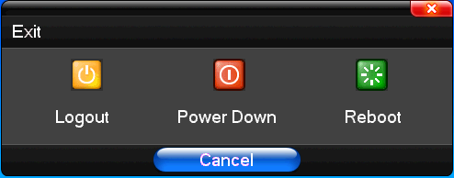
Figure1
As Figure2 style is OLD UI
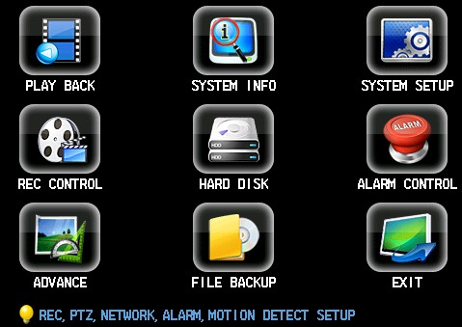
Figure2

