Chapter 1 Software Instruction
1.1 Summary
This is a Central Control Software with powerful function and Distributed Architecture,integrate many windows,users,languages,bidrectional Talk,video conference,Classic of electronic map,alarm center,be compatible with Other extended products and single directly connected devices surveillance system as one.
This software is only for connecting different devices (DVR,DVS etc...),the manual only descrip the software,for specific equipment features,pls refer to related product manuals.
1.2 Features
1.2.1 User and Authority management.
Support N level organization management,user management and authority setup.
1.2.2 Data interface technology adopted.
All datas adopt data interface technology,so it can support every database sizes very Flexibility,such as SQL,MYSQL,XML data and so on.
1.2.3 Support EXCEL edit to add device.
The platform support the user adopt Excel to add and edit devices,it's very convenience for user to maintain quantities of devices,improve system's useability and greatly reduce many works for maintenance
1.2.4 Intelligent Video Transport Protocol.
Intelligent Video Transport Protocol can do Maximize the use of network bandwidth,especially on the condition of Front-end network bandwidth limited,when to assure system based on high quality Image in very low network bandwidth,it can work well.
1.2.5 Scalable distributed network architecture.
Support multi servers running Coordinated,Intelligent load balancing,Flexibility to add server and Enhance the system capacity Effectively on the condition of Integrity assurance.
1.2.6 Perfect video monitoring.
While real time monitoring,system support alarm,recording,auto monitoring record,playback and so on,it can exactly control each channel recording status.
1.2.7 Dynamic regulation decoding buffer.
Flexibility in adjusting the Fluency/real-time of video images when real time monitoring which can meet different users need.
1.2.8 Adopting shelf technology

Modular Development and flexibly assembled applications.
1.2.9 Central management.
Centralized management of data throughout the system and Forwarding of data to provide the perfect multi-user real-time monitoring program.Remote users can real time monitor,record and playback through network.
1.2.10 Easy operation
In access control,Users can easily control and set each monitor point through the system,it also could integrates E-map.
1.2.11 High integration level
The system integrates other related informations,like Alarm and Voice etc...
1.2.12 High reliability
The system designs a special Fault tolerance measures to assure data Integrity and system runing dependability.
1.2.13 Good scalability
The system designs for Service,has good Scalability and Adaptability to maximumly protect user investment.
1.2.14 Support Network management and load balancing.
1.2.15 Support multi devices upgrade volumely via network.
1.2.16 Support User DIY interface and multi languages.
1.2.17 Support 4 channels real time playback.
1.2.18 Support connecting multi devices and view many videos(real time monitoring and playback)
1.2.19 XML data storage

Chapter 2 Installation instruction
2.1 Enviroment request of running
2.1.1 Hardware.
CPU P4/2.0G
Graphics must support hardware scaling(such as ATI,TNT2 and PRO,but suggest ATI9800 or above,dual channels,Memory(over 128M)/128bit
Note: it needs good configuration for memory,graphics and CPU If many screens need to be decompressioned.
Netcard:100/1000M
2.1.2 Software.
This CMS can run under Vista,Winxp,Win2000,Win2003 and Win2007,it's not suggestion for windows 98.
Pls close all Antivirus Software and firewalk so that it can write running program correctly and completely in the control center before installing the software,or it will not search any devices.
2.2 Installation step
2.2.1 Find "CMS_ChnEng_V1.0.0.6.T.20090315.Exe" in the CD and run it like below pic.
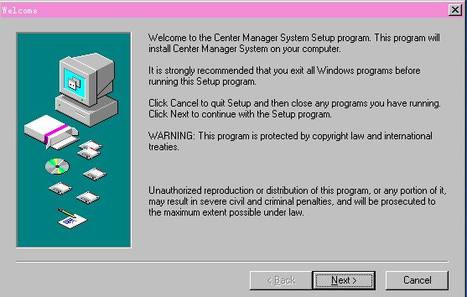
2.2.2 Click "Next",then go the below pic.

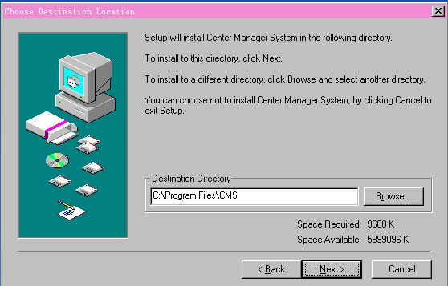
2.2.3 Click "Browser" to select setup path(default path "C:\Program Files"),then click "Next" to select Start Menu folder like below pic.
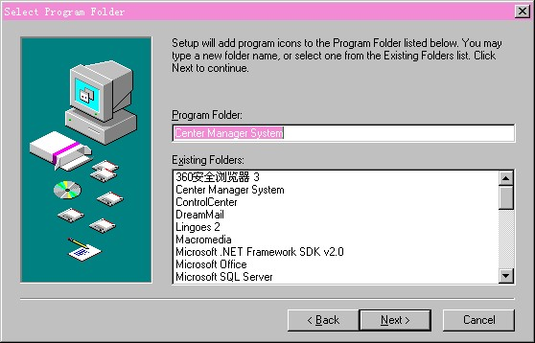

2.2.4 Click "Next" to start setup and end setup like below pic.
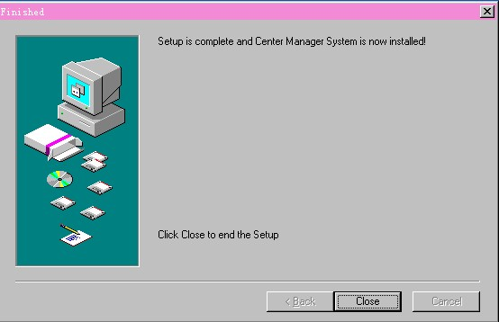
2.2.5 Click "Finish" to end the setup,at the time it will come up this icon in the desktop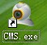
Pls follow Chapter 3,4,5 instructions to operate this software after finish installation.

Chapter 3 Introduction of basic functions
3.1 CMS Operation Main Menu
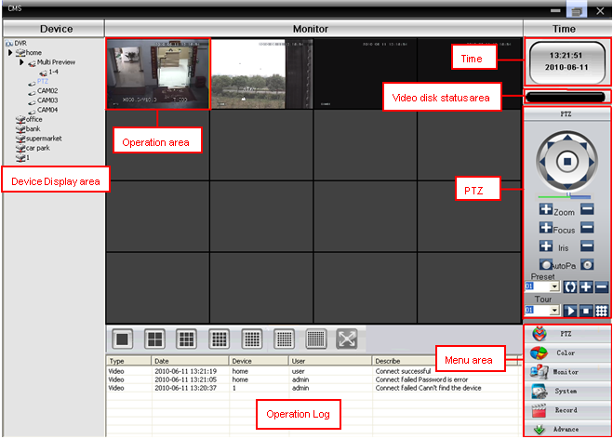
3.1.1 Device display area
In this area,you can preview live screens by device and super account administrator setting,click device name or channel group to change channes.
3.1.2 Operation area
You can preview live screens ,and setup parameters when system configuration and video searching in this area.
3.1.3 Time
3.1.4 Video disk status area
It can display the rest disk spaces where video files store
3.1.5 PTZ
3.1.6 Operation log
It will display any operation informations when setup and operating.
3.1.7 Menu Area
Users could set single menu and sub-menu in this area,select relevant menus to opearte video surveillance system in the control center.
Diagram 1 Menu Configuration
No. | First Menu | Second Menu | Third Menu | Function & Instruction | Operating right
1 | Preview |  |  | Click preview button "Monitor" to choose a preview of the screen,touring & switching among all channels and snapshot pictures of the screen. Shup down/open preview menu | Admin/User
2 | PTZ |  |  | Controling the speed cameras to go up,down,left,right and stop by operating panel,adjusting speed,zoom,focus,iris and auto pan, preseting and touring. | Admin/User
3 | Color |  |  | Set brightness,contrast,saturation and hue for video screen | Admin/User
4 | System | Device manager | Add zone | Add zone for all devices | Admin/User
4 | System | Device manager | Add device | Add video surveillance devices | Admin/User
5 | System | Device manager | Modify | Modify device name,ip address,user name and password | Admin/User
6 | System | Device manager | Delete | Delete video surveillance devices | Admin/User
7 | System | Local Config | Base config | Select disk,disk list and logs maintenance | Admin/User
8 | System | Local Config | Alarm setting | Enable audio activated by alarm | Admin/User
9 | System | Account | Group | Add and delete users' operating rights | Admin
10 | System | Account | User | Add,delete and manage users:  Set user name,password and operating rights of menu | Admin
11 | System | Local Log |  | Search alarm log and operation log in set time area. | Admin/User
12 | Record |  | Playback | Search record file and playback | Admin/User
13 | Record |  | Record Plan | Set record time for every day | Admin/User
14 | Advance | Decoder |  | Set DVR and decoder | Admin/User
15 | Advance | Map |  | Using this map,it can visually show every cameras location and find current monitoring page directly | Admin/User

Chapter 4 Monitor
In the menu area,click "Monitor",it will turn to preview screen.
Monitor functions: Preview,PTZ and video specification configuration.
4.1 Preview

Diagram 2 Functions and instructions of preview
No. | Button | Meanings
1 |  | click it to preview full screen for every channel
2 | 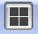 | click it to preview 4 screens
3 | 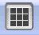 | click it to preview 9 screens
4 | 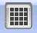 | click it to preview 16 screens
5 | 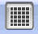 | click it to preview 25 screens
6 | 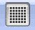 | click it to preview 36 screens
7 | 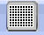 | click to to preview 64 screens
7 | 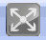 | click it to enter full screen interface

4.2 Right-click Menu
At operating area,user can do below operation by right-click:
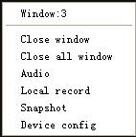
Close window: close the current screen
Close all window: close all the current screens
Audio: click it and hear the voices from preset screens
Local record: click it to record at current channel and save the record at the relevant disk.
Snapshot: Capture pictures from current channel at any time and save it to relevant disk.
Device config: click it and go to device configuration interface.
4.3 PTZ Control
When speed cameras are connected with DVR,user can control it at this center,turn up,down,left and right,stop running,adjust turning speed,zoom,focus and iris,preset and tour configuration.When user enable touring function,the speed cameras will tour according to preset.
Function:
No. | Button | Meanings
1 |  | means "turn", means "stop turning"
2 |  | Drag this pole to adjust speed rate
3 |  | Click to zoom in;Click to zoom out
4 | 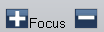 | Click to focus in;Click to focus out
5 |  | Click to iris it;Click to iris out
6

7 | 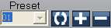 | Set a location for the preset, calls the preset points, PTZ automatically turns to the setting position,add,delete and config preset point
8 | 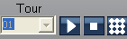 | Multiple preset points connected tour lines, call touring between points, the PTZ run around on the line

4.4 Color
No. | Button | Meanings
1 |  | Brightness
2 |  | Contrast
3 |  | Saturation
4 |  | Hue
Picture 4-3 Color
Note: Click to resume Initial values

Chapter 5 System

5.1 Device manager
5.1.1 Click 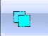 to add zone,see below:
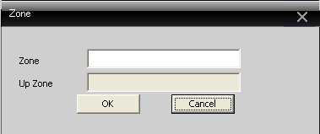
5.1.2 Click 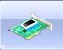 to add device,see below picture:
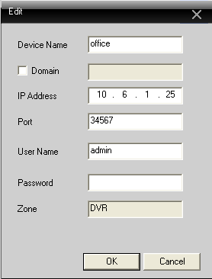
Device Name: Device name
Domain: Domain name by external network such as xxxx.3322.org; xxxx.dyndns.org; xxxx.oray.org etc...
IP Address: IP address
Port: TCP port
User Name: User name
Password: Password
Click "OK" after you have done above parameters,see below picture,you could only doubleclick to open this device.
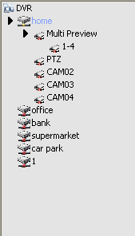

Note: Choose only one of Domain name and IP address
5.1.3 Click 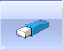 to modify device,see below picture:
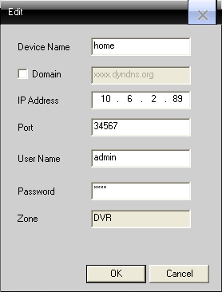
After finishing all the modifications,click "OK"

5.1.4 Delete device
Choose the devices which you want to delete,then click .
Note: Please make sure the device is disconnected before modifying and deleteing it.
5.2 Local Device
5.2.1 Base Config
See below picture:
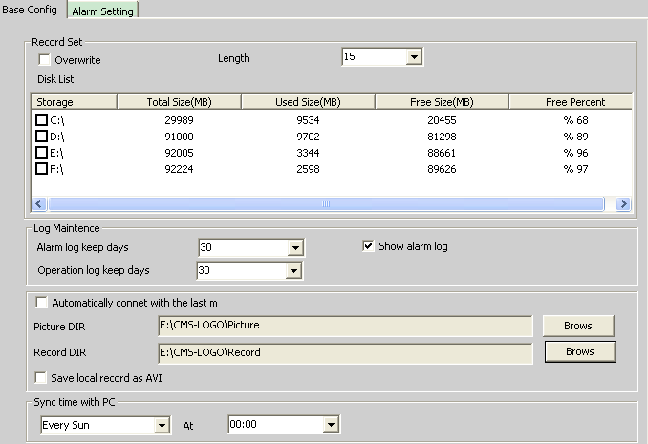
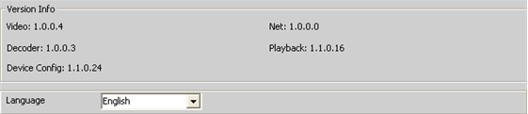
Overwrite: Click it,then it will cover the old records when HDD is full
Length: Time length for 1 record file
Disk List: C,D,E,F
Log Maintence: Alarm and Operation log keep days
Picture DIR: Picture storage location by snapshot
Record DIR: Record storage location by local recording
Sync time with PC: Adjusting device and PC in order to make both at the same time
Version Info: CMS's vertion(video,net,decoder,playback and device config)
Language: Choose language for CMS

5.2.2 Alarm setting
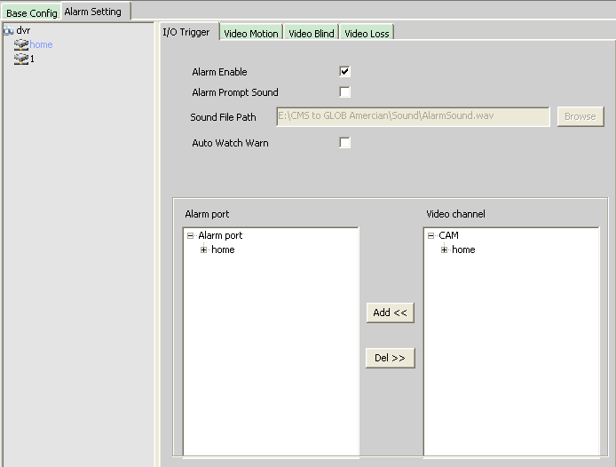
Device list: Choose 1 device to set alarms
Alarm Enable: Click it to make sure all alarm functions available
Alarm Prompt Sound: Select any alarm prompt sound which you like
Sound File Path: Browse and choose prompt sound
Auto Watch Warn: Choose it to add following channels by alarm activated
Note: Please go to choose alarm type first

5.3 Remote Config
Select a device first,then set its configurations,see below picture:

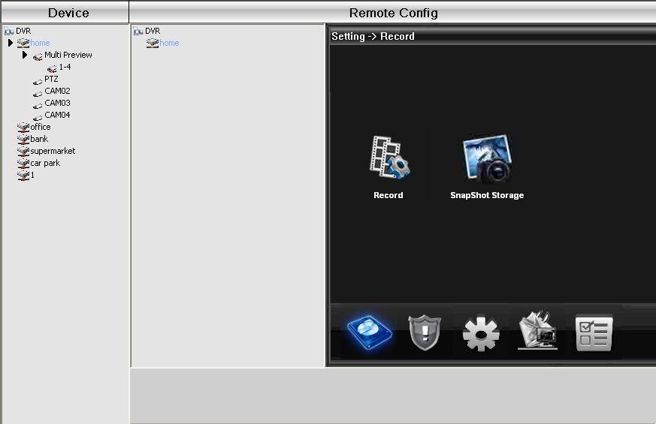
5.3.1 Record: Click  to go into record interface
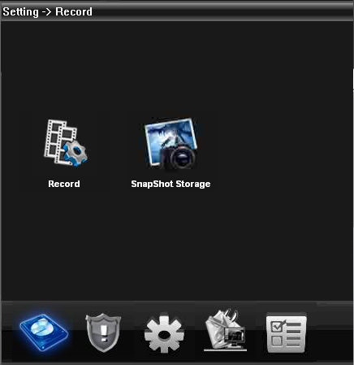
Set record length,period,type etc...see below picture:
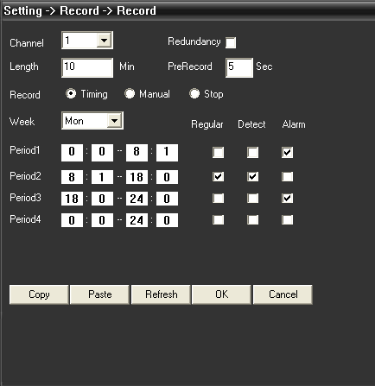

Snapshot Storage: Set presnapshot,snapshot type and period,see below picture:

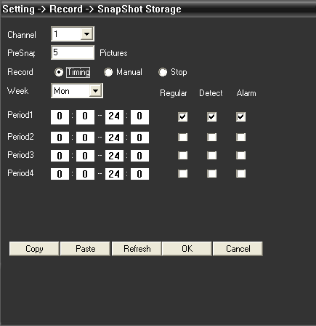
5.3.2 Alarm: Click  to go into alarm configuration,see below picture.
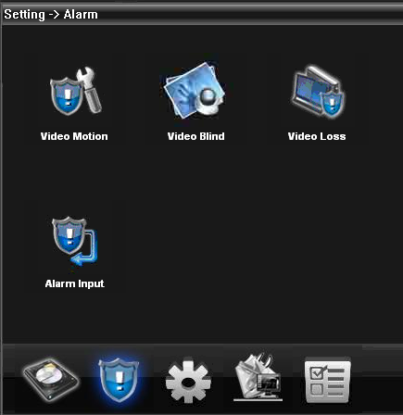
Alarm activation configuration(motion detect,video blind,video loss and alarm in),see below picture.
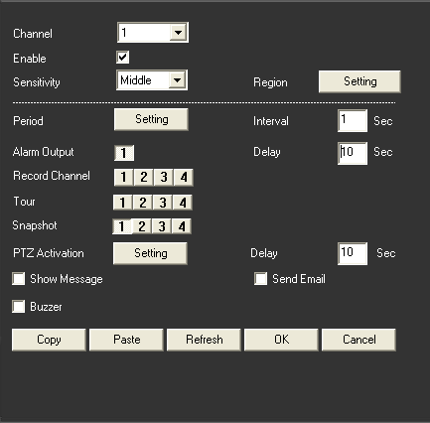

5.3.3 System
Click  to go into system set interface,see below picture.
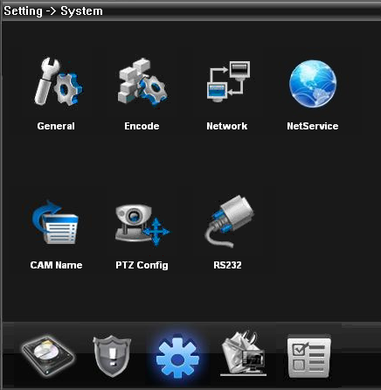
General:Set system time,language,video standard,DVR No.,auto logout and so on,see below picture.
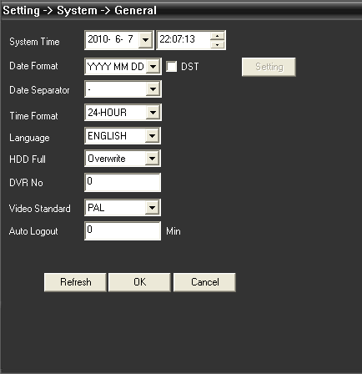
Encode: Set dvr specifications of resolution,FPS,video quality etc...see below picture.
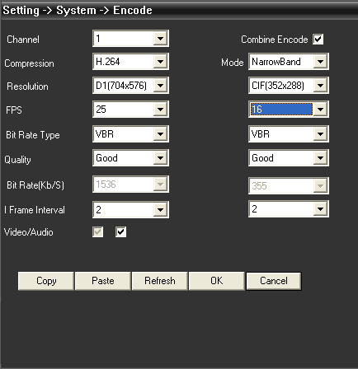
Network: Set IP address,port,DNS etc...in order to remote monitor by network and mobile,see below picture:
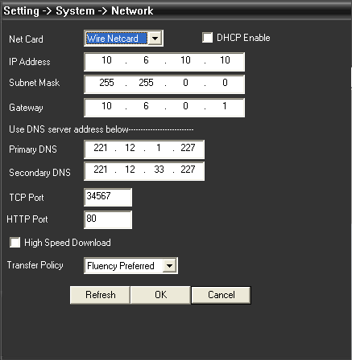
NetService: Set IP filter,DDNS,Email etc...see below picture
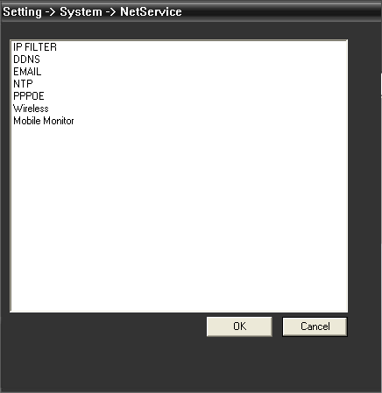
CAM Name: Add or modify camera name by your need,see below picture
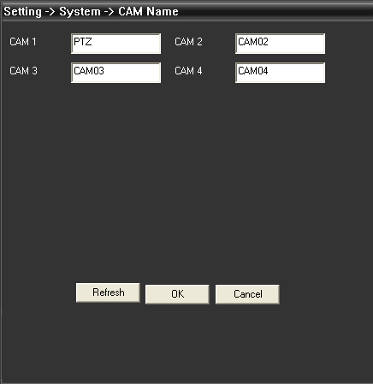
PTZ config: Set PTZ parameters to make sure the same as speed cameras.
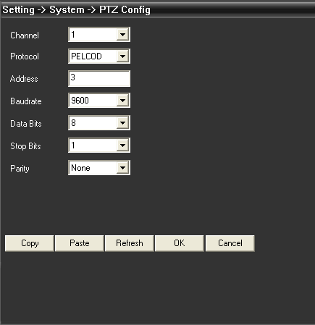

RS232: Set RS232 port configurations,see below picture.
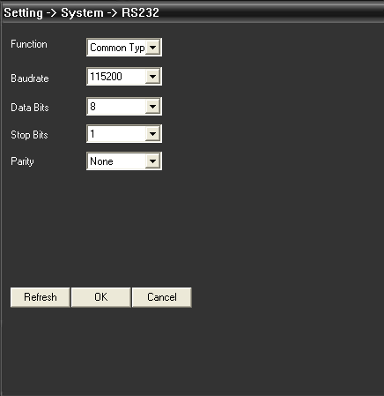
Advanced: Click  to go into advanced interface,see below picture.
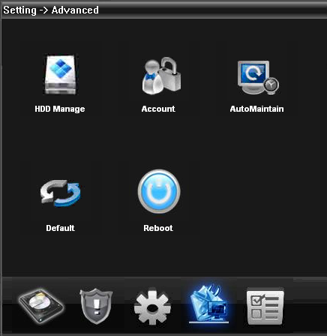
HDD manage
Account: Modify User,group,password,add user,group etc...see below picture:
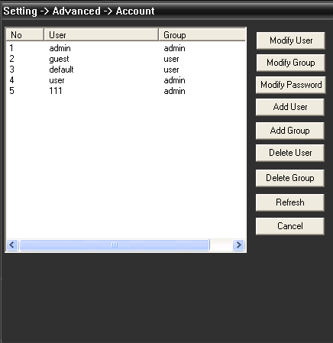
AutoMaintain: Set Auto-Reboot time and files management,see below picture
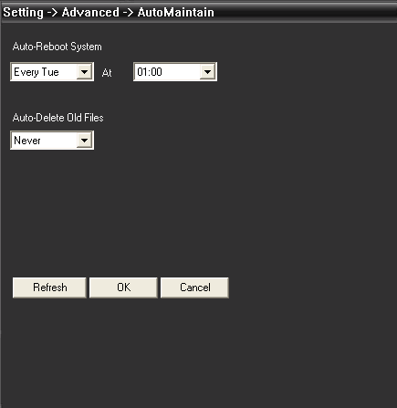
Default: Restore to factory settings
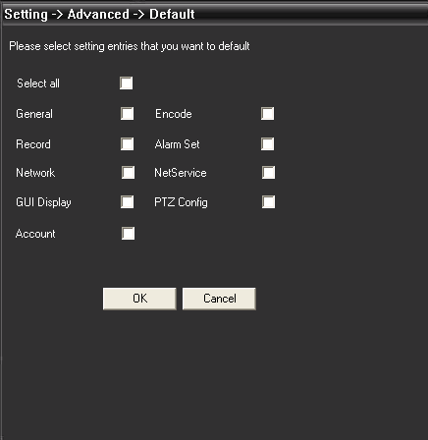
Info. Click  to go into system info interface,see below picture:
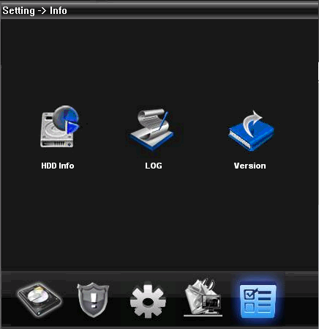
In system info,there are HDD info,LOG and Version.

Chapter 6 Account
6.1 Group
Add&delete group and set group right,see below picture:
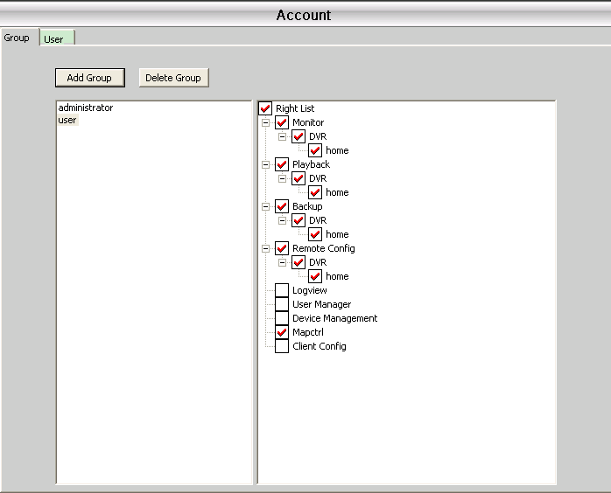
6.2 User
Add&delete user and modify password
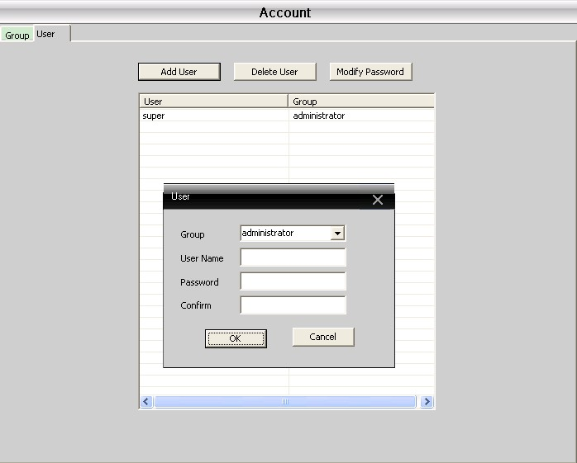

Chapter 7 Local Log
User could search menu operation log,alarm log and other logs by time,see below picture.
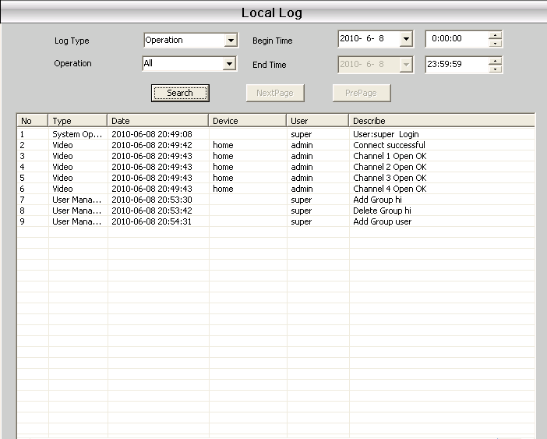

Chapter 8 Record
8.1 Playback
There are 2 playback modes---Remote playback and Local playback.
Remote playback: Playback at Device-side.
Local playback: Playback at Client-side.
User could playback record files of any times,max playback channels are 4.
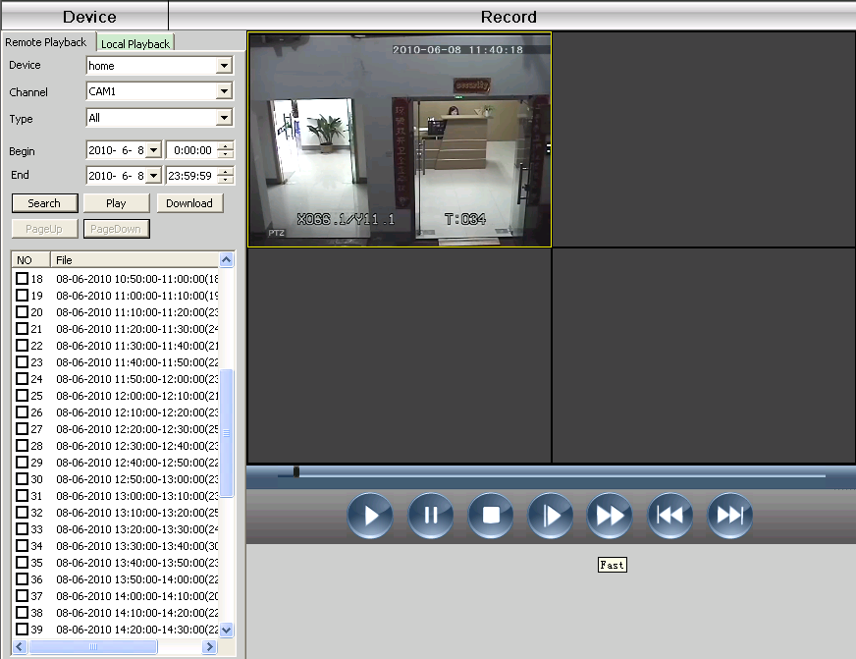
Button instruction
No. | Button | Meanings
1 | 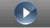 | Play
2 | 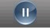 | Pause
3 | 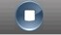 | Stop
4 | 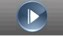 | Slow play
5 | 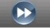 | Fast play
6 | 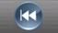 | Last frame
7 | 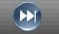 | Next frame

8.2 Downlaod & Backup
User could playback record files at set time and channels,select record fines,click "Download/Backup" and select "save directory".
Note: Remote playback----Download
Local playback---Backup
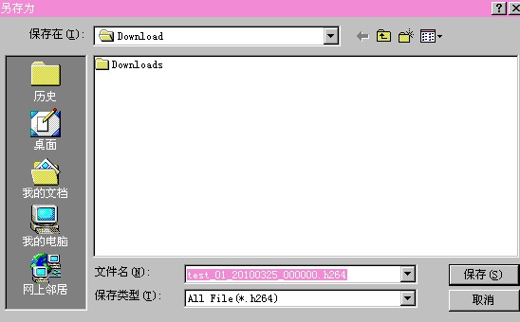
8.3 Record plan: Set your record plan on any clocks and days,see below picture:
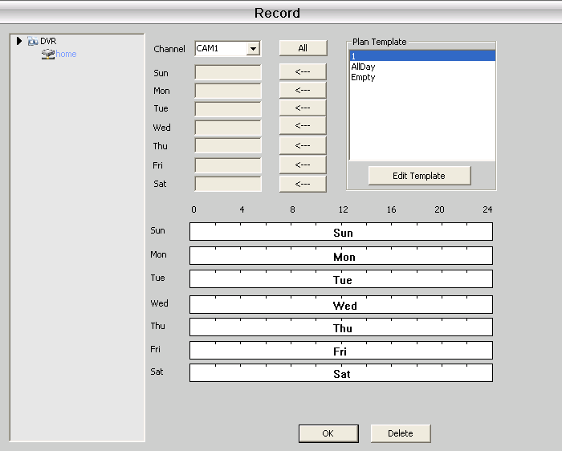
Edit Template,see below picture:
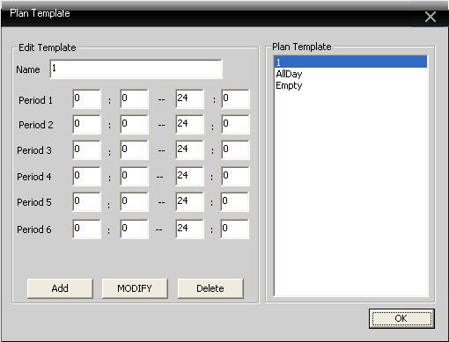
After set name,then click "add" and "OK"
Choose "channel" first,then go to set record time from Monday to Sunday.

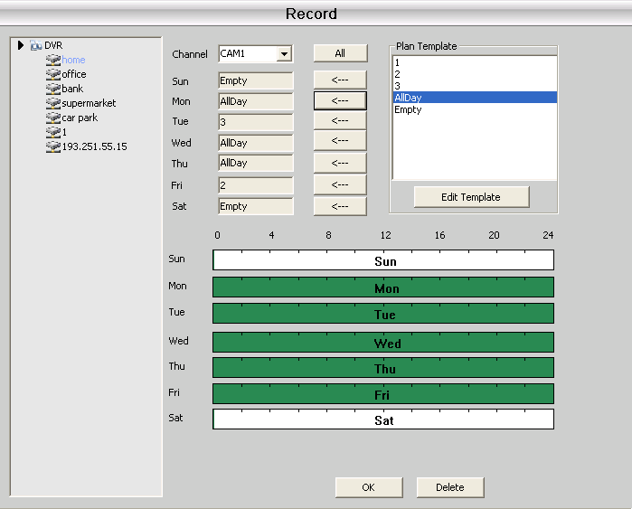
Note: After set record plan,If it need to record,please make sure the below 3 points:
1.Choose disk for recording at Local config.
2. Make sure the device is connected to network.
3. Make sure local computer is always open.

Chapter 9 Advanced
It contain two options---Decoder and Map.

9.1 Decoder
It can manage and config remote decoder very easy,see below picture:
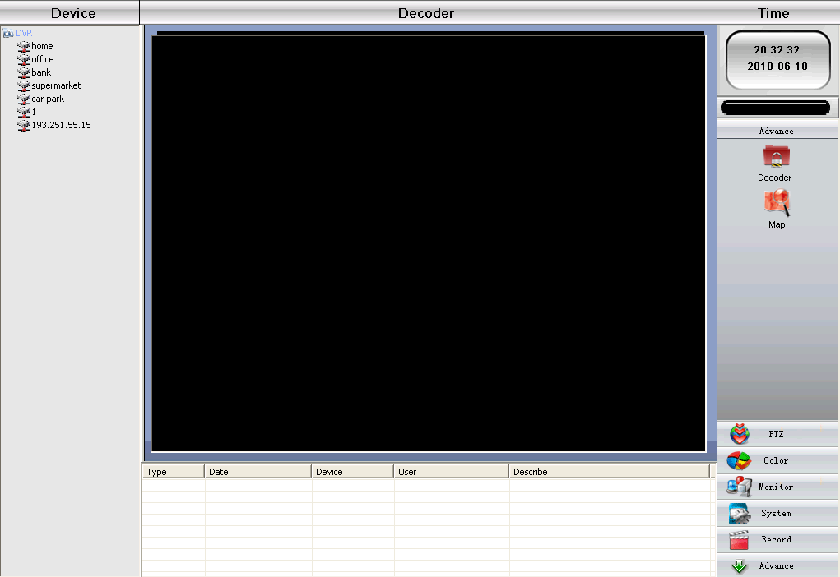
9.1.1 Add decoder
Right-click to add decoder,see below picture:
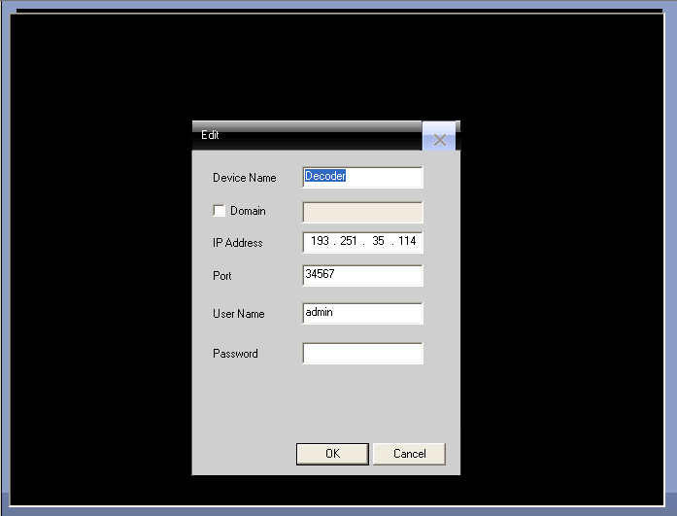
Device Name: Name of decoder,it's set by yourself
Domain: Domain name of decoder
IP address: IP address of decoder
Port: TCP port,default is 34567
User Name: Login name of decoder,default is admin
Password: Password of decoder
After you add decoder successfully,it will come out a "decoder" ico in this interface,right-click this ico to edit,delete and set attribute.
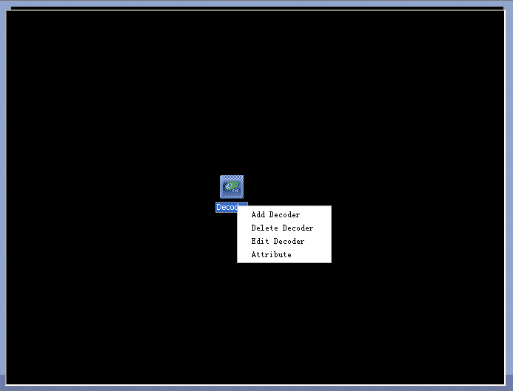
9.1.2 Edit
Right-click decoder ico to "edit decoder",see below pictures:
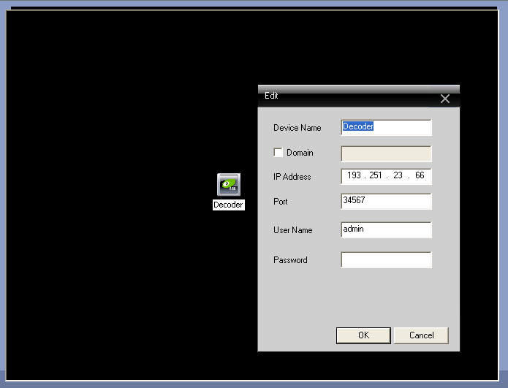

9.1.3 Set decoder Attribute
Right-click to click "Attribute",see below picture:
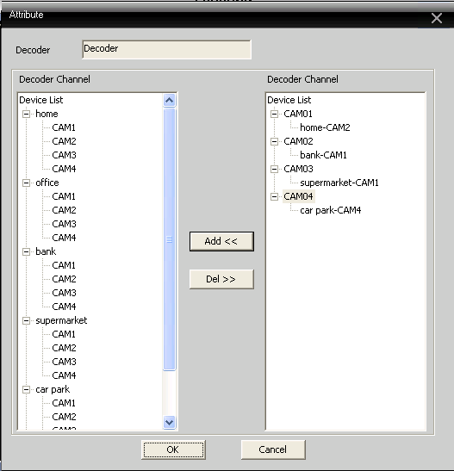
In the device list of left side,select 1 camera,then select 1 camera of right side,at last click "Add" in the center,for example:
See above picture,
Decoder CAM01 decode output for "home-CAM2"
Decoder CAM02 decode output for "bank-CAM1"
Decoder CAM03 decode output for "supermarket-CAM1"
Decoder CAM04 decoder output for "car park-CAM4"
Delete decoder
Right-click to delete decoder

9.2 E-MAP
E-MAP is a plan for simulating live screen,user can use it to add & delete cameras and set e-map alarm activation,see below picture:
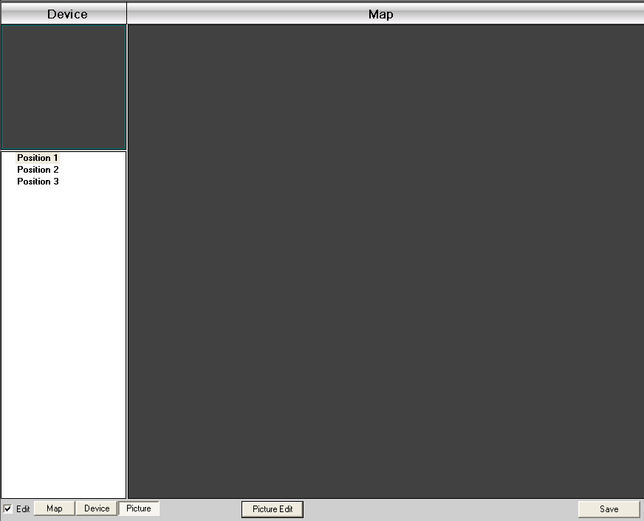
1.Click "Edit" first at the left bottom,then click "Picture Eidt",see below picture:
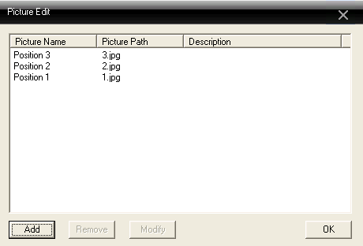
2.Click "Add" to add picture,see below picture:
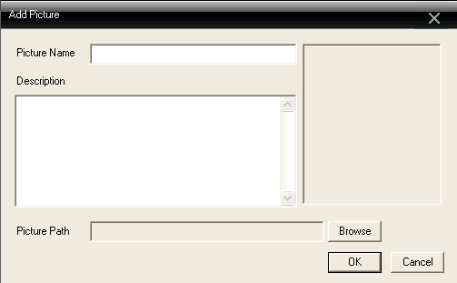
3.After set picture name,description,picture path,then click "OK" back to main interface.
Click "Picture" and drag 1 picture to the right side,see below picture:

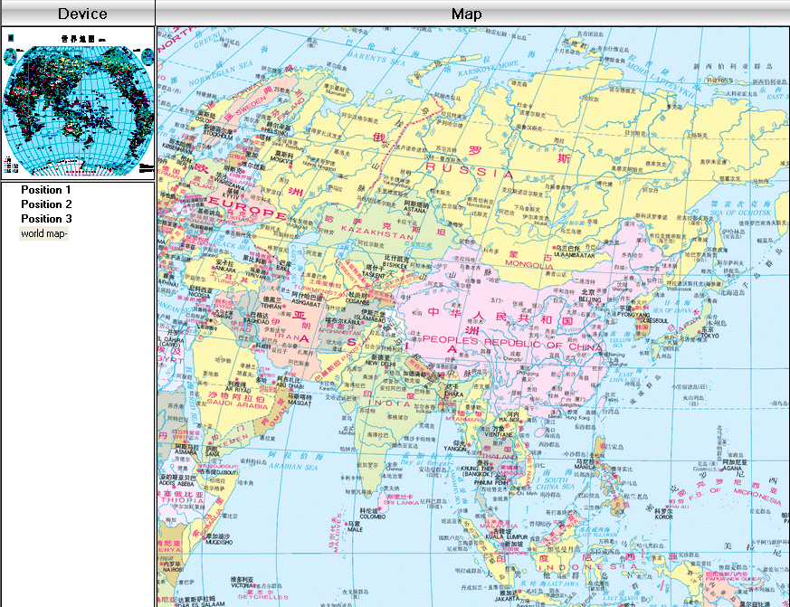
4.Click "Device" to drag device's channel to the map,then the channel name will appear at the map,double-click it to name and describe it.
Appendix A Abbreviations
Abbreviation | Full name | Chinese meaning
CMS | center manager system | 网络视频控制中心
DVS | Digital Video System | 数字视频监控系统
PTZ | Pan/Tilt/Zoom | 云台设备
TCP/IP | Transmission Control Protocol / Internet Protocol | 传输控制协议/互联网协议

Appendix B Main parameters
Video Compression |  |  | H.264 main profile
Audio Compression |  |  | G711A
Video Resolution |  |  | D1/HD1/CIF/QCIF
Display resolution | Resolution | NTSC | 704 x 480
Display resolution | Resolution | PAL | 704×576
Display resolution | Rate | NTSC | 30FPS
Display resolution | Rate | PAL | 25FPS
Frame rate |  |  | 30/25(NTSC/PAL) F/S
Video input |  |  | BNC input
Audio input |  |  | RCA input
Type of compressed code |  |  | Combine code
Rate of compressed code |  |  | 32kbps ~ 2048kbps(adjustable)
Network Procotol |  |  | TCP/IP,static IP , DHCP , PPPoE
Net Interface |  |  | 10/100M RJ45
PTZ procotol |  |  | Pelco-P/ Pelco-D/ Minking/ Linlin/ Neon/ Star/ Vido etc...
Remote Monitor |  |  | IE browse,CMS and Mobile

