Firefox Operation manual

1. Open firefox browser, go to https://addons.mozilla.org/zh-CN/firefox/addon/ie-tab/ to download activeX, see below pic.

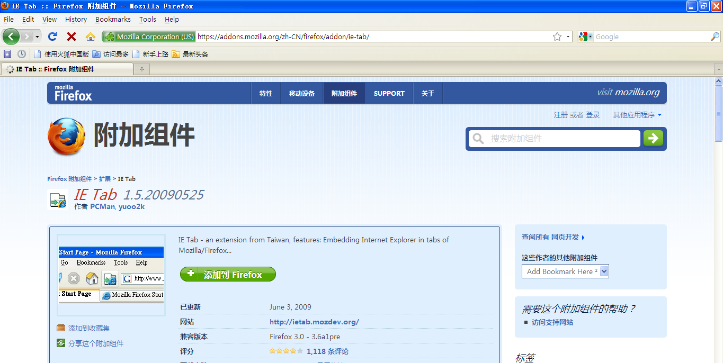
Click Here

-
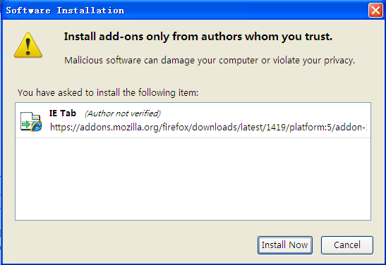
Click Here

-
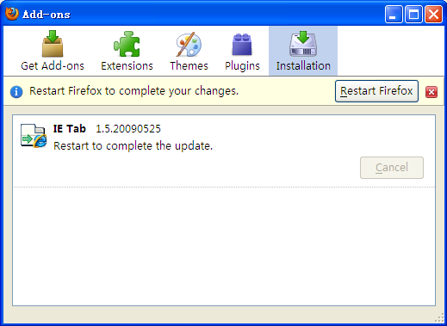
Click Here

- Pls go to Tools->IE Tab Options
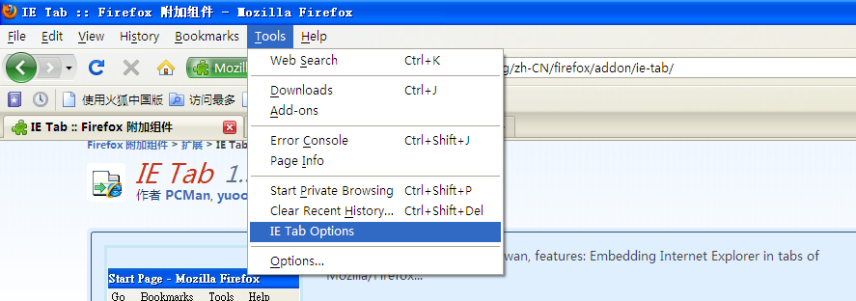
Click Here
Then add your dvr ip address,see below

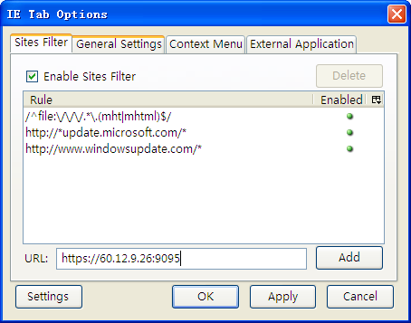
Input your DVR address here,then click Add,Apply and OK.
Then go to visit http://60.12.9.26:9095/ , see below pic
