Vmeye
For BlackBerry
User Manual

User Manual Version 1.0 (July, 2011)
Please visit our website www.meyetech.com

Contents

Chapter One Introduction………………………………….2
1.1Brief Introduction……………………………………….2
1.2Essential Condition………………………………......…..2
Chapter Two Acquisition and Installation………………......3
2.1 Acquire Vmeye from App World (E-Market)….…..3
2.2 Acquire Vmeye from Suppliers or manufacturers………….4
Chapter Three Application Setting…………………........6
3.1 Detailed Setting Introduction………………………….........6
Chapter Four Application Running…………………...8
4.1 Interface Description……………………………….............8
4.2 Functions of Corresponding Buttons………………........….8
4.3 Video Display……………………………………............10
Chapter Five FAQ…………………………….……………11

Chapter one Introduction

1.1 Brief Introduction
This document mainly introduces how to set and use Vmeye for BlackBerry OS.
Vmeye has three main functions.
- Realize real-time video watching function;
- PTZ control function (the device must be supported).
- Up to 16 channels switching.
In a word, our product enables you to process real-time video monitoring under normal network condition, which can help protect important property.

1.2 Essential Condition
This application favors Blackberry system higher than 4.6 released, fitting the resolution of 480*360, 480*320, 360*480, 320*240 cellular phones, such as 8520, 8900, 9000, 9700, 9630, 9530, 9500, 9800 etc.
Other details:
1. The 8520/8900/9000 needs system 5.0.0.90;
2. 9700 requires systems of 5.0.0.714 or 5.0.0.344;
3. The 9630/9530/9500/9800 needs system of 6.0.0.284.

Chapter two Installation

2.1 Acquire Vmeye from App World
Our users can acquire Vmeye either through downloading from App World or from the DVR manufacturers.
As downloading from App World, you may first search “Vmeye”, and install it to your BlackBerry phone, as the following picture shows:
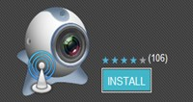 (Picture 1)
Then click “Install”, the application will be automatically installed into your mobile phone, just like the below picture shows:
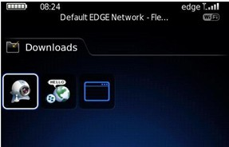

(Picture 2)
This means this application is successfully installed.

2.2 Acquire Vmeye from suppliers or manufacturers
If you purchase DVR devices from suppliers or manufacturers, this application will be attached in the DVD disk. You only need to copy Vmeye into the mobile phone and click to install it, and then the icon of this application will appear in the menu as above picture shows.

Chapter Three Application Setting

After successfully installed the application into mobile phones, it is ready to run, just click the Vmeye icon in the main menu.
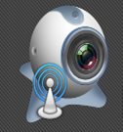
(Picture 3)
3.1 Detailed Setting Information
If this is the first time you use Vmeye, you have to fill in the setting information before you can successfully login. The setting information will be listed below:
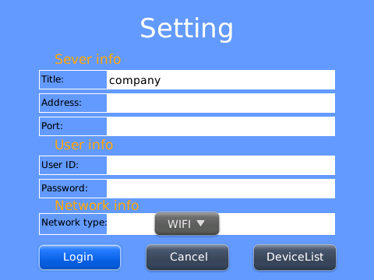
We can see six lines of blank needed to be filled. They are Title, Address, Port, User ID, Password and Network type. We will explain what they mean and what you should pay attention to.
(Picture 4)
Title (Name): The names of equipment, which can help you identify different devices, for examples, you can type the names based on the location of the equipment.
Address: DVR IP address or DDNS. (Must be an Internet address).

Port: It means mobile phone port, and you can acquire port number in the setting information of the device.
User ID: Usually the default is "admin", please consult your suppliers for more detail.
Password: The default of password is usually as "admin", the same as the ID.
Network type: In this line, you can choose access via WiFi or 3G network.
You can edit and manage your access book by clicking “Devicelist” button in the right bottom.
The above information can almost help all the users, if there is still problem, you can ask the suppliers or write e-mails to our technical supporter.

If you still have problem in this section, please visit our website www.meyetech.net for more information.

Chapter Four Application Running

4.1 Main Interface
After successfully login, the main interface will look like the below picture:
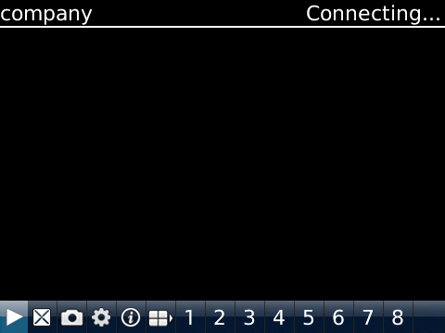(Picture 5)
4.2 Functions of corresponding buttons
There are many buttons in the main interface, here is the instruction for their functions. See table 1 in next page:

Function key | Name | Function description
 | Play | The procedure to start broadcasting a video camera
 | Snap pictures | To grasp a picture document appearing in the camera and save it the installed folder.
 | Setting | Enable users to edit DVR IP address, port, user's name and password setting and the change of equipment names and watching area switch as well as changing network type.
 | Next group | Select to the next group of gateways
 | About | Application information
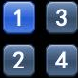 | Select channel | Enables to select a certain video of one gateway that broadcasts equipment to another. It can carry out eight roads one time, click "next group" button for the next eight roads.
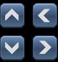 | PTZ control | Carry out PTZ control
 | Zoom control | To draw the camera from close to farther distance
 | Change focus | Carry out focal length from adding to subtracting
 | Aperture changing | Carry out diaphragm from adding to subtracting
(Table 1)

4.3 Video display
This application can both support routine mode and full-screen mode, when the mobile phone lies down horizontally, the application will automatically play in full-screen mode.

Chapter Five FAQ

In this section, we will conclude some frequently appearing problems and solution for users, for more information and interaction with us, you can visit: www.meyetech.com, which provides the latest information and versions of software, you can also directly submit your questions to us through: Support ——> Submit Online;

Q1: What is the function of Vmeye series applications?
A1: Vmeye series applications enable users to view their IP cameras or DVRs with their mobile phones remotely and real time.

Q2: Where can I find the apps?
A2:
- You can download apps in the E-markets of corresponding mobile OS with keywords “meye” or the name of the app, such as “HB player” and so on; presently, you can visit:
http://appworld.blackberry.com for Blackberry;
https://market.android.com for Android
http://applestore.com/itunes/ for Iphone
You can get the apps from your device seller, which will be attached

in the DVD of the devices.
Q3: Will I be charged for the data when I use the apps?
A3: If you use our software via WiFi connection, you will not be charged for data connection. But if you use GPRS or 3G network, you will be charged, you can ask your local mobile operator for detailed information.

Q4: What types of mobiles can I use with Vmeye series applications?
A4: Our products mainly support five main mobile OS, which are Android, Iphone, Blackberry, Windows and Symbian, other OS will be gradually added.

Q5: What is a port?
A5:
- A port is a “tunnel” through which the device exchanges data with the Internet.
- It is notable that a mobile port is different from a PC port; you can find out the mobile port in your device’s setting menu or ask the device suppliers because the mobile port is initially fixed by them.

Q6: Where do I get my User ID or Username and Password?
A6: Normally they are provided by your DVR suppliers, you can ask them for help. The default of User ID and password are usually “admin” and “admin”.

Q7: Why there is nothing showing after I have connected?
A7: This problem may be caused by the wrong settings of the input of mobile phone’s port. You can ask the DVR suppliers for help because the port is fixed by them.

Q8: How often can I update my app?
A8: Normally we will update the apps every one or two months online, to gradually solve the problem caused by the app itself and provide better service to you. Please visit our web: www.meyetech.com often to update your apps in time!

Q9: What should I do to ensure the app work well on my phone?
A9: To make sure that the app can run well on your phone, you had better pay attention to:
- Your device is compatible with our apps, you can visit www.meyetech.com to check the compatible devices list or you can

directly ask your device seller for help.
- Make sure that your phone model is supported by our apps, you can also visit www.meyetech.com to check the support phones list.
- Make sure that you are using the right app for your device, you can ask for help from our supporters and we will give you advices.
- That’s all and you will own an excellent experience with our apps!

Q10: What are the supported DVR devices of your software?
A10: We support certain device manufacturers that cooperate with us, which means our apps will run well on certain DVR models or IPcameras；For further details，please visit www.meyetech.com to get a complete list for compatible devices information.

Q11: How can I get the technical support service of your apps?
A11:
- You can write e-mail to us: support@meyetech.com;
- You can visit: www.meyetech.com and submit your questions through : Support ——> Submit Online;
We hope all of you enjoy an excellent experience with our apps, we will be appreciated to your valued opinion and waiting for your news.

