Instruction for Android

（brief introduction）
The documents mainly introduces how to set and use the Software for Android OS.

The Software has some main functions.
- Browse real time video function;
- Cloud stand control function (the front end is to control ball machine).

Essential condition
Favor Android system more than 1.5 releases, the cellular phone includes HTC G1、HTC Magic、HTC Hero、HTC G5 etc.

Install and operating instructions
Install TMEye.apk to wrap to make duplicate in the Android cellular phone through a data wire or go to google store search TMEye and install it on line, the following chart:
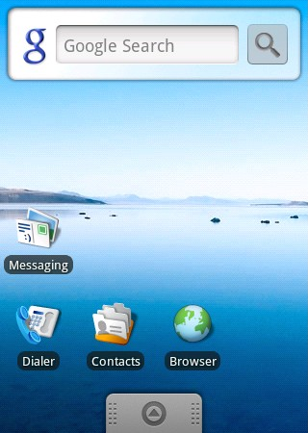

- Finding out under the appointed catalog is homologous.The apk clicks to apply a procedure setup(general cellular phone inside all from take apk setup machine if none already need to download an apk first setup software just can identify apk to wrap), will appear a routing diagram mark after the setup, the following chart:
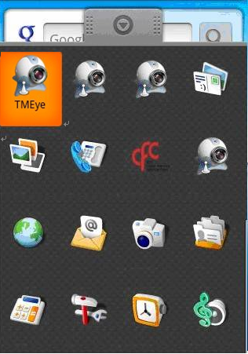
4）Click a homologous routing diagram mark, circulate after the procedure a beginning to start interface the following chart
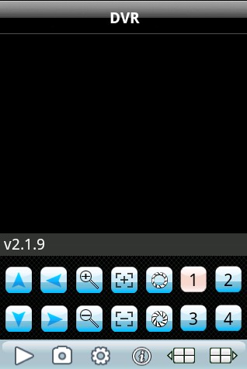

Press button vs in response to the function is as follows
Function key | name | Function description
 | play | The procedure connectivity equipment combines to start broadcasting a video
 | snap | Grasp beats  snap Grasp to clap a current ICON(grasp a chart document to recognize tacitly conservancy to the cellular phone of tacit approval of photograph catalog bottom.)
 | setting | Establish a DVR IP address or watch an area, port, user's name and password and equipment alias information
 | Up group | Can select up the gang gateway
 | Next group | Can select to descend gang gateway
 | About | About information
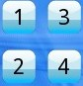 | Selective channel | Select gateway  Selective channel Select a some video of one gateway that broadcasts an equipment.Can carry out eight roads, 16 road gateways to cut over with"descend gang" team work
 | PTZ control | Carry out a cloud on the stage, next, left and right control
 | Zoom ratio | The realize tension far draws near
 | focus | Carry out focal length to add and subtract
 | aperture | Carry out diaphragm to add and subtract

5）Such as first time use or need to carry on parameter to change, please click 【setup 】button enter a parameter setup interface.The following chart
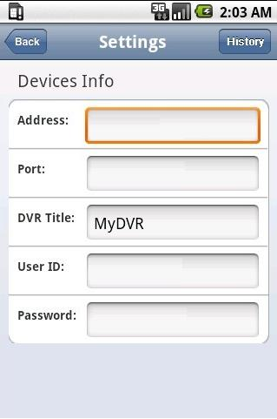

：
explain

Server address(Address):DVR male net IP address or dynamic state area

Server port(Port):In DVR setup ascend specialized give the port of cellular phone

Equipment denomination(DeviceName):The alias of equipment is easy to classify several equipments

User's name(User ID):The user's name reconciliation that carries a setup with IE

Password(Password):The password reconciliation that carries a setup with IE

Is a return button


Enter a history record page
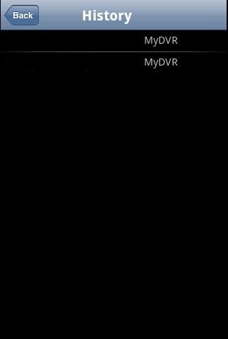

Pick out in the history record a certain click and then can carry on the watch a dot of watch

Delete a certain history record

Pick out the record that to delete to lengthways press down and then will flick a picking frame of delete or cancel open, select delete and then can recording to carry on a delete operation vs the
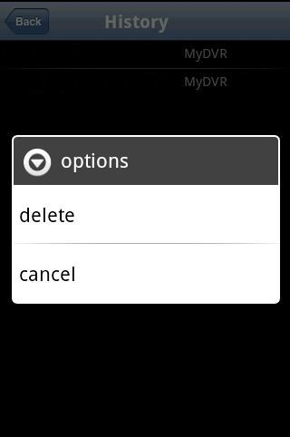
6）The video displays mode

Down the routine mode and full plate mode progress cuts o
Regular support mode
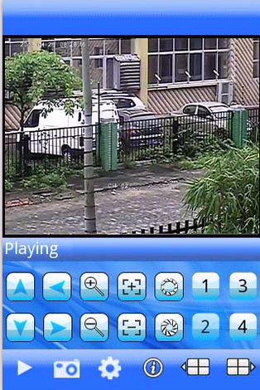

When the handle machine lays down horizontally will the automatic full plate broadcast

Full support mode
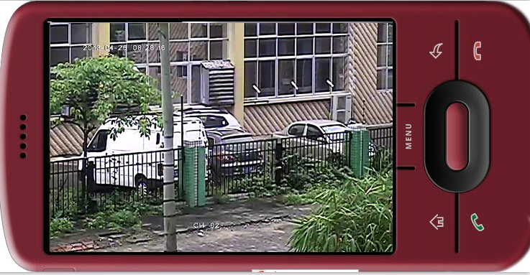

7）channel switching
Pick out homologous gateway, the procedure will open homologous gateway to combine to automatically broadcast a video.The procedure tacit approval will display 1~4 gateways bottom, win an election amid when the next gang gateway press button will gateway will cut over to 5~8, 8-12,12-16 cyclic transformation cutover

The DVR parameter that favors a cellular phone establishes a referenc
Resolution:CIF or QCIF
Leads:5-1
The code flows a type:Limit
The code flows:64-256Kb/S
Note:Can carry on tune according to the cellular phone performance and the network condition.Higher cellular phone performance and network condition can display better effect.If the network condition is worse, can appropriately the step - down lead and assure flowing freely

