instruction for Blackberry

Brief introduction
The documents mainly introduces how to set and use the Software for Blackberry OS.

The Software has some main functions.
- Browse real time video function
- Cloud stand control function(the front end is to control ball machine)
Essential condition
Favor Blackberry system more than 4.6 releases, the cellular phone screen resolution has for 480*360, 480*320, 360*480, 320* being 240 cellular phones, accounting:8520, 8900, 9000, 9700, 9630, 9530, 9500, 9800 etc.s, the release of blackberry needs to brush into special release to watch effect to be better
Concrete details
The 8520/8900/9000 needs system 5.0.0.90
9700 requirement systems 5.0.0.714 or 5.0.0.344
The 9630/9530/9500/9800 needs system 6.0.0.284
Install and operating instructions

Install TMEye.cod and TMEye.alx to wrap to pass a table's top supervision a machine to pack into a Blackberry cellular phone, the following chart
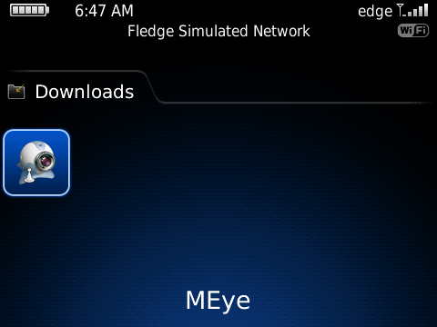
- click "options" of cellular phone table's top, enter to is shown as chart below a page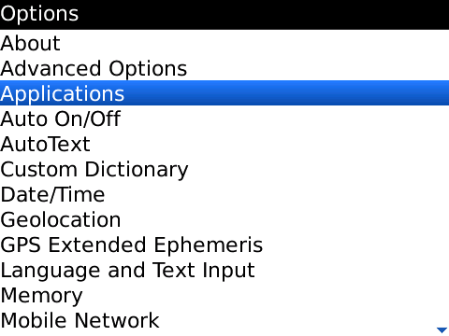
- click "application procedure", find out TMEye, click into, click "edit extent of authorith", establish all extent of authoriths in order to"allow", if having parts of extent of authoriths can not establish in order to"allow"(the picking is gray, can not change), don't need to be realized, directly click to keep all right
- Click TMEye routing diagram the mark , after circulating procedure, start to turn after a beginning of Shan plate interface, enter a beginning to start an interface, the following chart
. 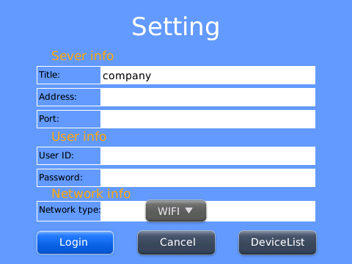
explain

Equipment header(Title):The alias of equipment is easy to classify several equipments
Server address(Address):DVR male net IP address or dynamic state area

Server port(Port):DVR up the server port of setup

User's name(User ID):The user's name reconciliation that carries a setup with IE

Password(Password):The password reconciliation that carries a setup with IE

Network type(Network Type):Select you wants the network type of use

Press button vs in response to the function is as follows

Function key | name | Function describe
 | Logging in | Enter to broadcast lord interface, the procedure connectivity equipment combines to start broadcasting a video
 | cancel | Program exit
 | Device list | Enter an equipment record page
- click an entry, broadcast a lord interface
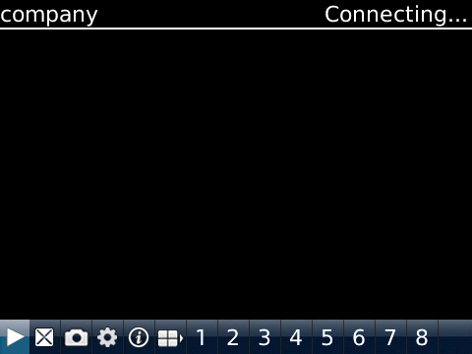
Press button vs in response to the function is as follows
Function key | name | Function describe
 | play | The procedure connectivity equipment combines to start broadcasting a video
 | Full screen | Full screen playing
 | snap | Grasp to clap a current ICON(grasp a chart document to recognize tacitly conservancy to the cellular phone of tacit approval of photograph catalog down
 | setting | Establish a DVR IP address or watch an area, port, user's name and password and equipment alias information
 | Next group | Can select to descend gang gateway
 | about | About information
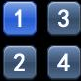 | Select gateway | Can select to descend gang gateway
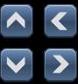 | Ptz control | Carry out a cloud on the stage, next, left and right control
 | Zoom control | The realize tension far draws near
 | focus | Carry out focal length to add and subtract
 | aperture | Carry out focal length to add and subtract

- Carry out focal length to add and subtract

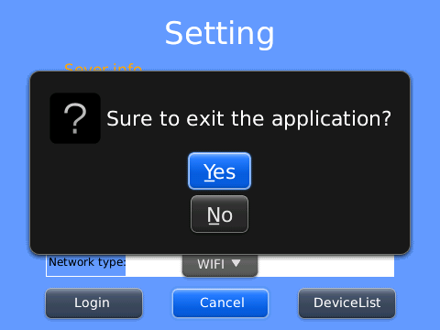

- click "equipment tabulator", enter a history tabulator, the following chart
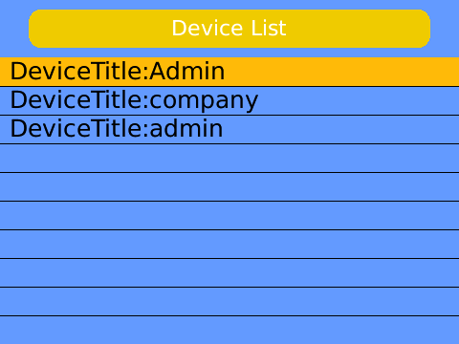
Click menu key, flick menu open, the following chart
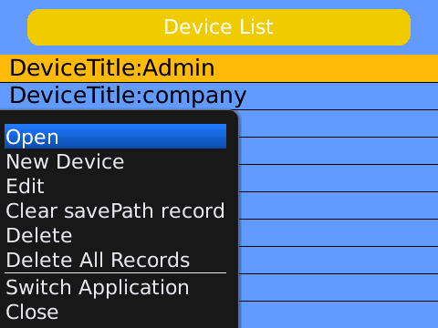
Click menu key, flick menu open, the following chart
Function key | name | Function describe
open | play | Click menu key, flick menu open, the following chart
New device | new | Lately set up a new record
edit | edit | Edit record
Clear record conservancy path | clear | clear Clearance keeps path(grasp the chart picture conservancy path)
delete | delete | The delete picks out a record
Delete all records | Delete all | Delete all records

The cutover applies procedure | switch | Cutting over is another of applied procedure
close | close | Close procedure

- The video displays mode
Down the routine mode and full plate mode progress cuts
Regular mode
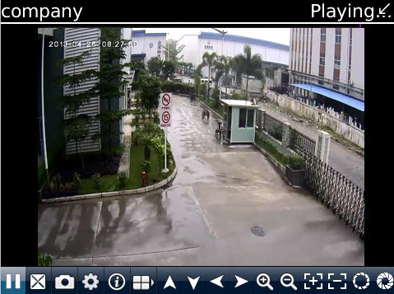

Full screen mode

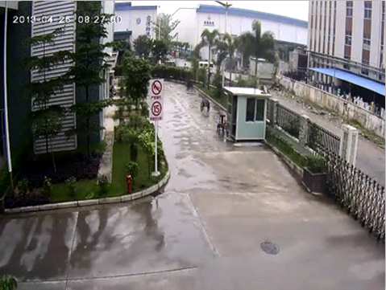
The DVR parameter that favors a cellular phone establishes a reference
Resolution:CIF
Leads:5-1
The code flows a type:Limit
The code flows:64-256Kb/S
Note:Can carry on tune according to the cellular phone performance and the network condition.Higher cellular phone performance and network condition can display better effect.If the network condition is worse, can appropriately the step - down lead and assure flowing freely

