Instruction for windows mobile
Brief introduction
The documents mainly introduces how to set and use the Software for windowsmobile OS.
The Software has some main functions.
- Browse real time video function
- Cloud stand control function(the front end is to control ball machine)
Essential condition
Favor windowsmobile system 2003 releases and it is above.Favors to touch to hold release just currently

Install and operating instructions
- Pass TMEyesetup.cab data wire to make duplicate the hand of windows mobile on board
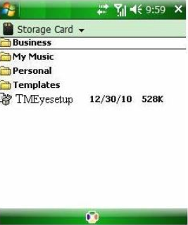
2) Find out TMEyesetup.cab under the appointed catalog, double click a progress setup, after finishing installing under the procedure(Programs) path will appear a routing diagram mark, the following chart
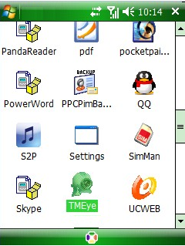

- Click pais in response to routing diagram mark, circulate a beginning to start interface the following chart after the procedure
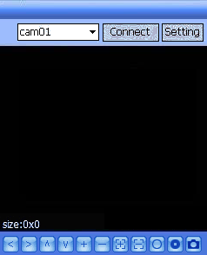
Press button versus in response to the function is as follows

Function key | name | Function describe
 | start | The procedure connectivity equipment combines to start broadcasting a video
 | setting | Establish a DVR IP address or watch an area, port, user's name and password and equipment alias information
 | stop | The procedure breakup broadcasts a video
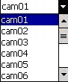 | Select gateway | Select a some video of one gateway that broadcasts an equipment
 | PTZ control | Carry out a cloud on the stage, next, left and right control
 | Zoom ratio | The realize tension far draws near
 | focus | Carry out focal length to add and subtract
 | aperture | Carry out diaphragm to add and subtract
 | snap | Grasp to clap a current ICON(grasp a chart document conservancy to arrive the photo catalog of installing the catalog down the following chart)
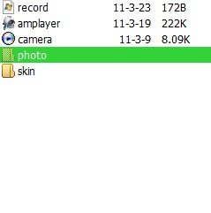
- ：
Such as first time use or need to carry on parameter to change, please click button to enter a parameter setup interface.The following chart
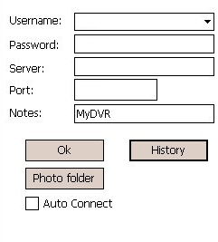

explain

User's name(User name):The user's name reconciliation that carries a setup with IE
Password(Password):The password reconciliation that carries a setup with IE

Server address(Server):DVR male net IP address or dynamic state area
Server port(Port):DVR up the server port of setup

Equipment denomination(Notes):The present of equipment is easy to classify several equipments

Click button to enter to grasp chart conservancy catalog

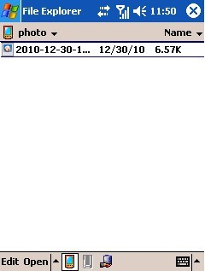

Click button to enter to grasp chart conservancy catalog
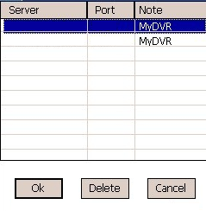

Pick out the record that to delete, at press Delete button and then can recording to carry on a delete operation vs the
Pick out a certain record to click[OK]the button can return to establish an interface
Again click[validation]button enter to link an interface
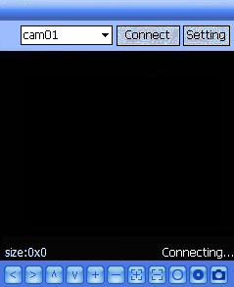
Wait to create a connectivity success and then will enter to broadcast menu
The video displays mode

Down the routine mode and full plate mode progress cuts over

Normal mode
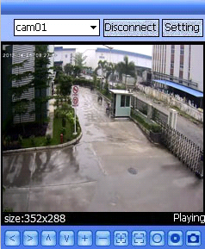

Clicking the button can stop watching

Full screen

While by hand pointing or touching an one - shot to broadcast menu will cut over full plate to broadcast
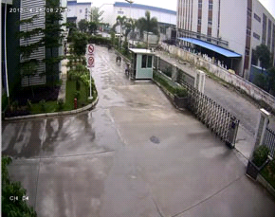
The full plate broadcasts the one - shot in time to broadcast menu cutover to return to routine to broadcast mode
- Switch channel
Click to down pull to press button

Pick out homologous gateway, the procedure will open homologous gateway to combine to automatically broadcast a video

The DVR parameter that favors a cellular phone establishes a reference
Resolution:CIF or QCIF
Leads:5-10
The code flows a type:Limit
The code flows:64-256Kb/S

Note:Can carry on tune according to the cellular phone performance and the network condition.Higher cellular phone performance and network condition can display better effect.If the network condition is worse, can appropriately the step - down lead and assure flowing freely

