XMEye
Iphone
monitoring client English manual

Written by：The test department
The date of writing：2015.08.13
Vision：V1.0

Contents
1. Introductions 2
1.1 Brief Introductions 2
1.2 Main Functions 3
2. Installation 3
2.1 Acquire XMEye 3
3. Operating Instructions 4
3.1 Login Interface 4
3.2 Real-time Preview 11
3.3 Remote Playback 14
3.4 Intercom 15
3.5 Menu 15
3.6 Main menu 20
3.7 Switch Language 26

Introductions

1.1Brief Introductions
Iphone is the video surveillance application designed for our monitor devices.This application supports IOS that is higher than 6.1 released.The manual will mainly introduce how to set and use XMEye.

1.2 Main Functions

Main functions:
- Support Chinese,English;
- View the video on real time via WIFI and GPRS;
- Support two ways to login:user and device;
- Support serial number、IP address and DNS；
- Support multiple channels to change(max to 64)；
- Support remote playback;
- Support configuration、modification and remove about device parameters;
- Support Pan control；
- Support snapshot and view；
- Support video and view；
- Support audio;
- Support real time intercom；
- Support alarm message;
- Support bit rate、video configuration;

Installation

2.1 Acquire XMEye
Users can acquire this app through following ways:search it from APP store,and download from manufactures.
1、If you download it from App store,enter “XMEye”,and install it ,then it will show on your phone.
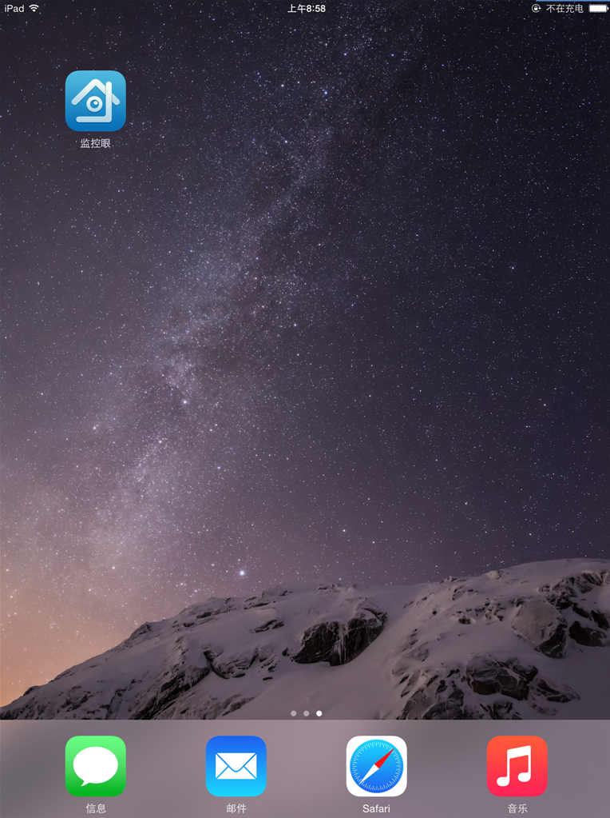
2.1a

Operating instructions

3.1Login interface
After installing successfully,click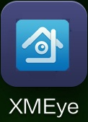,then the application will work.Enter the login interface,there are two ways :user login and device login, 3.1a:
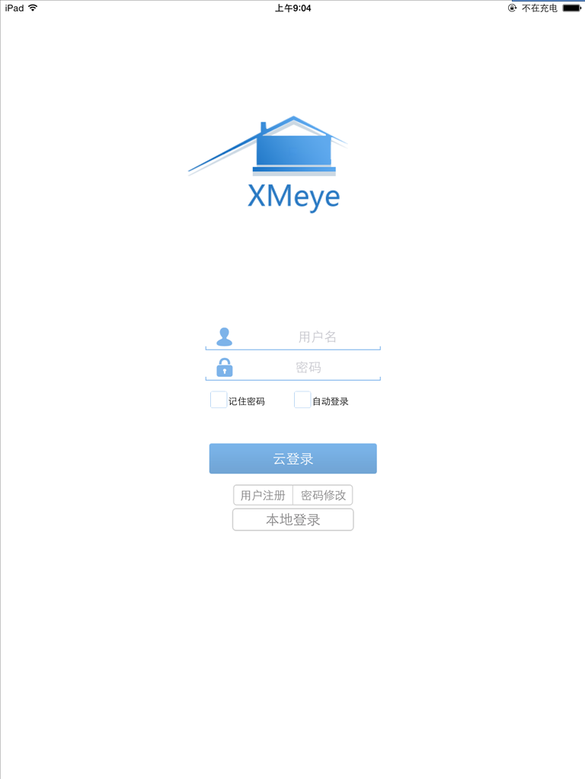
3.1a
- User register：In the interface of 3.1a,click “user register”,enter user name 、password、confirm password and email,then click “OK”,like 3.1b
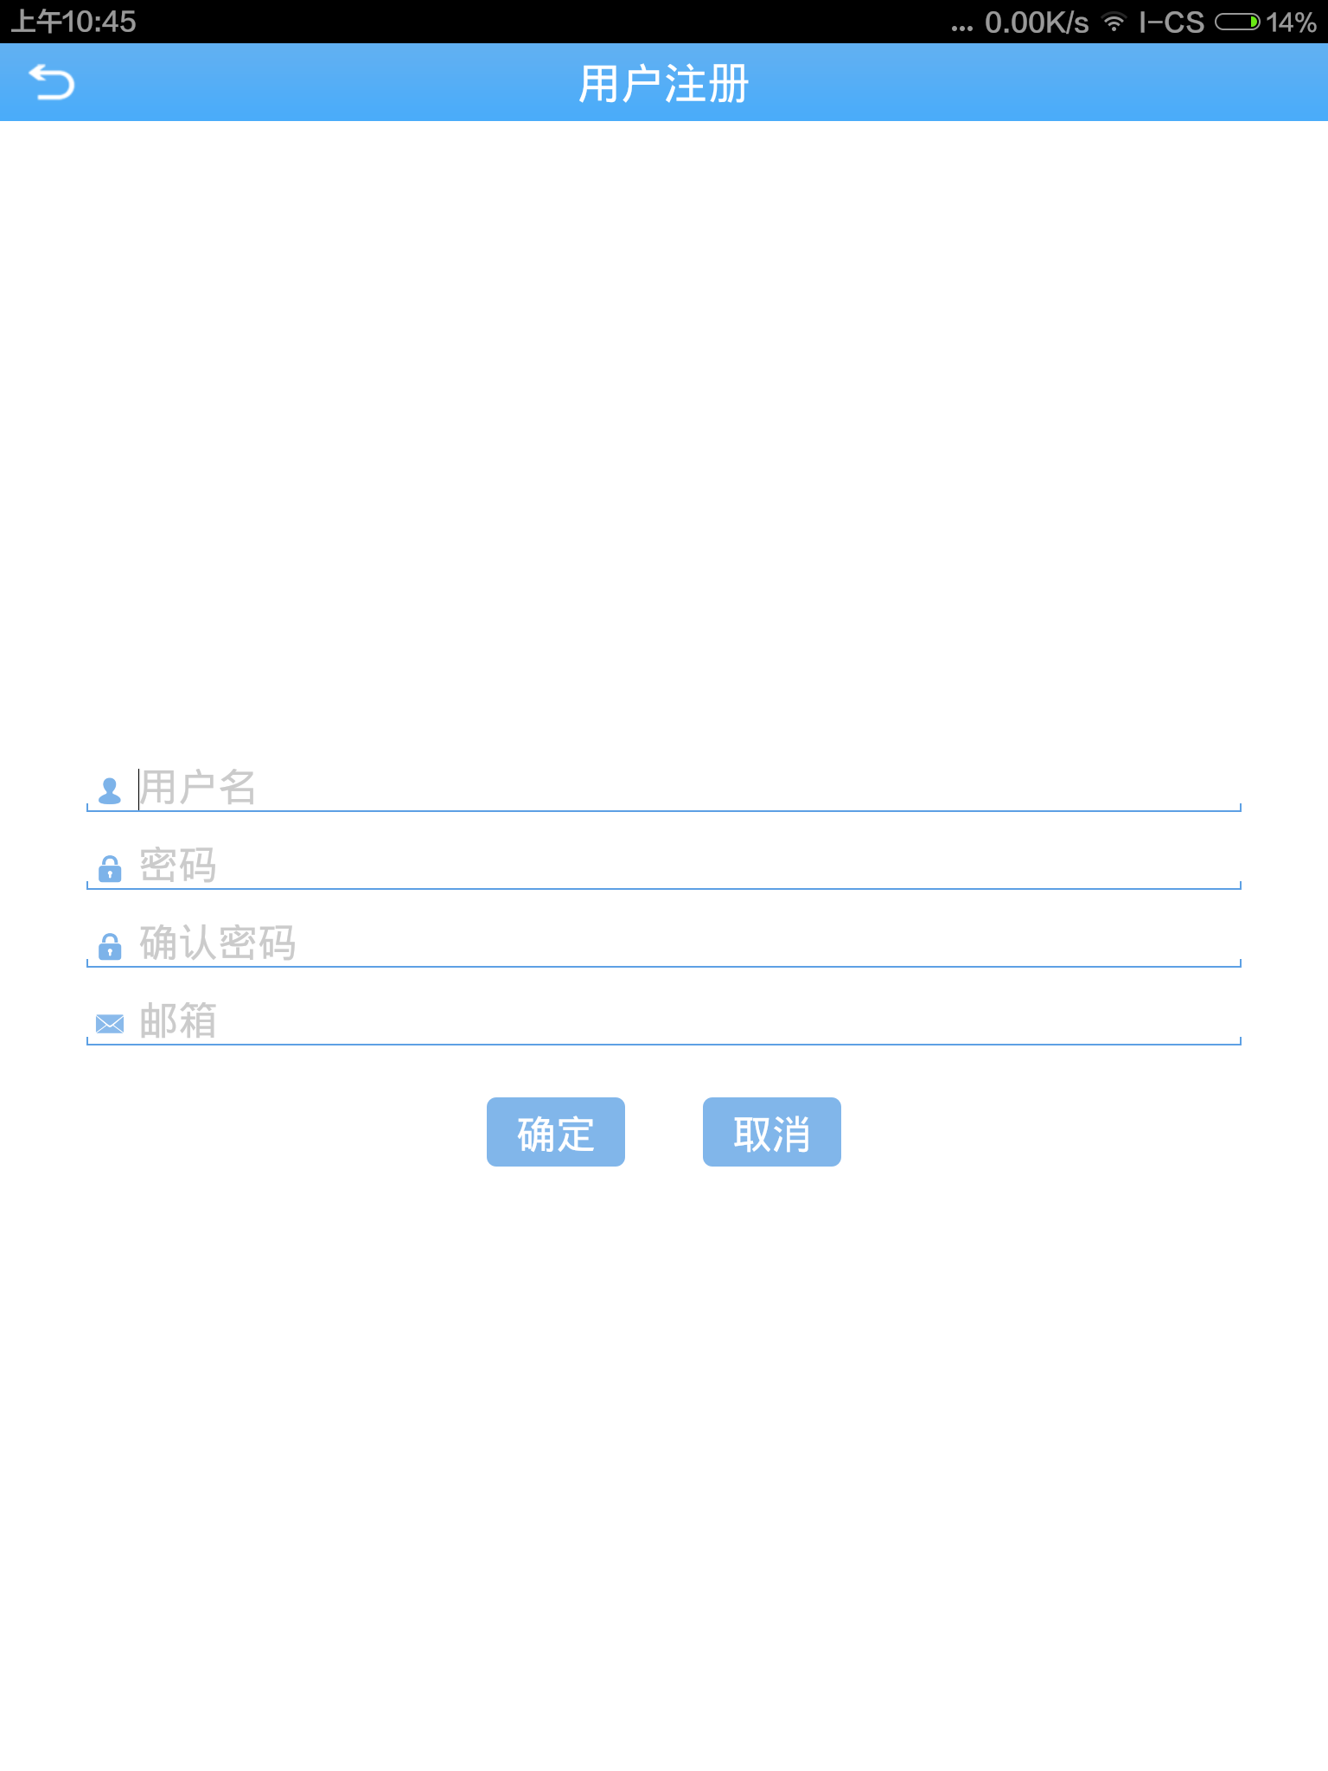
3.1b
- Modify password:
As shown below 3.1a，click “modify password”,then enter password、user name、old password、new password and confirm password,and click “OK”
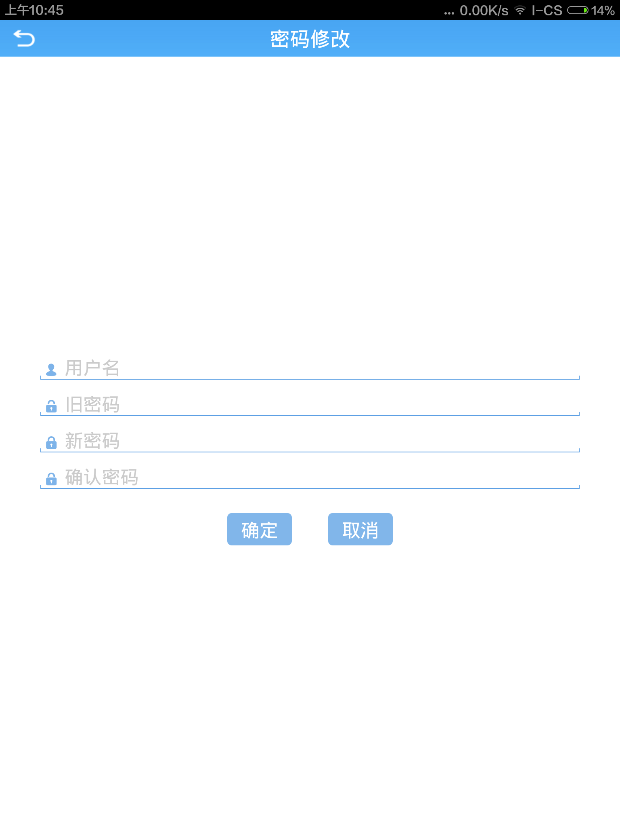
3.1c
User login(like 3.1d):user name and password are used for registering when logining http://xmeye.net/,also you can register through "user register"in login interface.When device is added and saved on the server,you can acquire device list ,also you can add device,there are three ways to add:manual、LAN and WIFI config.
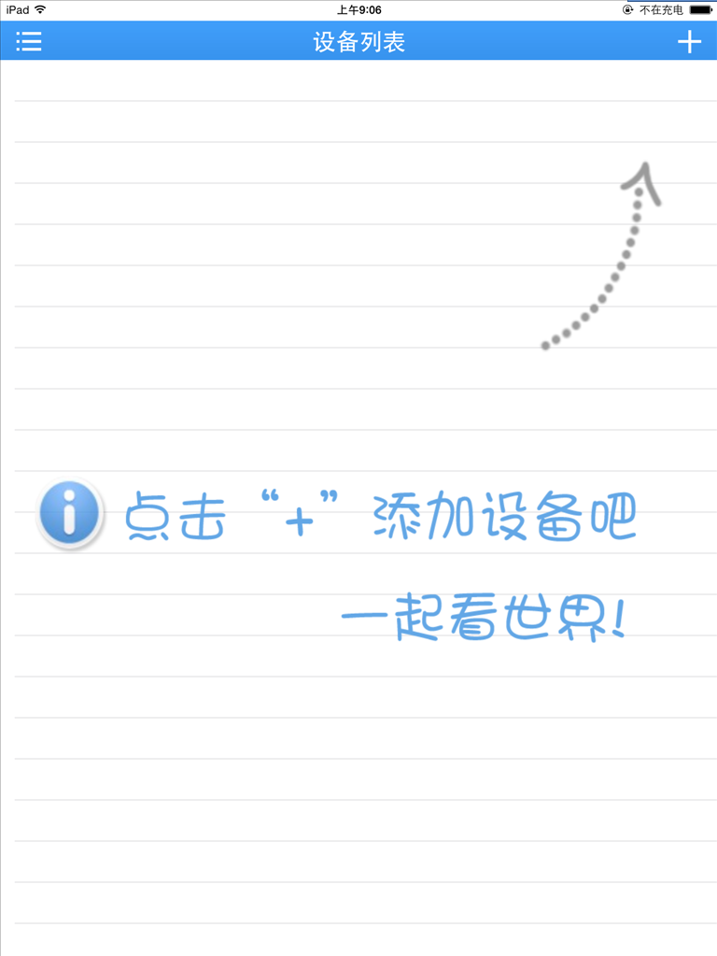
3.1d
- Add manually:it will show like 3.1d when logining successfully,click “+”on the top right corner of device list,to enter “add device”,default show add tab manually,as shown below 3.1e
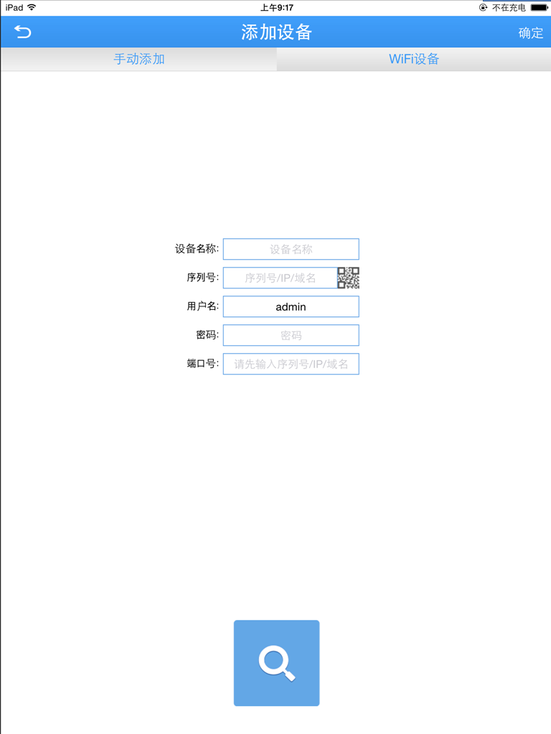
3.1e
- Device name:user can custom the name of device.
- Serial number:enter serial number(Users can acquire it in the PC or from tag,when entering,you can also scan QR code on the right; IP(the IP address of DVR/IPC or a DNS)、domain name.
- User:front device is default admin；
- Password:it is required that front password and user name should be matched,default is blank;
After finishing setting,click “save”,then click “back”to return “device list”,you can view device name、serial number or address
- Port:it should be consistent with media port(or router port)default is 34567
- LAN:
Click on the bottom of 【add manually】,then can search all devices in the same LAN,as shown below 3.1g
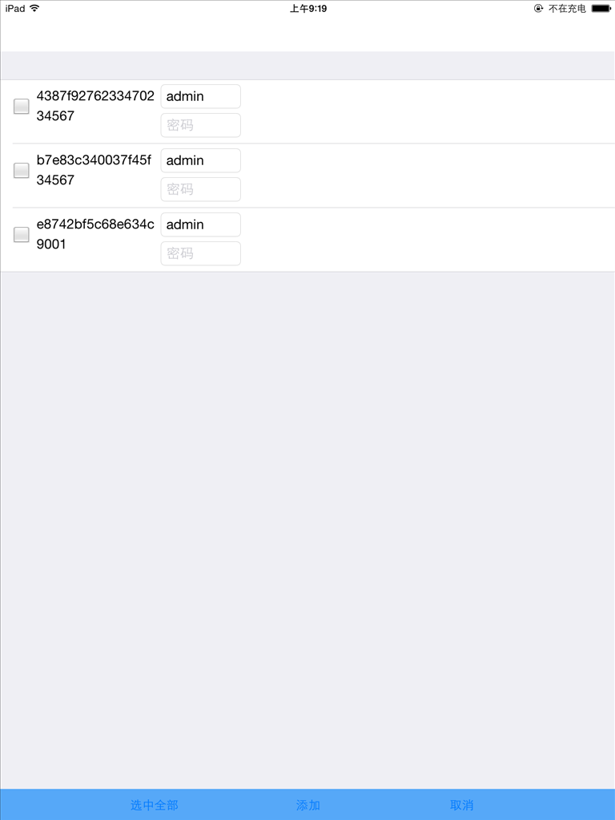
3.1g
- Wi-Fi Config:
(1)Fast config：Click “wifi config”,enter relevant interface,then enter wireless password,finish it according to tips(it will show green in the region of tips)，click “complete all of the above operation”,scan the green radar,add device,display as follows 3.1h、3.1i
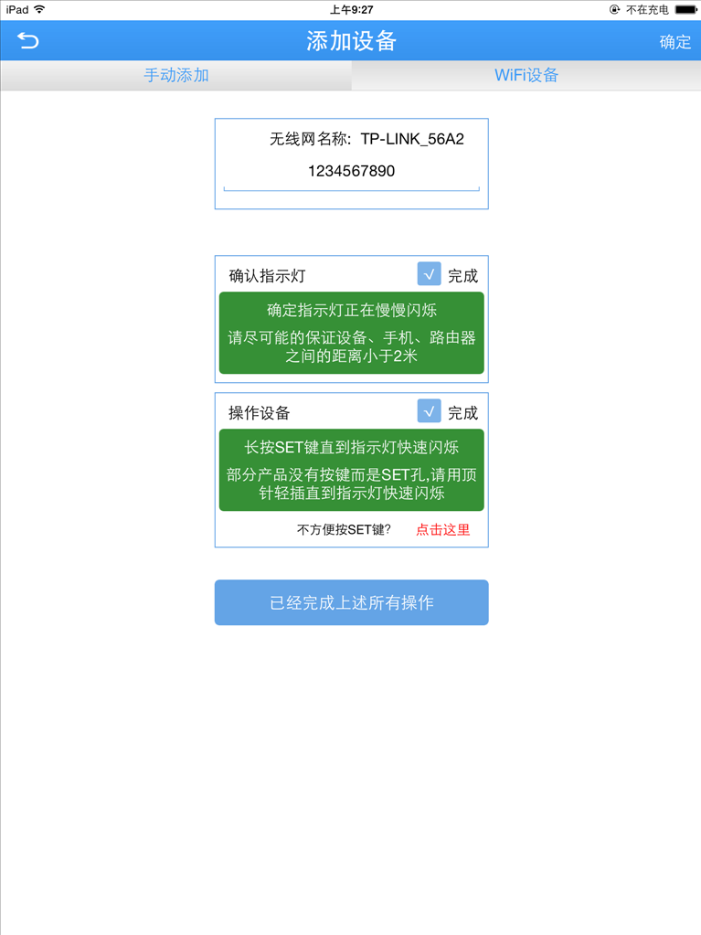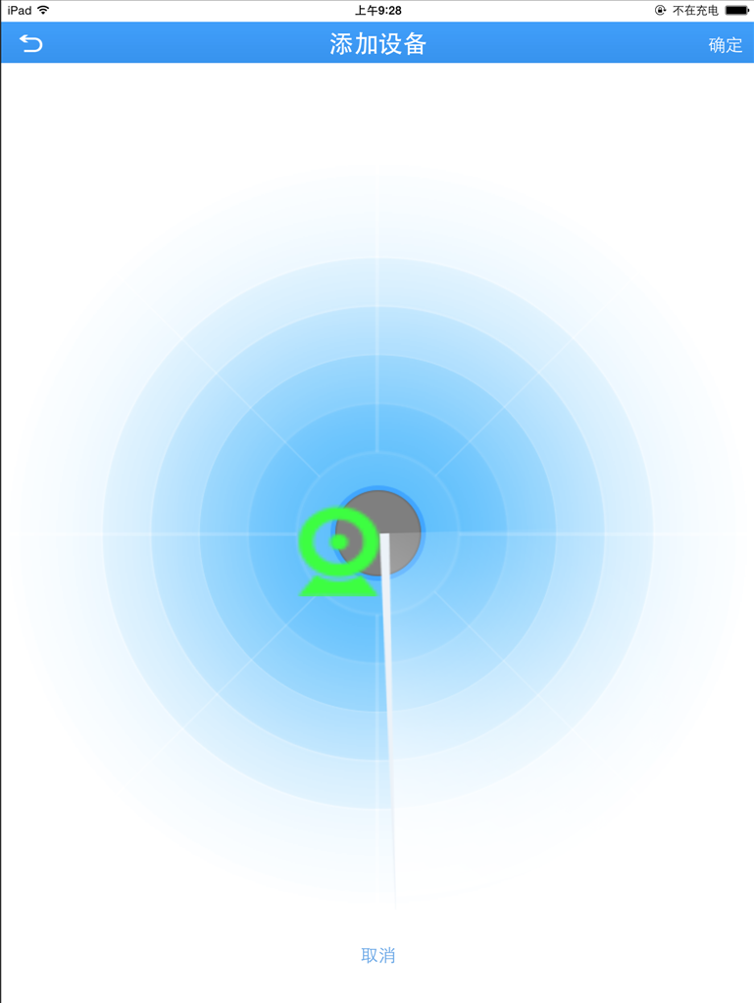
3.1h 3.1i
(2)Deep config：If it can’t search device by WIFI configuration,according to tips like 3.1j to restore factory setting,change system wireless,then select Wi-Fi to return original interface ,click “OK”,it will show 【deep config】on the bottom ,like 3.1k,click “deep config”to enter radar interface,after a period of time ,you can search device,like 3.11.While it fails to configurate,back to the home page,show “config failure”,like 3.1m.
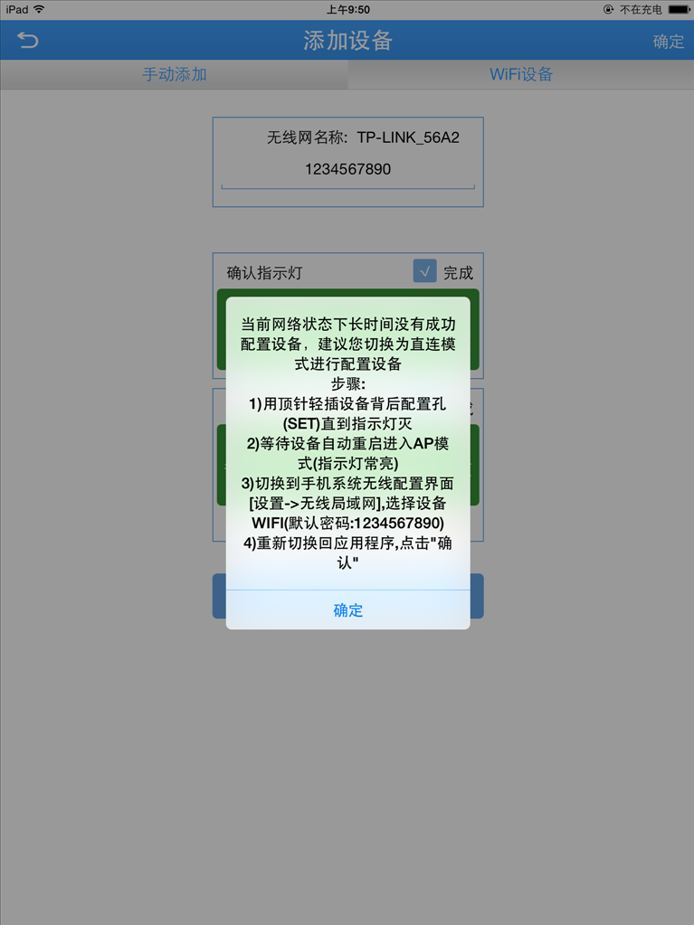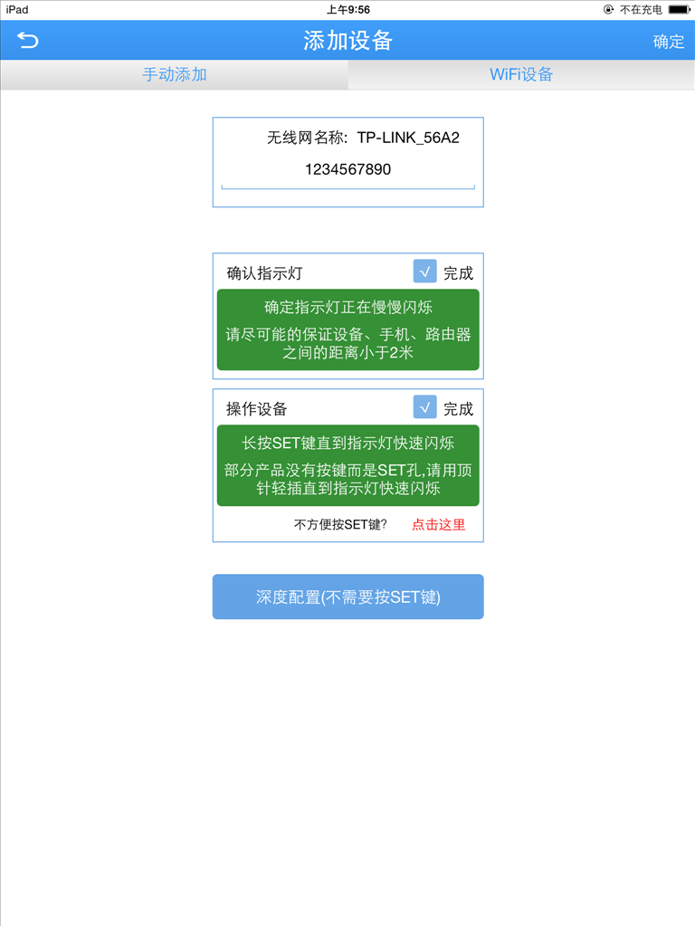
3.1j 3.1k
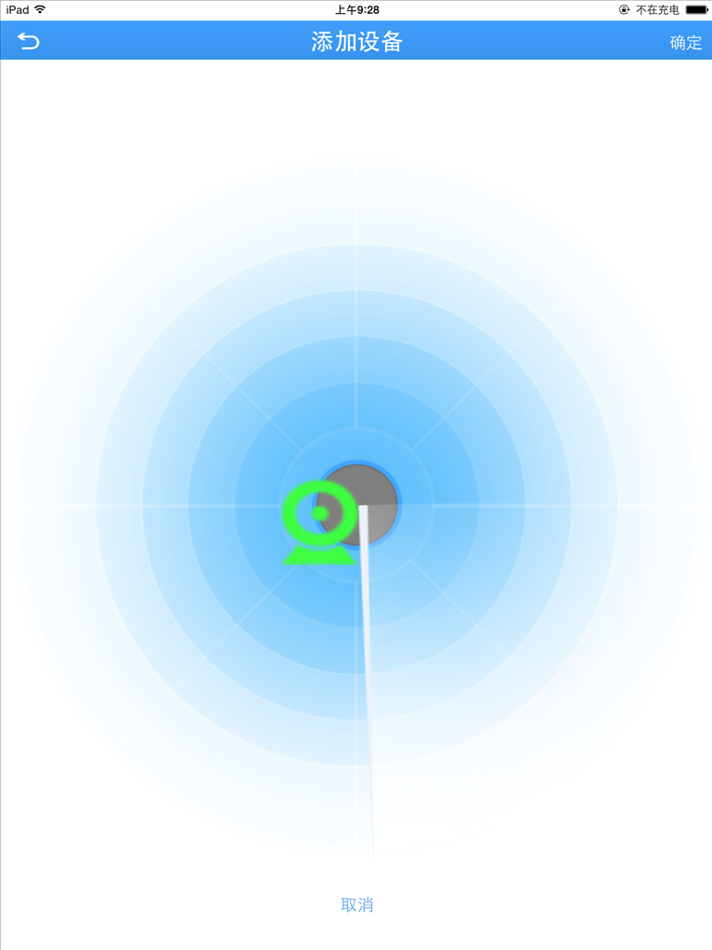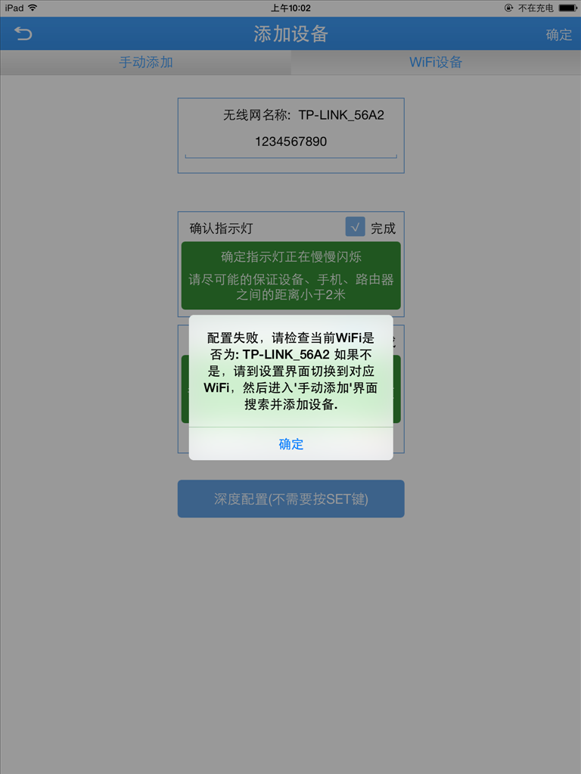
3.1l 3.1m
After adding device successfully,long press device name to delete、copy serial number and edit,as shown below 3.1f.
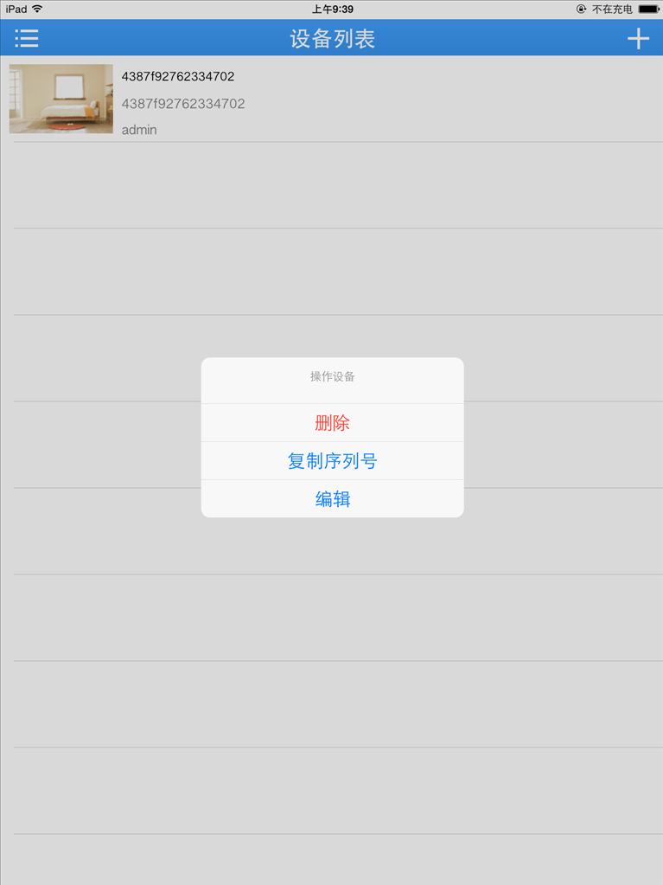
3.1f
- Local login:In the interface(3.1a),there is no need to enter user name and password,you can click【local login】to access to device list.For more details about deleting device,please refer to the operation of user login.
Note:user login does’t support cloud video.
3.2 Real-time preview
Click “device list”to enter the “real-time video”,it will play video,as shown below 3.2a and 3.2b:
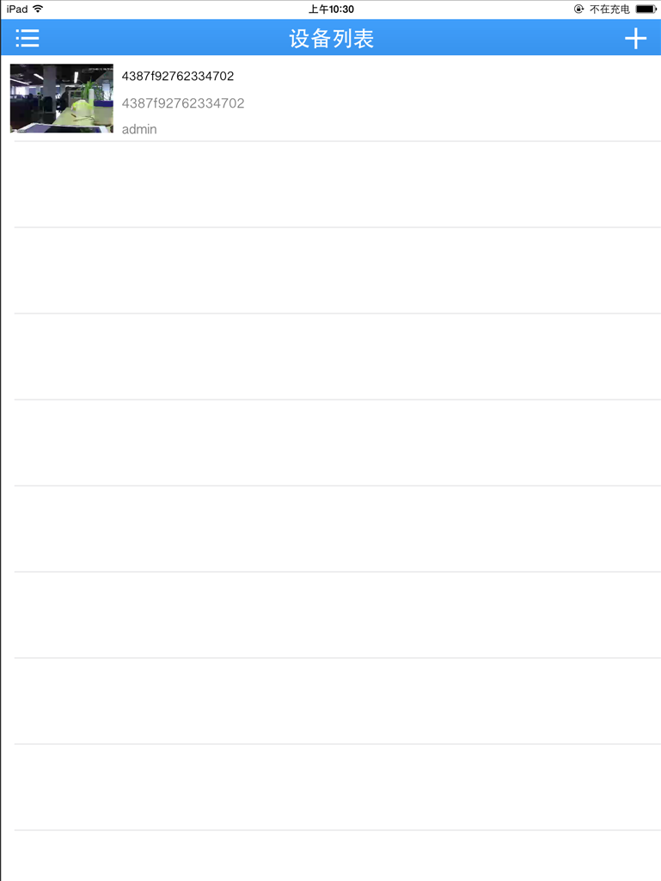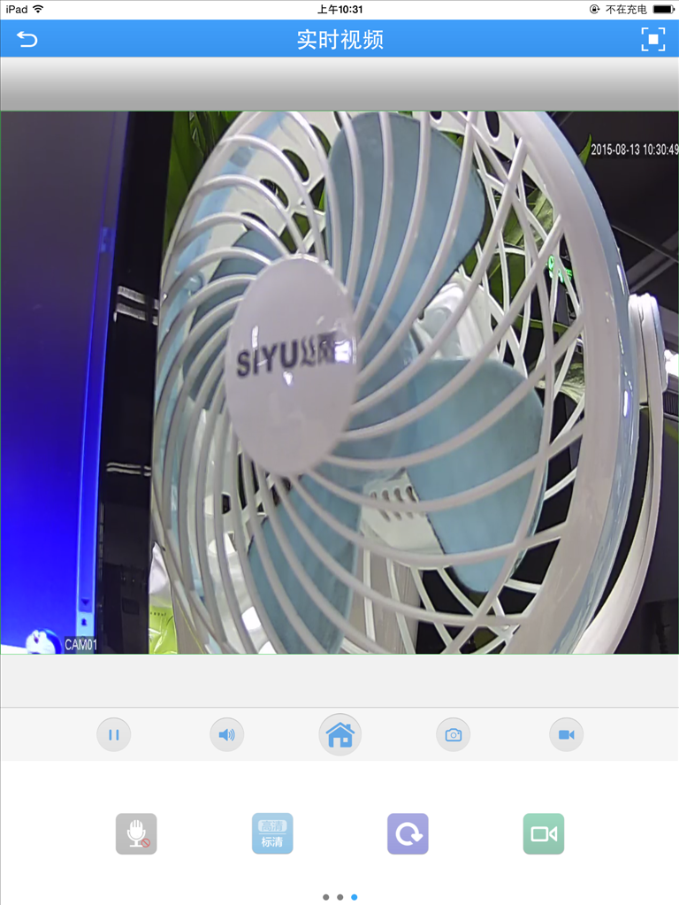
3.2a 3.2b
Buttons’ functions of video monitoring introduction,as shown below chart:
Button | Functions instruction
 | Back to device list
 | Full screen
 | Play/stop
 | Audio
 | Menu
 | Snapshoot
 | Recording
 | Intercom
 | HD/SD
 | Renovate
 | Remote playback
 | Change port/channel
  
 | PTZ
 | Magnify/shrink
 | Focus
 | Iris

3.3Remote playback
Client can visit remote device,and you can acquire video profile which saved in hard disk,to achieve remote playback,and select time on the top right corner,and start inquiring,as shown below 3.3a：
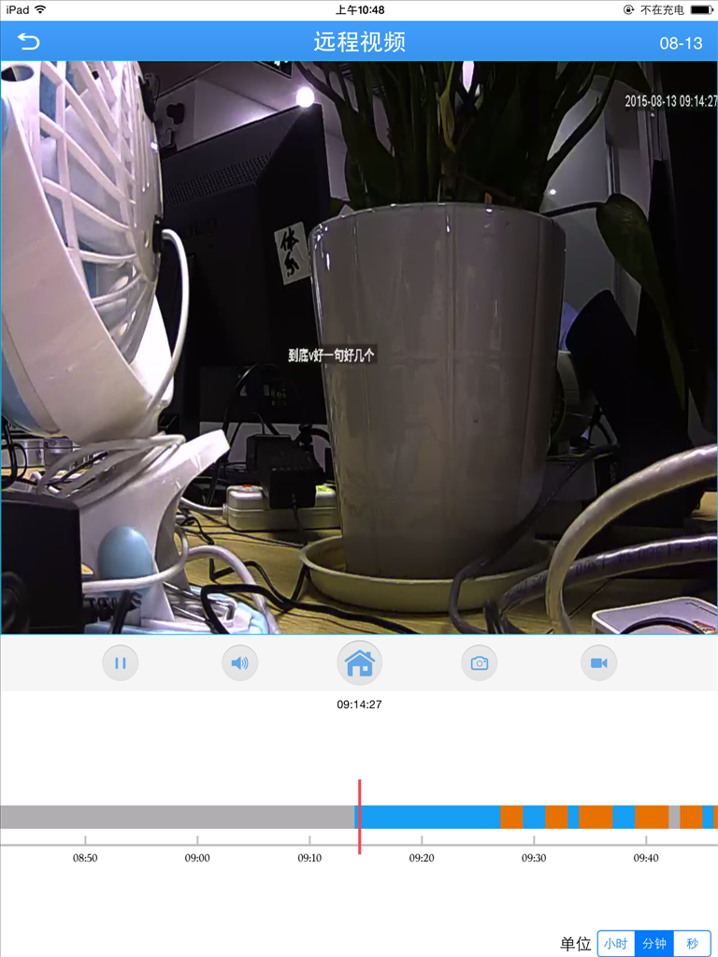
3.3a
During remote playback,you can play/stop、audio、snapshoot and recording
【Notes】
Only have videos can refer to them,otherwise it will not work.

3.4 Intercom
Real--time dual intercom for selected device .During previewing,click“”,and it will change to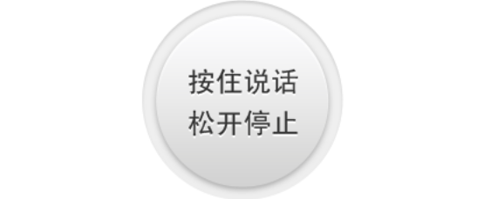，press it and speak,then client will receive voice,when you remove from it,voice from client will also be received,easy to achieve dual intercom between client and device.

3.5 Menu
Click，enter the interface like 3.5a,then you can operate :encode config、record config、alarm config、image config、remote playback、modify password、download and about：
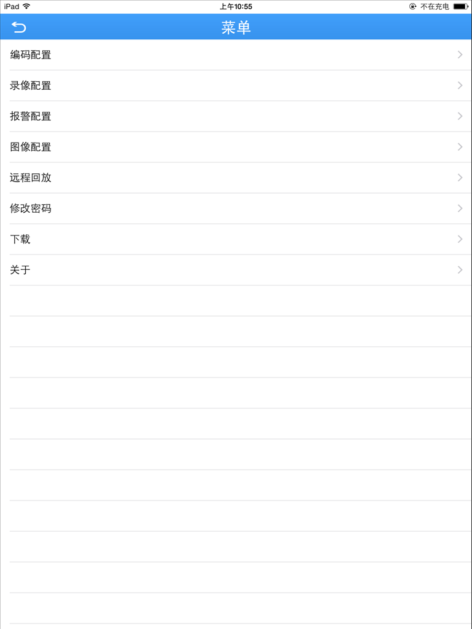
3.5a
1.Encode Config：Select【encode config】，it will show like below 3.5b，then you can modify resolution,frame rate,definition,audio and video of the device；
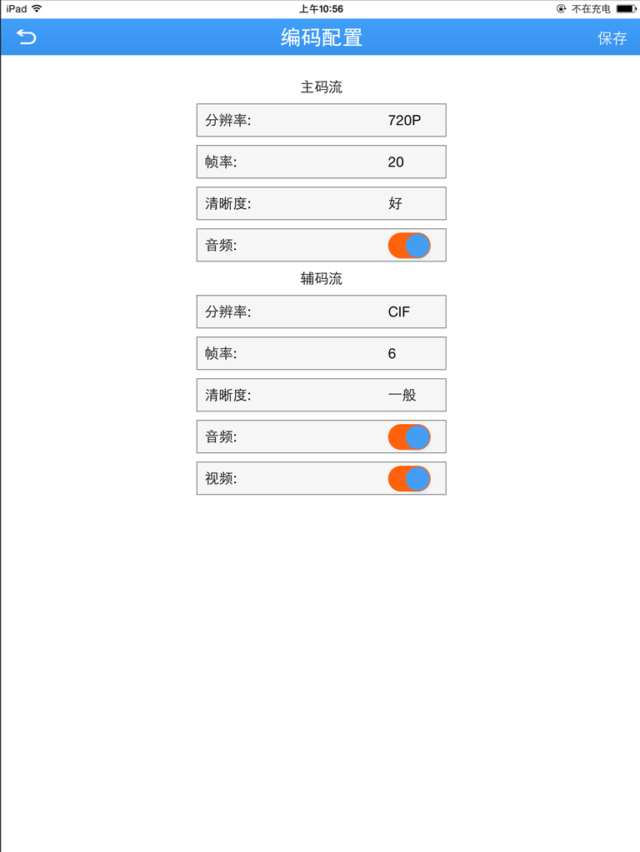
3.5b
2.Record Config：Select【record config】，it will show like below 3.5c，you can modify pre-recording time ,record length and record.
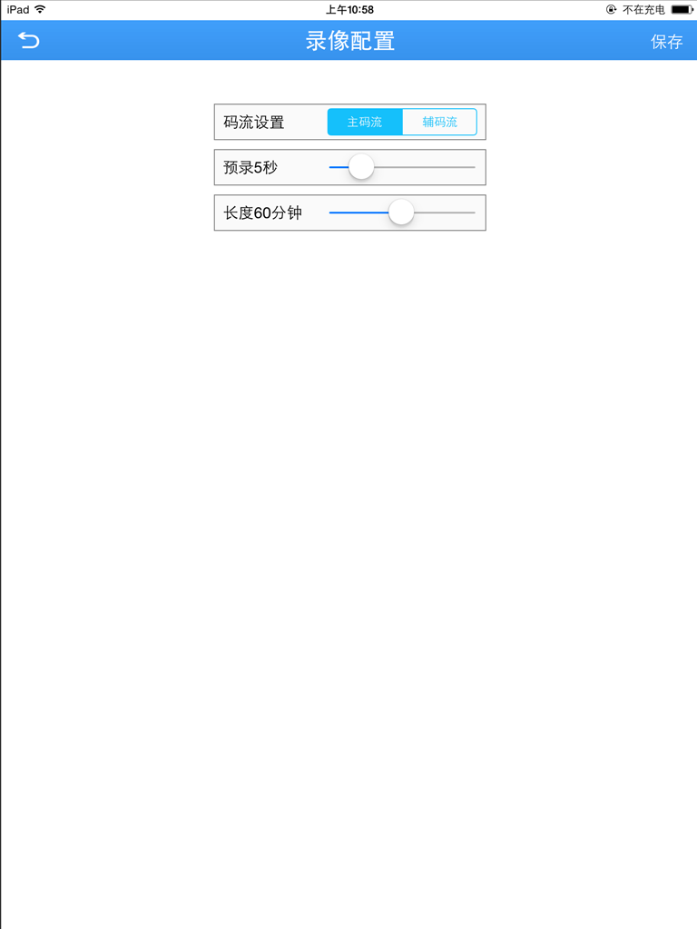
3.5c
3.Alarm Config：Select【alarm config】，it will show like below 3.5d,when video touches alarm,client will receive alarm information.
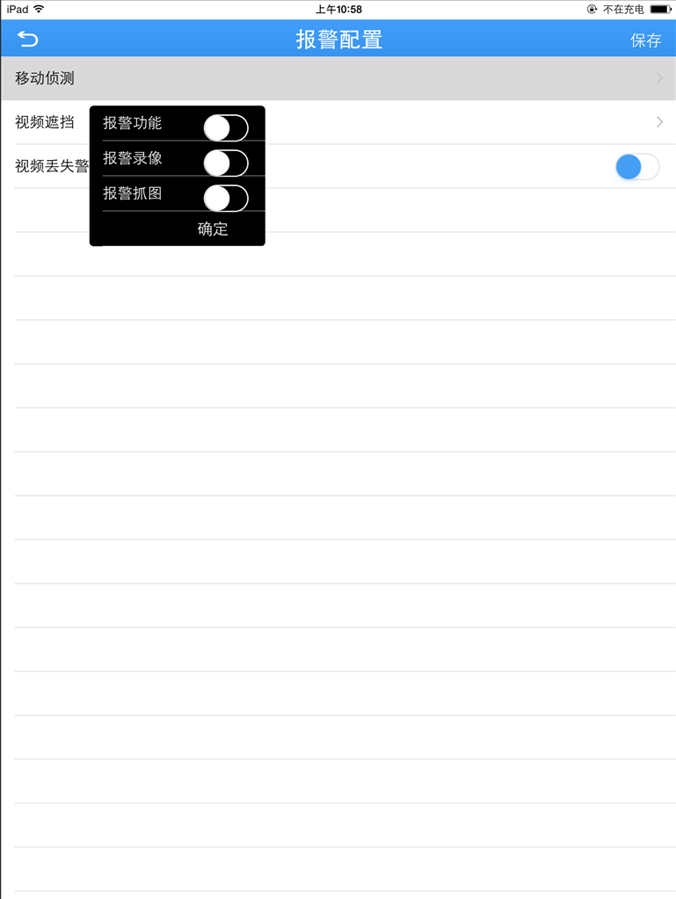
3.5d
4.Image Config：Click【record config】,it will show like 3.5e,open reversal,then it will change to relevant image.
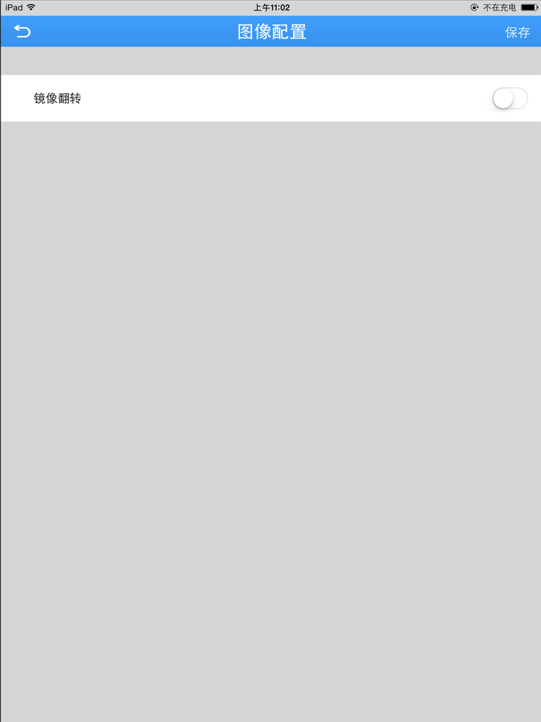
3.5e
- Remote Playback：Please refer to 3.3
- Modify password:Select【modify password】,as shown below 3.5f
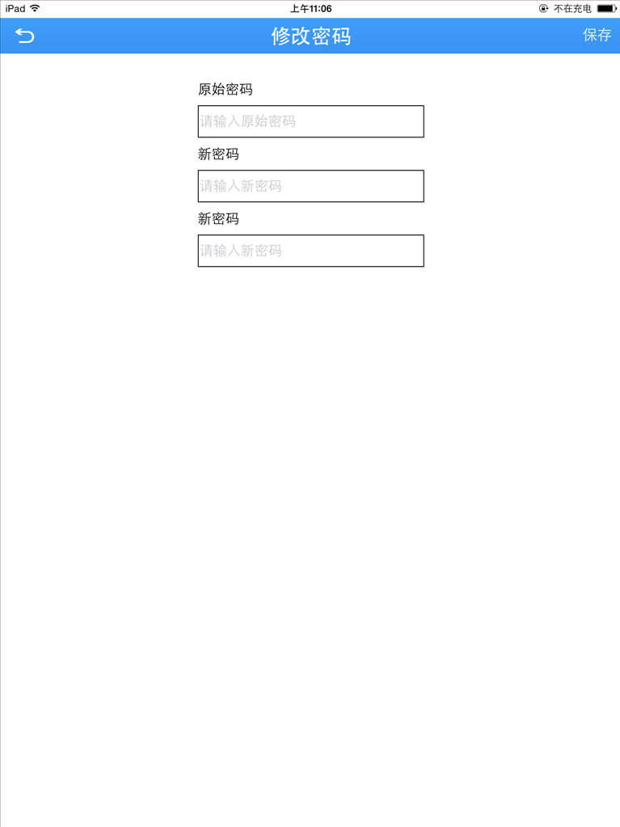
3.5f

7.Download：
(1)Select by file：Select ,click download,means progress of downloading ike 3.5e.
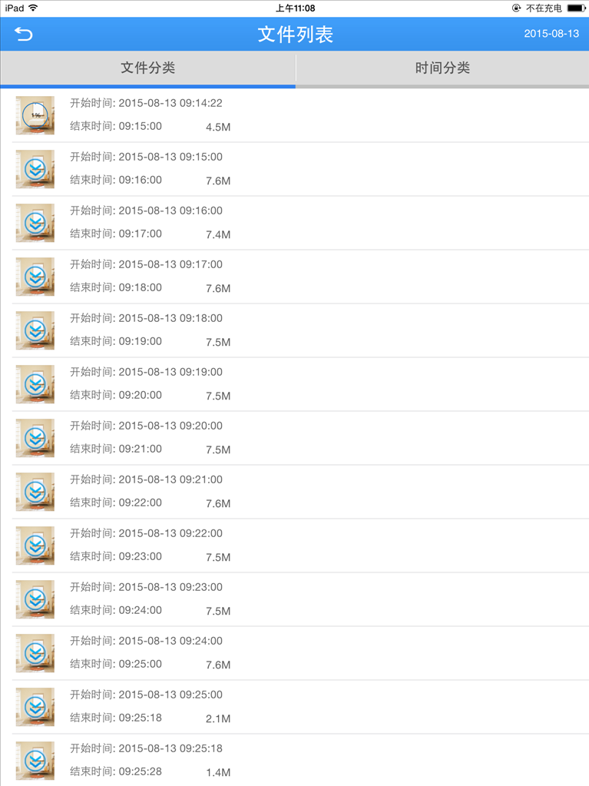
3.5e
(2)Select by time：Choose a period of time,click download,like 3.5f
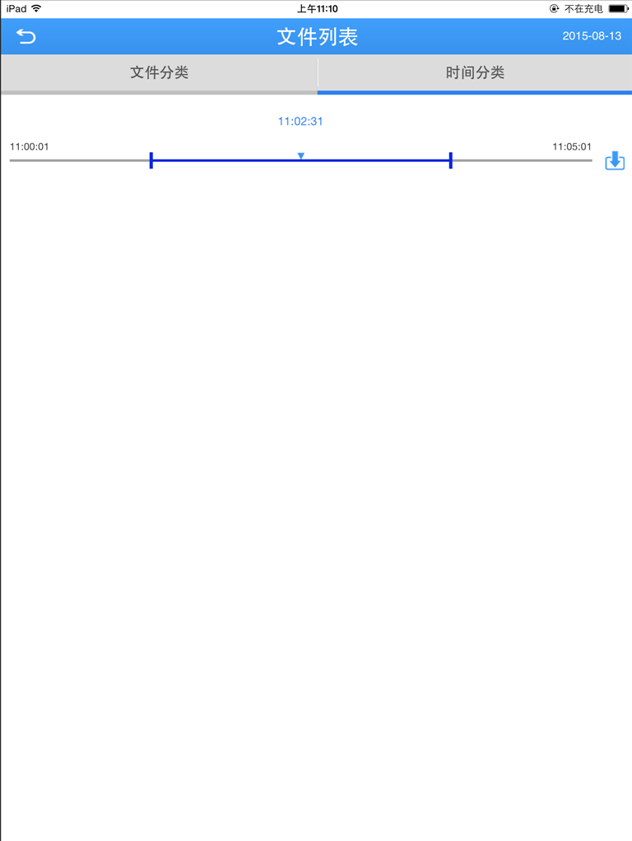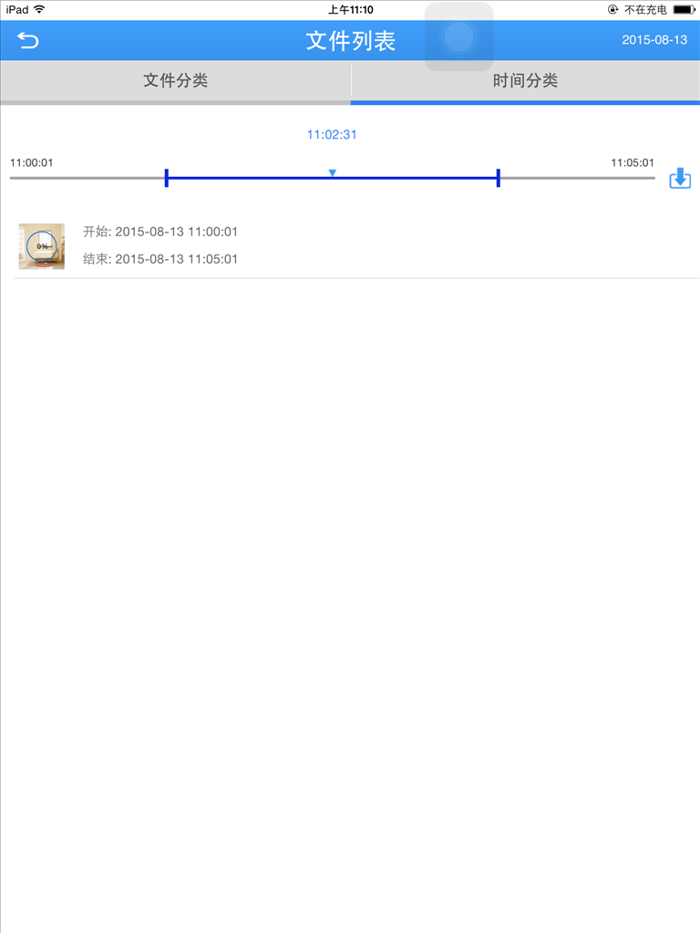
3.5f
9.About：Select【about】，it will show like below 3.5g,can refer to QR code、serial number、device version、software version、released date、running time、network mode、cloud status and device update.
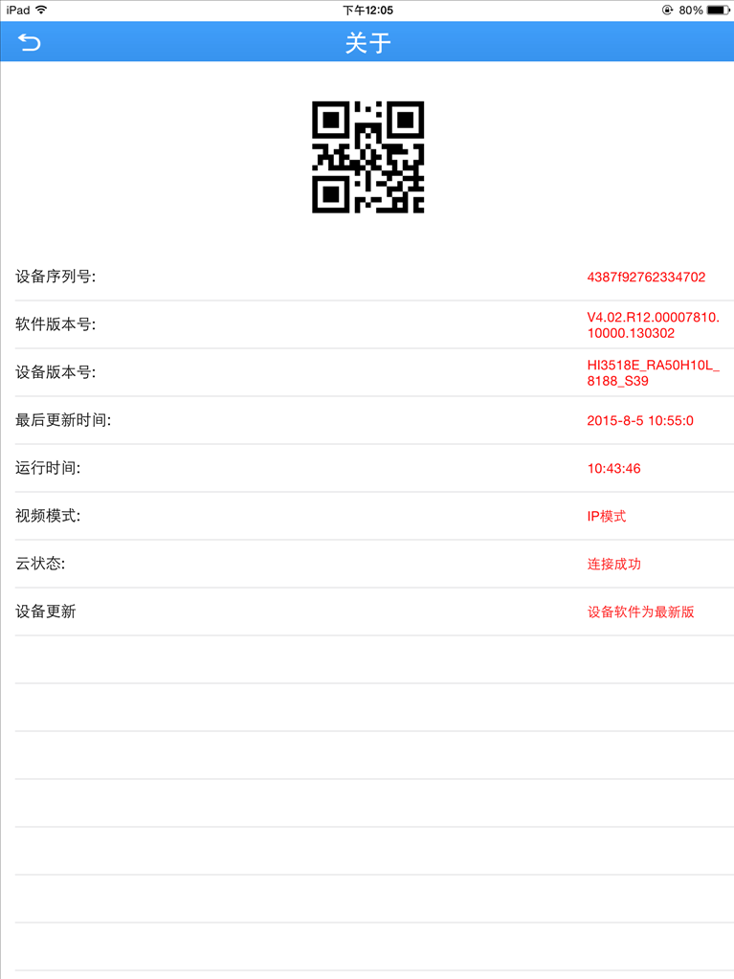
3.5g

3.6 Main menu
In the interface of real-time preview,click“”,you can view operation as follows:
(1)User login：Main menu contains——device list、local record、local album、alarm push、cloud storage、local setting、logout，like 3.6a.
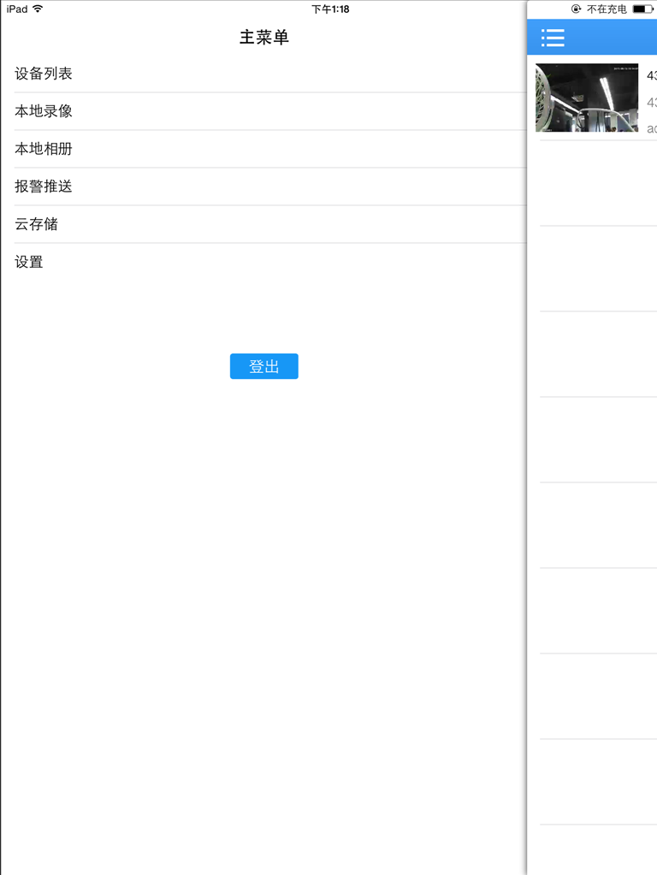
3.6a
(2)Local login：Main menu contains——device list、local record、local album、alarm push、local setting、logout，like 3.6b.
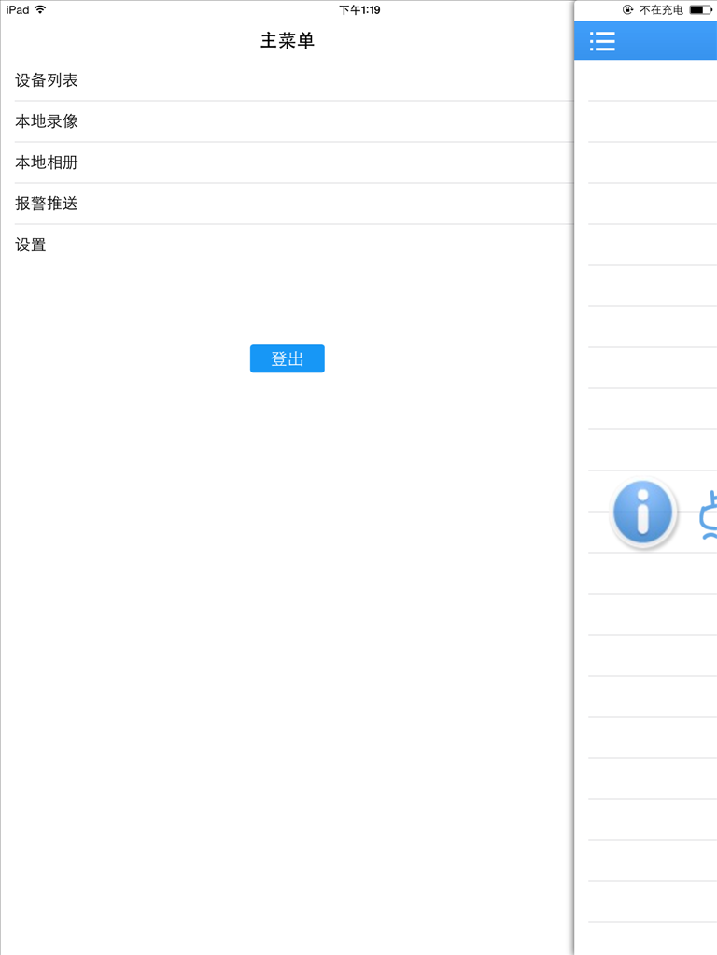
3.6b
- Device list：Display main menu
- Local record:the video recorded through client will saved in memory card.
【Remark:If there is no memory card in the mobile,local record can’t work 】
Play video：
- Click“”to enter main menu，select “local record”，then enter the interface,as shown below 3.6c;
- Click some video,for example 2015-08-13 09:15:00,then view it
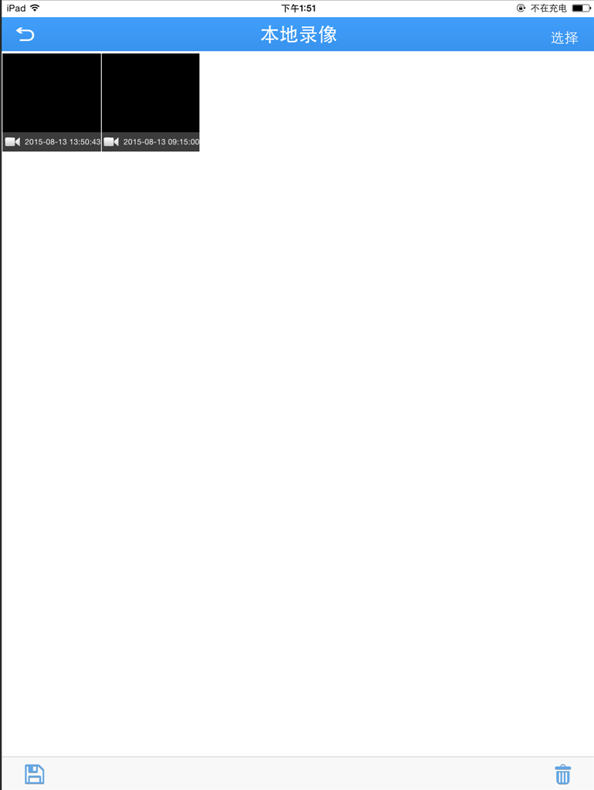
3.6c
Delete：
- Click“”,select needed video,like 3.6d,click “”to delete
- Click“”，save selected video to the mobile
- Click “cancel”to turn back to “local record”;
- Click“”to back previous operation.
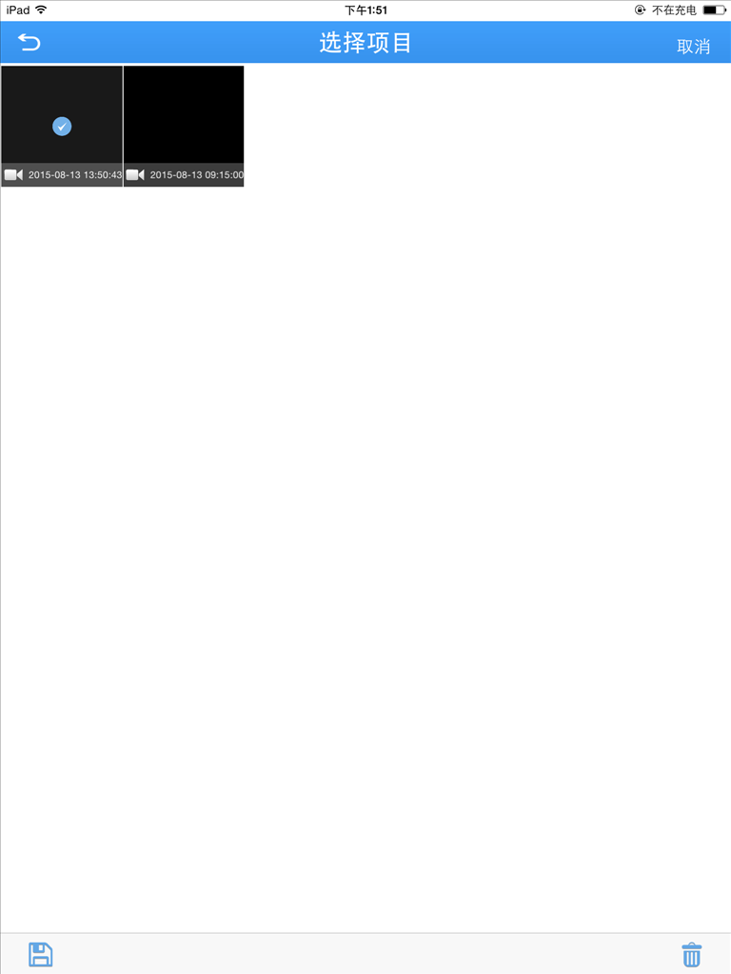
3.6d
【Remarks】：
Only have videos can be searched,otherwise,it will not work.
- Local album：the images saved in album are snapshoot when viewing monitor video；at the same time ,you can view or delete these images in batch ,it’s same as【local record】
- Alarm push：Open it,when touching it,the mobile will send messages and voice,as shown below 3.6e.
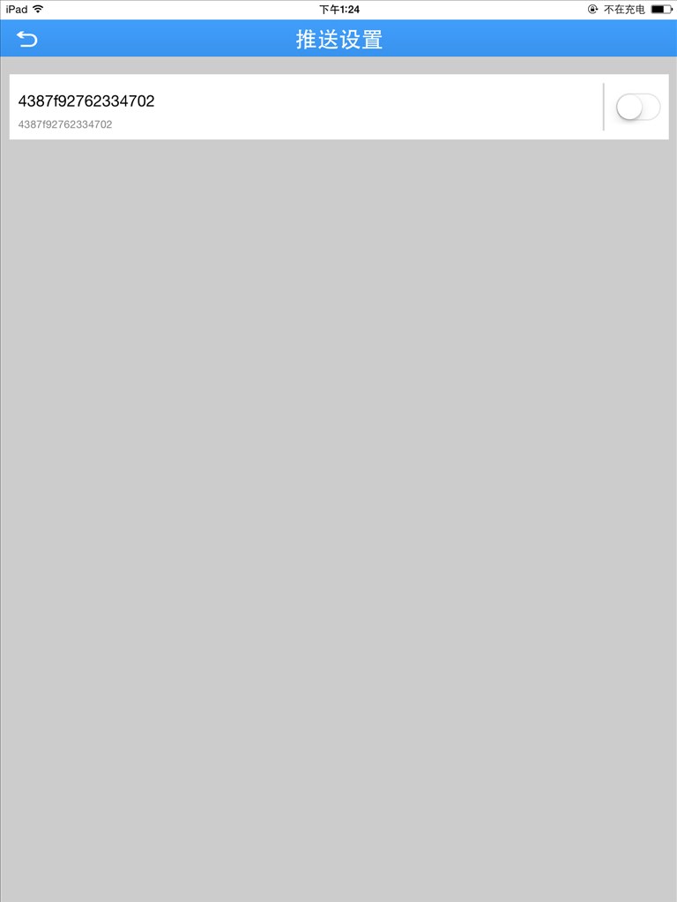
3.6e
- Cloud storage：click it,then click cloud storage device,it will show like 3.6f
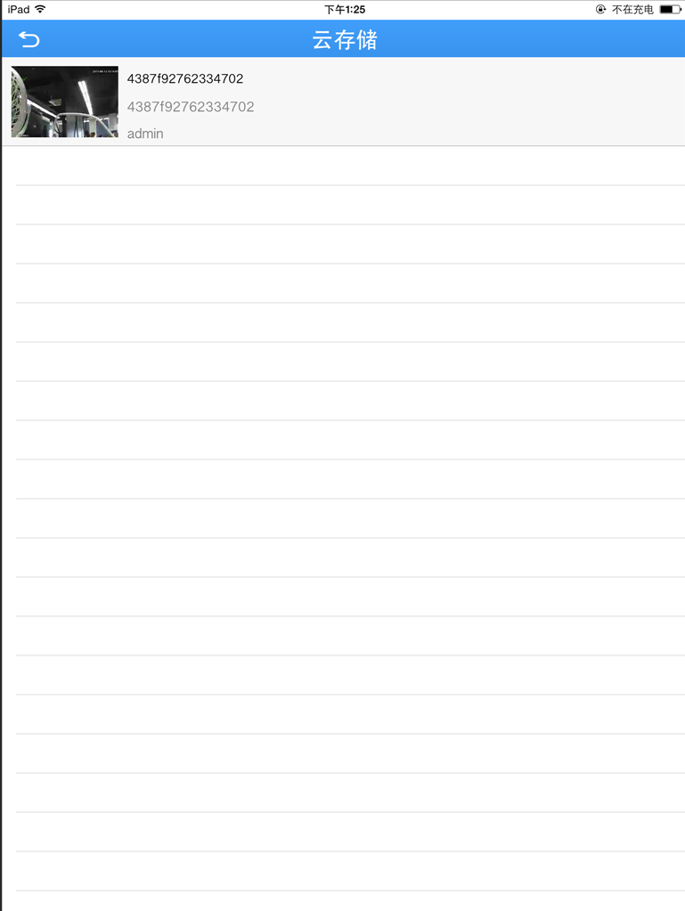
3.6f
- Local settings：View software version,as shown below like 3.6g

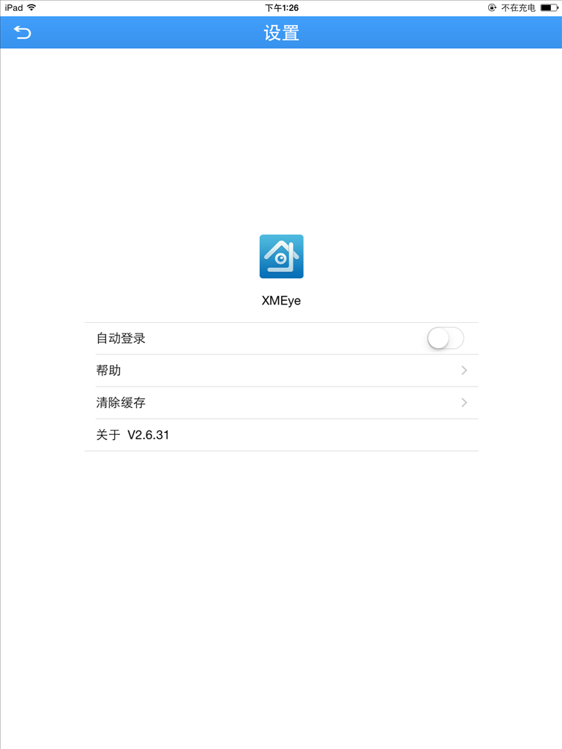
3.6g
- Automatic login:open it,and it will login automatically next time,and show device list.
- Help:Click “help”,there are operating instruction.
- Clear cache:click it,then display “if clear cache”,click “yes”,that means clearing successfully.
- About:To show software version
- Logout：Back to login interface

3.7Switch Language
When you switch the language on your phone ,the language of the application will be changed as well.For example ,it’s switched to English on your phone,the language of application will be switched to English as well.

