1. Install the app XMEye on your cellphone as the following pic1 shows.
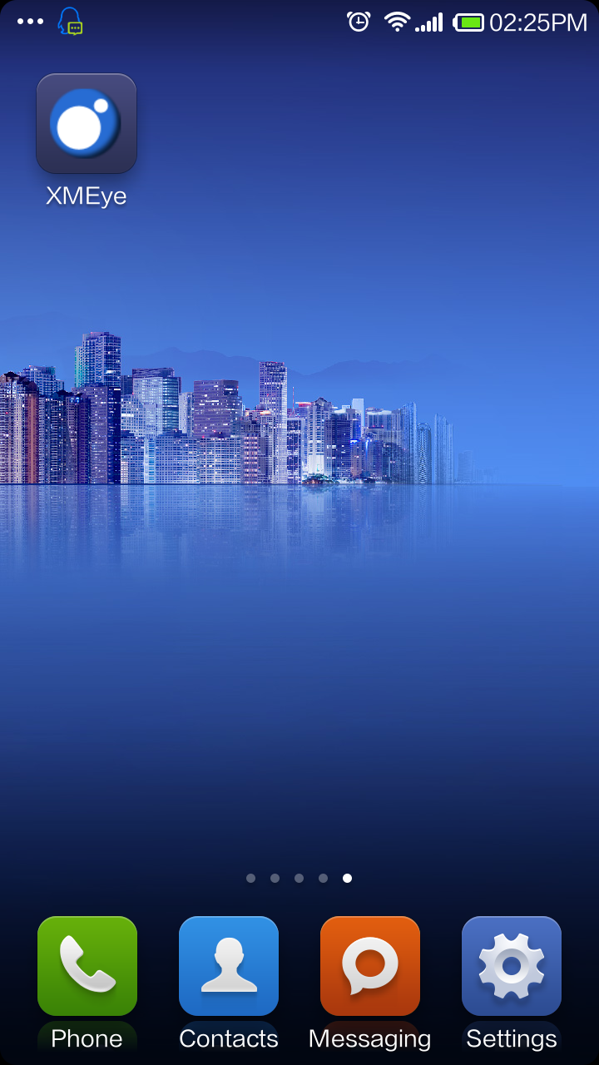
Pic 1
2. Click the XMEye icon to run the application. As you can see in the following landing surface Pic2.1，there are two login ways, one is user name login , the other is local login.
(1)Username login: First you need to register an account, add and save the devices under this account. Then you can log in by username directly, monitor and manage the devices.
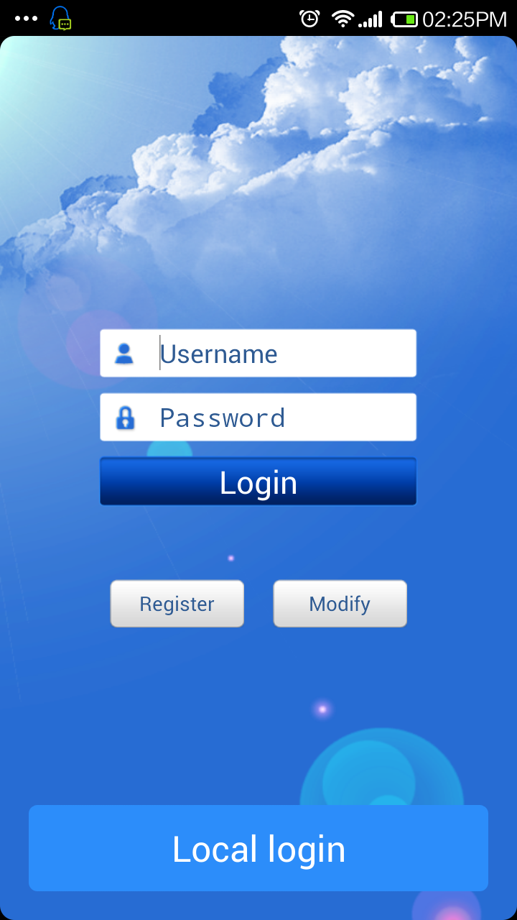
Pic2. 1
(2)Local login: Pic2.2.There are two ways with local login, one is by serial number, the other is by IP /DDNS.
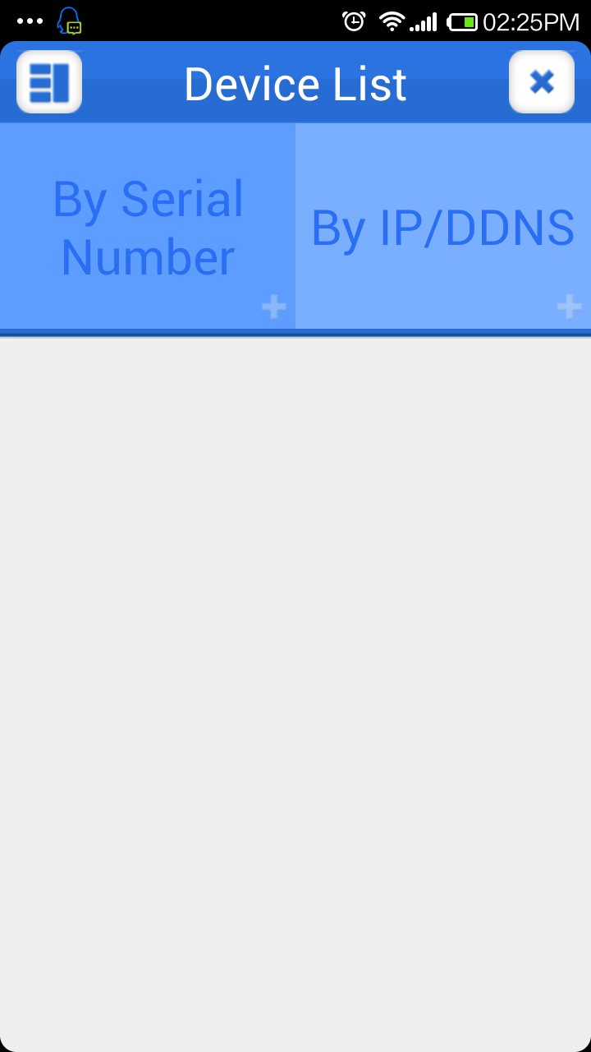
Pic2. 2
- By Serial Number：Pic2.3a, Pic2.3b. You can access the device directly by manually adding the serial number with 16 letters and Numbers; the default user name of terminal device is “admin”, the default password is blank .You can also click the “Automatic seach device” icon to add the devices on LAN.
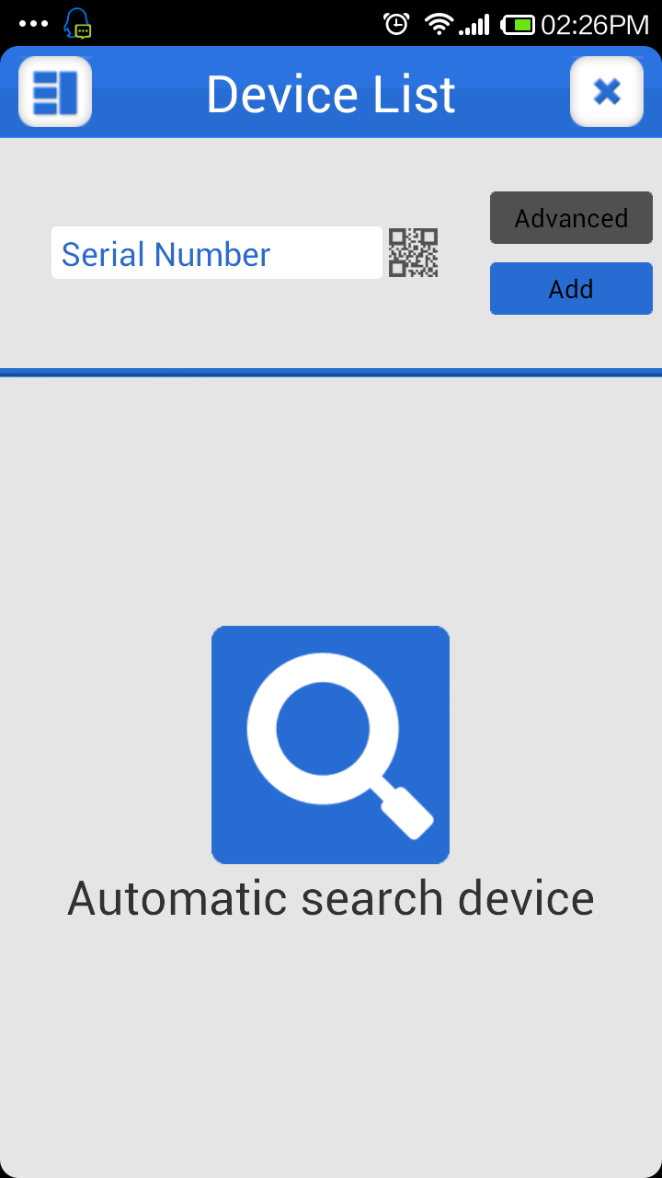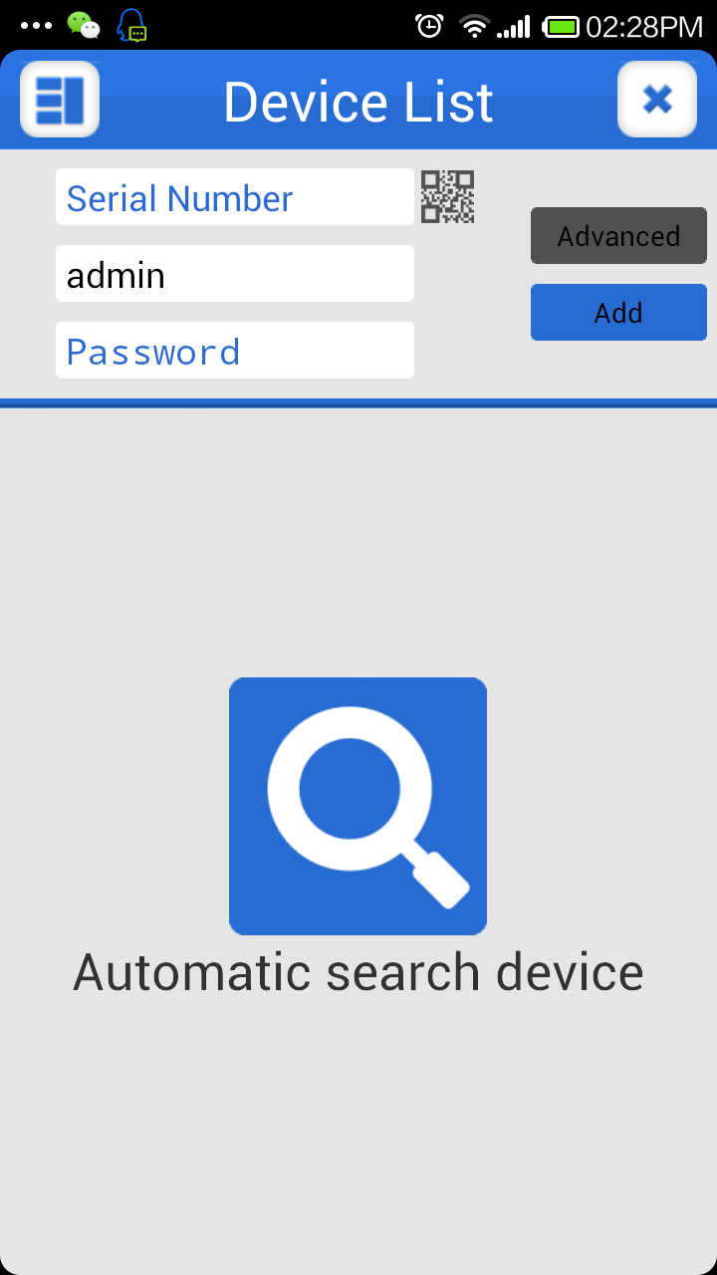
Pic2. 3a
Pic2.3b
- By IP/DDNS：Pic2.4a ,Pic2.4b.It refers to the device’s IP address on LAN or the bonding IP and and DDNS to the public network. You can add manually or click “Search” to add the devices on LAN.
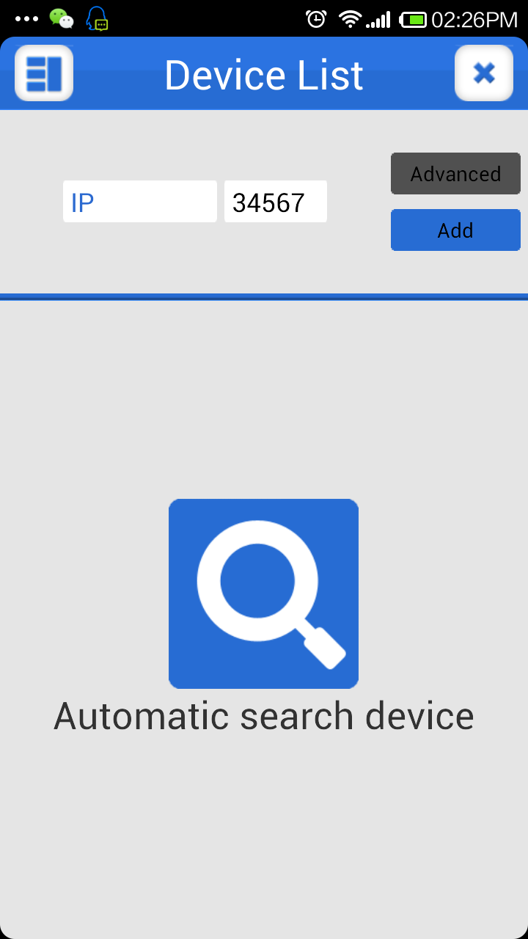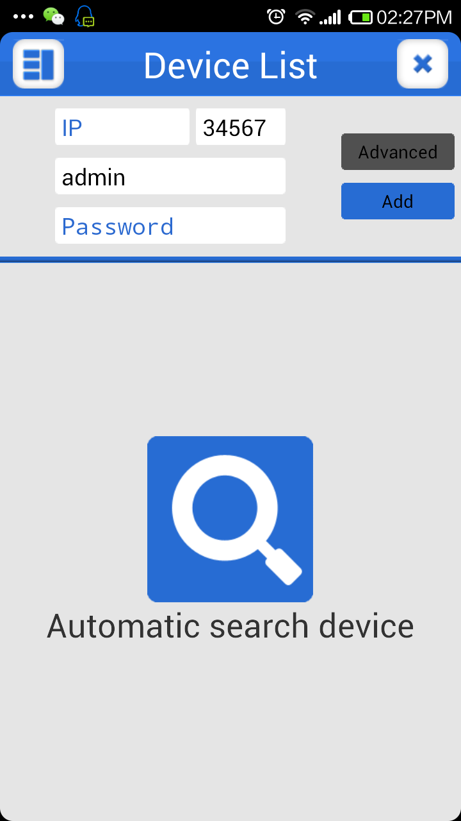
Pic2.4a
Pic2.4b

3.LIVE PREVIEW：Pic3.a,3.b; Click the icon after adding to access the device, then choose the channels to preview.
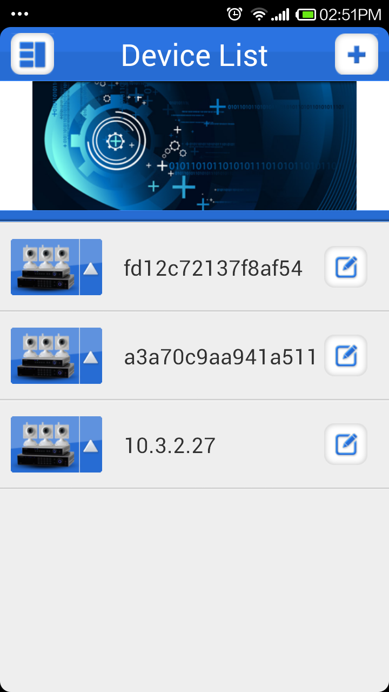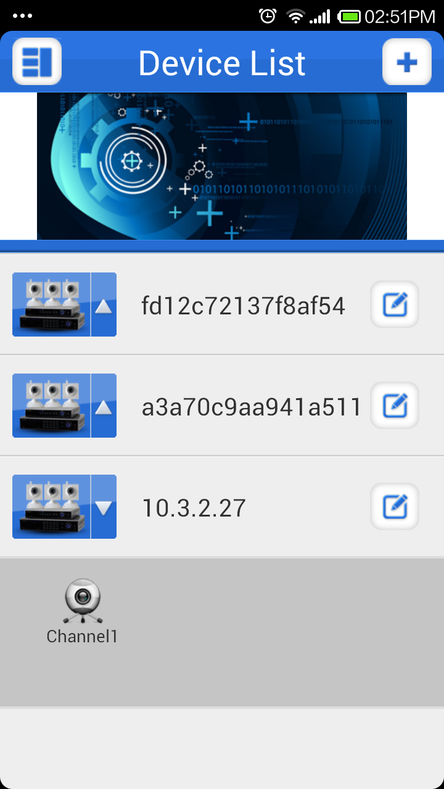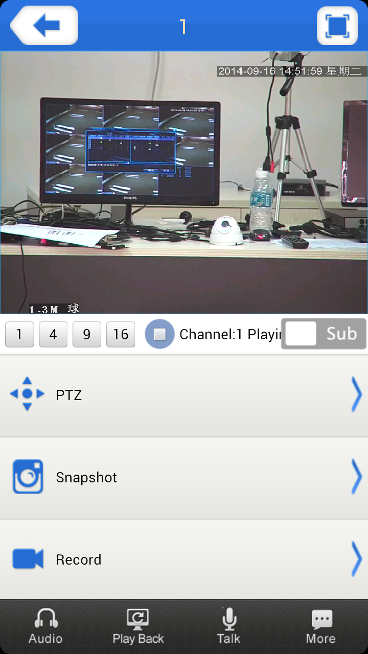
Pic3.a
Pic3.b
Pic3.1

3.1 Like in Pic3.1, the instructions of the functions on live preview interface as below:

Function Key | Description
 | Back to Main Menu
 | Full screen
 | The total number of channels/Switch the channel
 | Play/Stop
 | Snapshot
 | Video records
 | Voice
 | Remote Playback
 | Voice intercom
 | PTZ Direction control button
 | Zoom in / Zoom out
 | Convergence control
 | Aperture Control

3.2 Access to the main menu，and you can see the corresponding operation options, including device list, local video, local image, setting, user login ect, as Pic3.2：
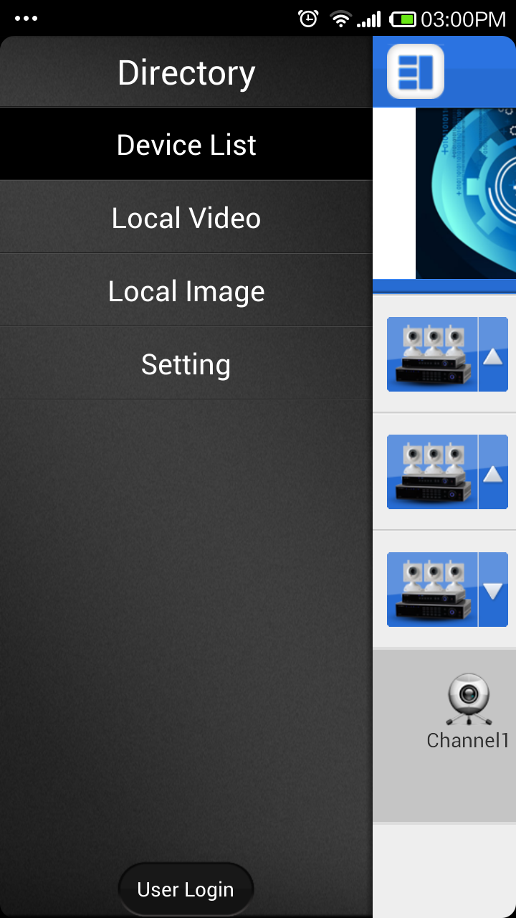
Pic3.2
- Device list：Inventory display area of the devices
- Local video：You can see the related details if you record though XMEye. The default video file name is generated according to the recording time.
- Local image：The images captured in the process of mobile surveillance is saved in the local image album. Click it, you will see the images shown in the thumbnail way. You can click the image and zoom out the image to view.
- Setting：To check the software version information，as shown in the picture below.
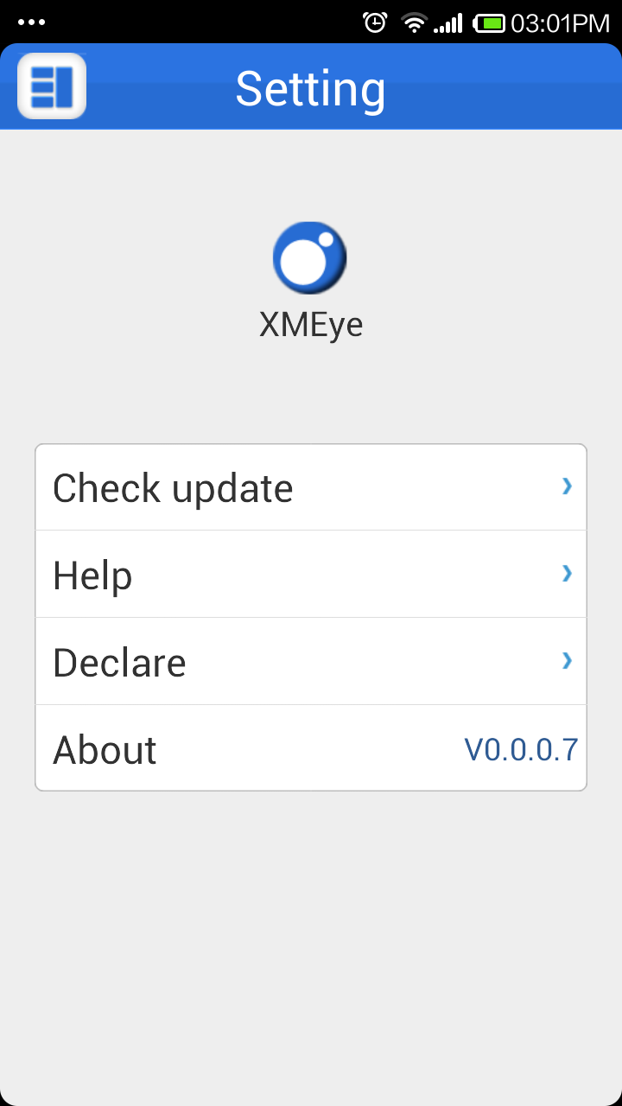

- Log out：Return to the login page

