Contents
Chapter One Product Description 2
1.1 General 2
1.2 Technical Parameters 2
Chapter Two Structure Appearance Description 3
2.1 Panel Description 3
2.2 Product Interface Description 4
2.3 Remote Control Description 5
Chapter Three Description for Operation System 5
3.1 Turn on / off 5
3.2 Preview 5
3.3 Menu basic operation instructions 6
3.3.1Enter menu mode 6
3.3.2 Menu Composition instruction 6
3.3.3 Exit menu mode 6
3.4 Main Menu Introduction 6
3.5 Video Playback 7
3.5.1 Video Search 7
3.5.2 Article replay tools 7
3.6 Manual Recording 8
3.7 PTZ Control 8
3.8 Menu 8
3.8.1 Video Search 8
3.8.2 File Backup 9
3.8.3 System Setup 9
3.8.3.1 Miscellaneous Setup 9
3.8.3.2 Encode Setup 10
3.8.3.3 Record Setup 11
3.8.3.4 Network Setup 11
3.8.3.5 Screen Setup 12
3.8.3.6 Motion Detection 13
3.8.3.7 PTZ Setup 13
3.8.3.8 Sensor Setup 14
3.8.4 Management Tools 15
3.8.4.1 User Management...............................................................................................15
3.8.4.2 HDD Management..............................................................................................15
3.8.4.3 System Maintencance ........................................................................................16
3.8.4.4 Factory Setting......................................................................................16
3.9 Information System 16
3.9.1 HDD Information 17
3.9.2 System Information 17
3.9.3 Log Information 17
3.10 System Logout 17

Chapter one Product Description

1.1 General
This equipment is designed specifically for the field of a number of digital security surveillance products, which uses an Embedded Processor Init (MPU) and operating systems, combined with the field of the latest IT technologies, such as video and audio encode/decode, high-capacity hard disk recorder, TCP / IP network technology, firmware in FLASH, making system operation more stable. This equipment, with digital video and audio recorder (DVR) and digital video and audio server (DVS) features at the same time, can works not only in local independently,but also be networked to form a powerful security monitoring network. It applies to bank, telecommunications, electric power, justice, transportation,residencel, factory, warehouses, water conservancy facilities and other areas and departments of the safety precautions.
Model | 4 channel DVR | 8 channel DVR |  | 16 channel DVR
Operation system | Embedded Linux operation system
System resource | 4/8/16 channel CIF real-time video and network-wide transmission, 1 ,4,9or 16-channel CIF Playback at the same time.
Operation interface | Graphical user interface (GUI), mouse, panel, remote control operation
Video standard | PAL、NTSC
Image compression | H.264
Audio compression | ADPCM
Recoding mode | Manual, timing, alarm, motion detection
Video Search | Time search, event search, channel search, the log search
Backup | network backup, USB backup
Video input | 4BNC | 8BNC |  |  | 16BNC
Video output | 1BNC,1VGA out
Audio input | 2ch | 2ch |  |  | 2ch
Audio output | 1ch | 1ch |  |  | 1ch
Monitoring quality | PAL：720x576（D1）；NTSC：720x480（D1）
Playback quality | PAL：352x288（CIF）；NTSC：352x240（CIF）
Image Control | 6 shifts for regulable
Motion Detection | for each channel of the detection area (16 × 16), multi-level sensitivity can be set
Image display | 1,4 Image display |  | 1,4,8 Image display |  |  | 1,4,9,16 Image display
Video Speed | PAL: 25 frames / sec (adjustable) NTSC: 30 frames / sec (adjustable)
Video Save | The hard drive, network
Local playback | 1,4 Image display |  | 1,4,8 Image display |  |  | 1,4,9,16 Image display
Alarm Input/output | 4 channel/in&1 channel out (optional)
PTZ | RS485
HardDisk Interface | 1 SATA interfaces |  | 2 SATA interfaces |  |  | 2 SATA interfaces
Network interface | Self-adaptive Ethernet interface.  RJ45 10MB/100MB,TCP/PPPOE/DHCP/DDNS/FTP/UPNP
USB Interface | 2USB2.0 high-speed interface;
Power | 12v power

Chapter Two: Structure Appearance Description

2.1 Panel Description
4 channel DVR Front Panel Description：
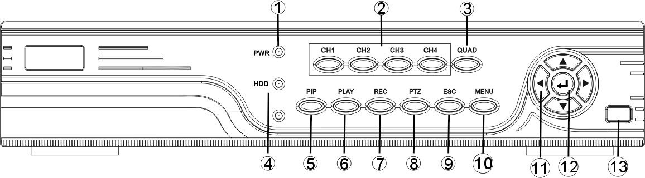
1.POW：Power States LED 8. PTZ：Pan/Tilt Controling mode switch
2.CH1~CH4：Single-Screen Switch 9. ESC：Exit Key
3.QUAD：Multi-Screen Switch 10. MENU：Menu Key
4.HDD：HDD State LED 11. ▲▼ ：Direction Key
5.PIP：Reserved 12.  ：Select Key
6.PLAY：Record Playback Key 13.Ir Receiver
7.REC：Manual Recording Switch

8 channel DVR Front Panel Description:

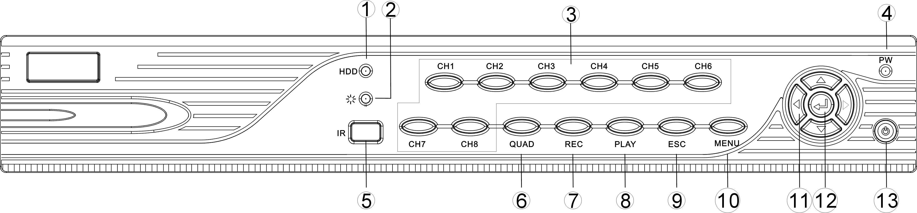
1.HDD：Power State LED 8.PLAY：Video Playback Key
2.：System Running State LED 9.ESC：Exit Key
3.CH1~CH8：Single-Screen Switch 10.MENU：Menu Key
4.POW：Power State LED 11. ▲▼ ：Direction
5.IR: Ir Receiver 12. ：Select Key
6.QUAD：Multi-Screen Switch 13.Power Switch
7.REC：Manual Recording Switch

16 channel DVR Front Panel Description:
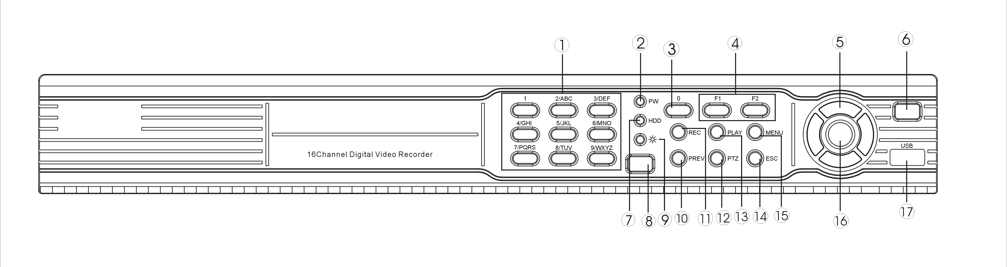

1．1~9：number key 2．PW:POWER Light
3．0：number key 4．F1、F2：Reserved Key
5． ▲▼ ：Direction Key 6．POWERP:Power Key
7．HDD：HDD Light 8．IR：Infrared Receiver
9． ：System Running State LED 10．MUTE：Multi-screen Switch
11．REC: Record Key 12．PTZ: Pan/Tilt Mode Enable/disable
13. PLAY：Playback Key 14. ESC：Exit Key
15. MENU：Menu Key 16. ：Confirm Key
17.USB：USB Connector

2.2 Product Interface Description
4 channel DVR Rear Panel Description：
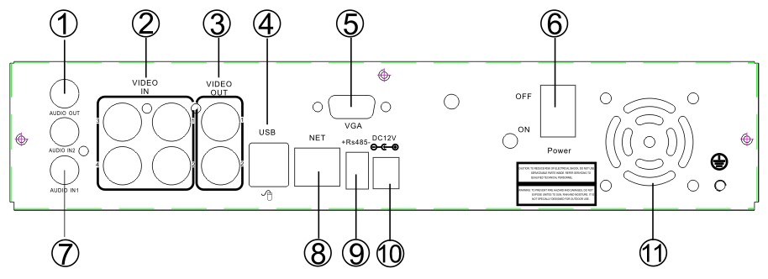

1、AUDIO OUT：Audio Output Connector 7、AUDIO IN：Audio Input Connecor
2、VIDEO IN：Video Input Connector 8、NET：RJ-45 Standard Network Connector
3、VIDEO OUT：Video Output Connector 9、RS-485：485 Pan/Tile Device Connector
4、USB：Standard USB Connector 10、DC12V：12V(DC) Power Connector
5、VGA：Video Output Connector(Optional) 11、FAN:cooling fan with temperature control
6、POWER：Power key

8 channel DVR Rear Panel Description：
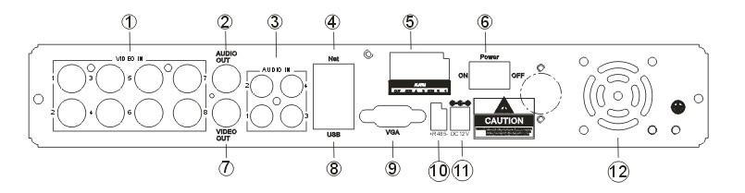
1. 1-8: Video input interface 7. VIDEO OUT: BNC video output interface
2. AUDIO OUT: Audio output interface 8. USB: USB interface
3.1-4: Audio input interface 9. VGA: Video output interface
4. NET: RJ-45 network interface 10. RS-485: RS-485 interface
5. Alarm: Alarm input interface 11. DC12: 12V DC power input
6. POWER: Power switch 12. Fan: cooling fan with temperature control
16channel DVR Rear Panel Description：
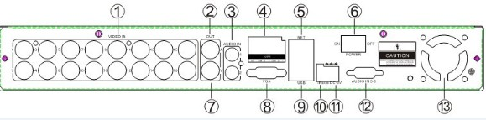
1. VIDEO IN：Video Iutput Connector 7.VGA：Computer monitors with VGA interface 2.VIDEO OUT：Video Output Connector 8 .NET：RJ-45 Standard Network Connector 3.AUDIO IN：AUDIO Input Connector 9.USB：Standard USB Connector
4. Alarm mode 10.R485：485 Pan/Tile Device Connector
5.POWER: Power key (RESERVE) 11.DC12V：12V(DC) Power Connector
6. AUDIO OUT: AUDIO Output Connector 12.Audio enlarge connector
13.Fan: Prevent over-heated,temperture-controlling

2.3 Remote Control Description
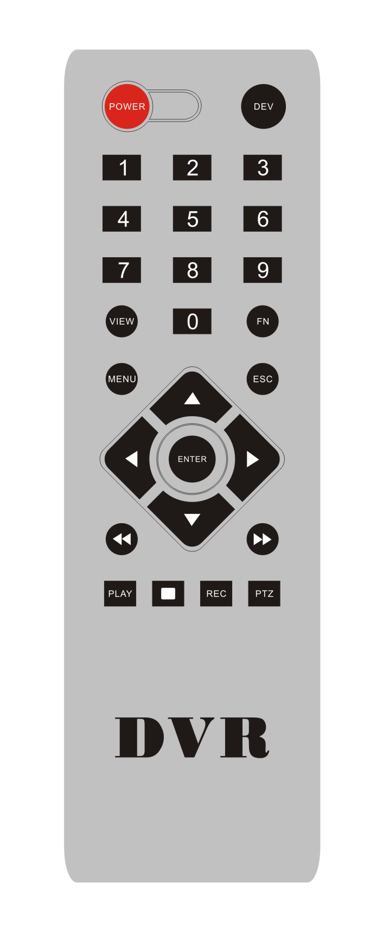
POWER | Power switch
DEV | Device button：input the corresponding device number with equipment after pressing device button，press “ENTER” to save the setting.Then can operate equipment.
0-9 | Number button
MENU | Menu button;eliminate all the areas when set up motion detection area
ESC | Exit
▲ | In menu mode，select upwards；in PTZ mode，control the dome camera to revolve upwards
▼ | In menu mode，select dowmwards；in PTZ mode，control the dome camera to revolve dowmwards
 | In menu mode，select left；in PTZ mode，control the dome camera to revolve left
 | In menu mode，select right；in PTZ mode，control the dome camera to revolve right
ENTER | Select key
PLAY | Video playback
FN | Subsidiary key
REC | Recording key
VIEW | Multi-screen key

Note:Many devices in near space,remote control should select a device according to device number.So each device needs a unique device number,unless remote control may operate devices with the same number.

Chapter Three: Description of Operation System

3.1 Turn on / off
Confirm that AC voltage accessible matches the requirements of digital video recorder.Ensure that the digital video recorder power outlet to a good middle ground termination. Access to power, the device started 【POWER】 light is on, into the system, the panel RUN light flashing as normal conditions.
3.2 Preview
Preview screen can be seen immediately after equipment is normally starts. In the preview screen you can see the system date, time, channel name. Press corresponding number key of panel or click the left mouse button, then a single image preview can be available; Press panel "QUAD" key or click the left mouse button, you can return to a multi-screen monitoring state.
3.3 Menu basic operation instructions
3.3.1Enter menu mode
【Main Menu / MENU】 key to enter the device's main menu interface. 【PLAY / PLAY】 shortcut keys to enter playback interface.
【Video / REC】 shortcut keys to enter manually recording interface. 【PTZ】 shortcut keys into PTZ control interface.
Description: Default password is empty, click "enter" can into menu directly.

3.3.2 composition of the menu
Menu component units mainly in the following categories:
（1） Check box: providing two kinds of status options, "√" represent enable, "□" disable, use 【confirmation /】 button or 【↑】, 【↓】 key or click the left mouse button to choose.
For example: file search menu page, the "Select Channel" and the "video type" check box.
（2） Selection box: According to the system, the contents of the drop-down box options, select the target content. Use 【↑】, 【↓】 key or click the left mouse button to select.
For example: in the encode setup menu,choose "Select Channel" and the "video type" check box.

（3） List Box: Displays the inquiry results of information in the list, you can select one option for operation in the provided list.
For example: Choosing the file in the Video backup result list by pressing 【OK/】 button or the left mouse button.
（4）Edit box: Enter the target name into edit box
For example: System Configuration menu pages, the “equipment name” edit box, enter numbers, English letters, punctuation and so on

use panel key 【↑】【↓】【←】, 【→】or after positing the edit box by mouse, press "" key or click the left mouse button, then the enter keyboard appears, select the desired input target characters through the arrow keys or click the left mouse button.
b) Safe or Exit the editing status by pressing 【ENTER】 【CANCEL】 button or button【ESC】
（5） Button: used to implement a specific function or enter the next setting menu, enter by clicking 【OK /】 key and the left mouse button.

3.3.3 Exit Menu mode
Press 【MENU】, 【Exit / ESC】 or the right mouse button to exit the menu mode
Click the right mouse button, return to the previous menu level.

3.4 Main Menu Introduction
Press MENU key or the right mouse button pop-up the main menu, main menu consists of the following three components
Preview mode: in the menu column, select the corresponding screen preview mode.

Shortcut menu: in menu column, there are: video playback, manual recording, PTZ control, sound shortcut menu can be directly into the corresponding pages in the menu.
The main menu bar: Click into the post includes video inquiry, document backup, system setting, management information, system information , exit menu column.

3.5 Video Playback
Click main menu column "video playback" into file search interface.

3.5.1 Video Search
Channel selection: select the target channel, click check box to choose. "√" is checked; "□" not selected.
Record mode: select the record mode of searching, click check box to choose. "√" is checked; "□" not selected. DATE Time setting: enter the beginning and end time in the edit box to search the video.
Storage device: in the selection box select the target backup storage device.
Search : after searching criteria set, click the button, the system will begin to search the corresponding video information, and list the search results. “RED”-regular time recording,” GREEN”- Motion Detection recording, ”YELLOW”-alarm recording.

Playback: Go into video playback interface, use up-down-left-right button or mouse to set the time period, click【】or left of mouse go into playback interface.
Cancel : back to previous menu

3.5.2 Article playback tools
Select the playback file or playback by time, it will enter the video playback interface.
Article playback tools: Article playback tools will appear below the in the playback interface, you can click the left mouse button to magnify or narrow channel video.

Stop Play: Click the button, the system will stop playing and exit the playback interface
Pause / Play: Click the button 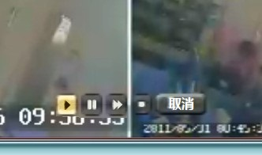to pause playback, click to continue video playback.
Fast forwarding: click can fast forwarding playback. Times fast forwarding can be set by click again.
Exit playback：Click “ESC” orbutton to withdraw playback screen at any time; After play all,it will quit the playback screen voluntarily

3.6 Manual Recording
Click left mouse button to choose "manual recording" in main menu column or click【Video / REC】to enter its settings interface.
Manual Video Interface Description
Manual recording interface consists of several components:
Channel number：correspond to the equipment video channel.“☑” open；“□”close。
Full On：choose all channels video settings "on"
Full Off：choose all channels video settings "off"。
OK：Confirm and exit。
Cancel：Click return button, it will exit Manual recording interface and back to main menu column
Remark：Manual recording must be stopped by manual,or it will record continually

3.7 PTZ Control
Click "PTZ control" in main menu interface for access to its settings interface
Main operation of PTZ control include: directional control; horizontal sweep; zoom control; adjust the focal length; adjust aperture; PTZ speed.

3.8 Menu
Click "menu" in shortcut menu enter into the main menu interface, including: video inquiry, record backup, system settup, information management , information system,system logout.

3.8.1 video inquiry

In the playback shortcut menu （see3.5playback）

3.8.2document backup
Choose"channel"and "record mode", set the range of date and time，click "search".
After choosing a file from the column--"enter". It will be backup success when it show 100%.
Remark: Backup USB device must be fat32 form.

3.8.3System Setup
In the main menu interface, select "System Settings" to enter its sub-menu interface. Including: Miscellaneous,Encode setup,record setup,network setup,screen setup,video detection,PTZ set up,sensor setup.

3.8.3.1Miscellaneous
Choose"system setup"
DATE TIME：preview time show in DVR . After setting,click"refresh".Notice: Recording will stop during time change period. OK,safe.
Date Format：setting in ：Y/M/D”、“D/M/Y”、“M/D/Y”
Key Lock：system will logoff present user if there is 10munite without operate. It needs login again to operate.
Key Buzzer ："enable"--controller and panel key with sound ."disable"--without sound选
Language：Chinese and English can be used.
Video standard：PAL and NTSC can be choose. PAL is default setting. It will work after setting,safe and reboot.
DVR ID： controller connect by device number when it is used to control.The controller must correspond it's ID so that it can work. (see 2.3)
After setting this interface,click"ok",the information will safe and exit.click"cancel",the information will not safe and exit.

3.8.3.2 Encode setup
In the "system setup" menu, click "Encode setup "
Channel ：chose the right CH you like by clicking the select box
Stream： chose the right stream : "main stream" or "sub stream "
Encode mode：chose the right encode model you need : "video only "means only encoding for video ; "AV combined" means encoding for both video and audio.
Bitrate mode ：chose the right bitrate mode you need : "constant bitrate " means system encoding video as user-defined bitrate and and frame rate. "variable bitrate" means system encoding according to user-defined image quality and video frame rate , but bit rate is automatically adjusted by the system depending on the video sceen. "average birtrate " means system automatically adjusted fluctuation as user- defined bitrate.
Encode format： encoding resolutions defined by user' need : （QCIF）176*144、 （CIF）352*288 (HD1)576*288 （D1）704*576
Bitrate： users select the encoding bitrate as needed. The higher bitrate ,the better image but with large disk space
Fluctuation： image quality fluctuations , user identified.
Frame rate ：users select the video frame rate as needed. The higher frame rate ,the better image but with large disk space
Copy to ： select the target channel on the right of "copy to "button ,click "copy to" & ''ok " then system will set the current channel setup informations to other target video channel. Click button "cancel", the setup informations is non-saved but to exit.

3.8.3.3Recode setup
In the "system setup" menu, click "Record Setup "
Channel ：chose the right CH as needed by clicking the inverted triangle
Weekday : chose the right day as user's need, "ALL" means all days in a week.
Image mode and time ： every time slot can set different recoding mode in all 4 time slot. "Time " recording with red color , "Motion" recording with green color , "Sensor"recording with yellow color ; “☑" means working , “□” means invalid. The bottom parts has times status display, whole schedule from time 0~24 hours
Copy to ： select the target channel on the right of "copy to "button ,click "copy to" & ''ok " then system will set the current channel setup informations to other target video channel. Click button "cancel", the setup informations is non-saved but to exit.

3.8.3.4Network setup
In the "system setup" menu, click " Network Setup "

MAC address：showing the device's MAC address
DHCP：select whether to start up DHCP to automatically obtain IP 。“☑”means works ；“□” means non-work
IP address ：the IP address must be unique and can not be in conflict with the host or workstation on the same network segment
Subnet Mask ：subnet for the network segment。
Gateway：need to set the gateway address to achieve communication between the different network segments.
DNS address ：devices used PPPOE protocol to access network to gain a dynamic IP address
HTTP port ：port number IE browser visit , default port is "80"
Client port ；port number device and mobile visit , suggest to set above 2000
ESeenet ID： after connecting internet , click“☑ Eseenet” to gain a Eseenet ID , which can be used in IP remote monitoring in ESeenet network server
PPPOE configuration :
Start using ：“☑ PPPOE”means to start up PPPOE dial-up. “□” means not to start up
PPPOE user： input the user name of ISP into edit box
PPPOE password ：input the password of ISP into edit box
After the page setup is completed, click '"OK " to save the changes ; click "cancel " , non-save but exit.
DDNS setting: automatic analytical function of dynamic domain name, supported 3322 and DYNDNS
In the "network setup" menu, click " DDNS "
Start using ：“☑”means DDNS dynamic domain services start using ;“□”means not to start up。
Select the right network server and input user name, password and domain name （edit method pls refer to 3.3.2(4)）
In the "system setup" menu, click " Network Setup "

3.8.3.5 Screen setup
In the "system setup" menu, click " Screen setup "

Channel ：chose the right CH as needed by clicking select box
title ：edit any channel title as needed
OSD title : “☑” means display channel title, “□”means non-display
OSD Alpha： OSD menu transparency. Can be adjusted as needed
OSD time ：“☑”display system time，“□” non- display;
Sequence Dwell ：the time of auto switching preview image , can be single screen or 4 Channels screen.
Start using：“☑”start using ，“□” non-start using

After the page setup is completed, click '"OK " to save the changes ; click "cancel " , non-save but exit. 3.8.3.6 video detection
In the "system setup" menu, click " video detection "
Sensor ：chose the right CH as needed by clicking the inverted triangle
Sensitivity ： chose the trigger video detection sensitivity
Detection type：select detection type --motion, video loss ,“keep out" alarm
Alarm duration: after chose the trigger video detection, the time alarm last
Area edit : set motion detection area ;move by choosing left of mouse.
Record channel : system defaulted channel after trigger video detection,,
Alarm：“☑”means start ，“□”means non start 。
Buzzer ：“☑”means start ，“□”means non start。
OSD ：“☑”means '"detection " marks shows on screen,，“□” means non show
E-Mail notice ：“☑” means E-Mail valid，“□” means E-Mail invalid。
Copy to ： select the target channel on the right of "copy to "button ,click "copy to" & ''ok " then system will set the current channel setup informations to other target video channel. Click button "cancel", the setup informations is non-saved but to exit.

3.8.3.7 PTZ Control
In system setup,click"PTZ set up"
Channel: choose the right channel, click the select box to choose
Protocal: the selected one must be the same with the one of PTZ
Data bit: choose the matched one of the PTZ
Address: input the address of appointed decoder
Stop bit: choose the matched one of the PTZ
Baudrate: choose the matched one of the PTZ
Parity check: choose the matched one of the PTZ
Copy set: choose the object route in the right select box, click the button of copy setting, then the informations of setting will be showed, which also can be applied in other object routes. After the setting, click the button of sure to exit with saving the , or click the botton of cancle to exit without saving.
3.8.3 8 Sensor setup
In the system setup , choose the "PTZ setup"
Channel: choose the right channel, click the select box to choose
Work mode: setting to start alarm or not
Alarm duration: set up the alarm duration time
Alarm: “☑”start alarm, “□”close alarm
Buzzer: “☑”start buzzer, “□” close buzzer
Screen note: “☑”alarm icon shows on the displayer, “□” no alarm icon showson the displayer
E-mail: “☑”start "e-mail" senting function, “□”shows close the function
Copy to setup: choose the target channel in the right select box, click" copy to" ,the setting information will be applied to other channel.
After the setting, click "OK" to exit with saving the , or click"cancle"to exit without saving.
3.8.4 management tool
In main menu, choose"management tool", it includes four interface of the user management, disk control, system maintainance and factory reset.
3.8.4.1 user management
In the management tool, click" user management ".
Add user: input a new user name in the edit box and set up the operational authority. Choosing in the right check box, “☑” users can use it, “□” users can not use it. Click the "password setup" to set the password, or it can be the default password.
Delete user: delete the secelted user
Edit user: edit the selected user
Set password : set up the password
After the setting, click "OK" to save and exit, or click t"cancle" to exit without saving.
3.8.4.2 HDD management
In the " management tool", click "HDD management"
Overwrite: “☑” early videos will be covered when the disk is full, “□"shows not cover.
Format: “☑” stands selected, “□” stands not selected, when click "format" a confirm interface will pop up, then click confirm to format, click cancle to return the main interface.
3.8.4.3 system maintenance
In the " management tool", click "HDD management".
Auto reboot: setting the time of automatic reboot, it can set" Saturday to Sunday" . "Never" means donnot reboot automatically.
sysytem upgrade: copy the upgraded file to the root directory of USB drive, select the USB storage device, then click "begin" to upgrade the system. After upgrading,click"OK" then system auto reboot.
Remarks: the upgrade document name must be: FWHI1504A_***.rom(4ch), FWHI1508A_***.rom (8ch), “***” means the publish time: such as FWHI1504A_20110520.rom
3.8.4.4 factory setting
In the " management tool", click"factory setting"
Select the terms which need factory setting, click "OK"to save and exit or click "cancle" to exit without saving.
Remarks: after factory setting, all the settings will be the initial one, please use carefully.
3.9 system information
In the main menu,click"system information"which include HDD information, system information and system log .
3.9.1 HDD information
The listbox shows the HDD status information
3.9.2 system information
Device name,device model,H/W version, S/W version could be check here.
3.9.3 system log
Choosing the log type which need checking from listbox, First select the type in the , and input the time in the editbox, then click" search", the relevant informations will showed below, you can turn the page by click " former" and "next", or input the No. of the page.
3.10 system logout
In the main menu, click"system logout"
User logout: uesd for exit users. After logout, if you want to use the device continue, it is necessary to relogin after logout.
System reboot: It will reboot after "OK".

Esee net operational description
- DVR connect with network and insure it is running.
- Setup the UPNP function from Router: this Router is TP-LINK, just find the UPNP out and setup.
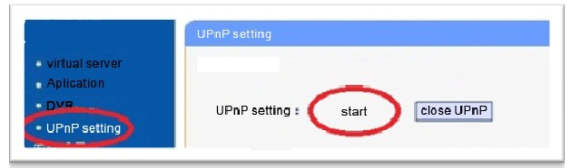

- Turn into DVR: click right button of mouse-setup-system setup-network setup,as below:

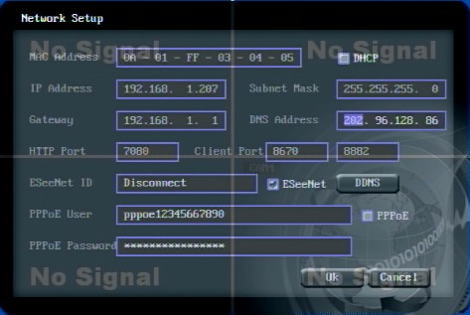
IP Address：Default for：192.168.1.114（fill out according to your actual situation:1 segment: 192.168.1.114，0 segment: 192.168.0.114，If IP without conflict, no need to change.)
Subnet Mask：default for 55.255.255.0
Gateway：default for 192.168.1.1（can be change according to the actual situation）routers running status can check from segment.
DNS Address：192.168.1.1, change into user's network DNS. (can check the DNS address from router)
After full fill all the information and save, exit to menu then turn into above menu again. Esee ID will appear.
4、visit IE browser and input: www.e-seenet.com

First setup enable the active-X as picture:
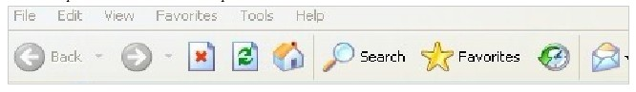
Click Tool- internet option- security-user defined safety level-enable all section related to Active x . Remark:if there is a remark showing (not safe),can ignore-then choose ok. Download and install the Active x. Before install,pls close all IE windows.
- input Esee ID into Device ID, user name and passwords as DVR. Default user name: admin, passwords: nothing.
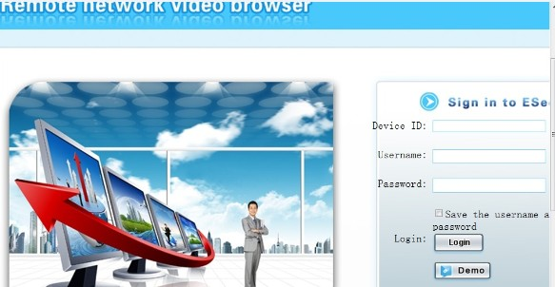
1.1 video monitoring homepage:
Monitoring homepage including: preview window, PTZ control,preview mode, code stream selection, channel opening,setting,playback, user logout as below:
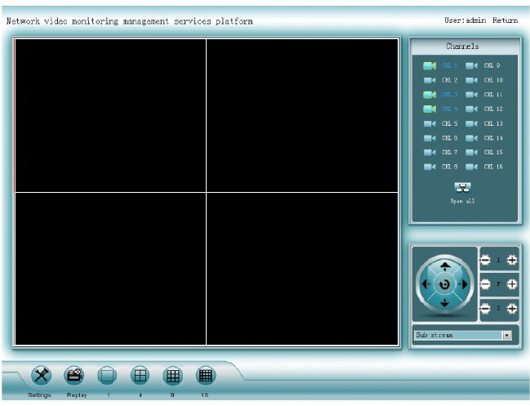

Turn on preview：click the target channel with left button of mouse, red color means select already. Double click the channel can open or close the correspond preview channel, such as: open; close
Preview mode：can click to choose the mode, or double click preview window to switchover into multi-channel mode.

