______Instruction for iPhone
_
Brief introduction
The documents mainly introduces how to set and use the Software for iPhone OS.
The Software has some main functions.
1 、Browse real time video function
2、Cloud stand control function(the front end is to control ball machine)
Essential condition

Need iOS 3.0 or higher release, the cellular phone includes iPhone, the iPod touch waits

Install and operating instructions

Circulate iPhone App Store procedure, cut over the huning label page, search to input TMEye+ in the column, will find out to apply a procedure setup to wrap, click to carry on a setup then.The following chart

Will appear a routing diagram mark after the setup, the following chart

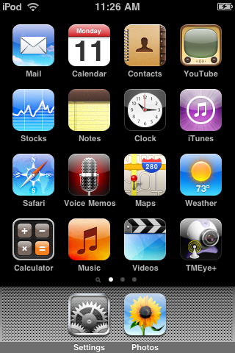

Click TMEye+ routing diagram mark, circulate a beginning to start interface the following chart after the procedure

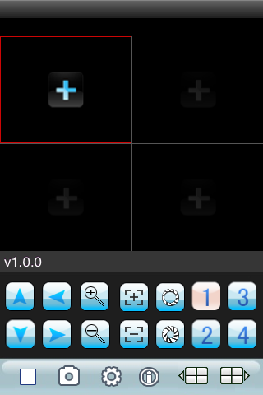

Press button vs in response to the function is as follows

Function key | name | Function describe
 | play | The procedure connectivity equipment combines to start broadcasting a video
 | snap | Grasp to clap a current ICON(grasp a chart document to recognize tacitly conservancy to the cellular phone of tacit approval of photograph catalog bottom.)
 | setting | Establish a DVR IP address or watch an area, port, user's name and password and equipment alias information
 | Up group | Can select up the gang gateway
 | Next group | Can select to descend gang gateway
 | about | About information
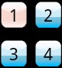 | Select gateway | Select a some video of one gateway that broadcasts an equipment.Can carry out eight roads, 16 road gateways to cut over with"descend gang" team work
 | PTZ control | Carry out a cloud on the stage, next, left and right control
 | Zoom ratio | The realize tension far draws near
 | focus | Carry out focal length to add and subtract
 | aperture | Carry out diaphragm to add and subtract

5）Such as first time use or need to carry on parameter to change, please click 【setup 】button enter a parameter equipment control interface.The following chart

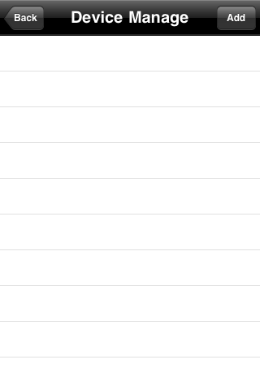

：Enter to add an equipment interface as follows

1. .Add an equipment:

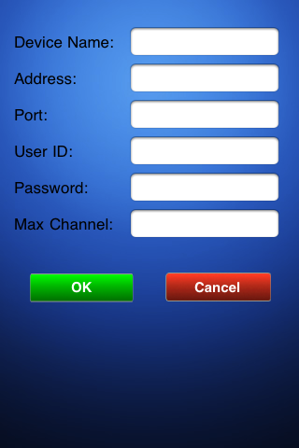

Explain
Equipment denomination(Alias):The alias of equipment is easy to classify several equipments。
Server address(Address):
DVR male net IP address or dynamic state area

Server port(Port):DVR up the server port of setup。

User's name(User ID):The user's name reconciliation that carries a setup with IE。

Password(Password):The password reconciliation that carries a setup with IE

The gateway counts:(MaxChannel):the equipment total number of gateways

2.Delete an equipment:
Lightly sweep a certain record, click again 【delete 】button, can immediately delete an equipment, the following chart:

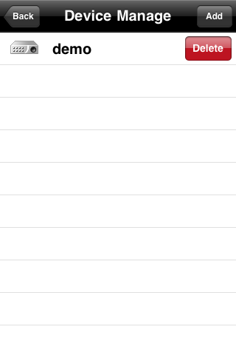

7）Watch video and display mode
1.Return lord interface

2. Click one menu respectively up of, enter an equipment tabulator interface, the spread equipment gateway, the following chart, then after clicking gateway, automatically enter to broadcast lord interface, other three menus strobe the operation can immediately watch four menus at the same time.

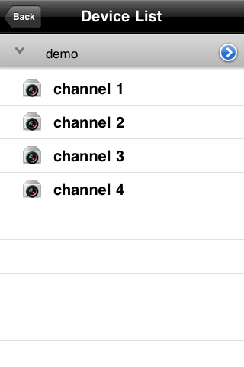

8）Down the routine mode and full plate mode progress cuts over
1.Normal mode

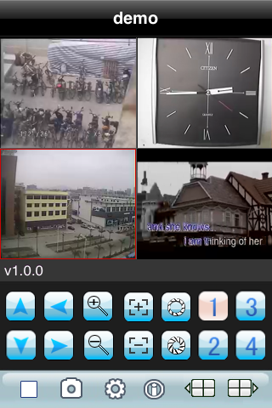

2.Full plate mode
When the handle machine lays down horizontally will the automatic full plate broadcast

7）The gateway cuts over
Pick out homologous gateway, the procedure will open homologous gateway to combine to automatically broadcast a video.The procedure tacit approval will display 1~4 gateways bottom, win an election amid when the next gang gateway press button will gateway will cut over to 5~8, 8-12,12-16 cyclic transformation cutover
The DVR parameter that favors a cellular phone establishes a reference
Resolution:CIF or QCIF

Leads:5-10

The code flows a type:Limit

The code flows:64-256Kb/S

Note:Can carry on tune according to the cellular phone performance and the network condition.Higher cellular phone performance and network condition can display better effect.If the network condition is worse, can appropriately the step - down lead and assure flowing freely

