Instruction for symbian
.1 Brief introduction

The documents mainly introduces how to set and use this Software on the Symbian OS.
The Software has main features, as follows:
1、 Browse real-time's video capabilities;
2、 Use PTZ to control video's views (controllable ball machine at the front);
Essential condition
The phone can support symbain OS more than 9.1 version (namely S60 V3 and S60 V5), include S60 V3 that screen size is 240*320 and 320*240 (Nokia 6120c, e71 and so on) and S60 V5 that screen size is 360*640and 640*360(Nokia 5800, Nokia 5230 and so on);
Install and Operate
- Installer (sisx) is downloaded to phone and opened to Install.
2. After of installing, the phone has icon of the software. Please find the icon which is named of TMEye at designated areas, as follows:
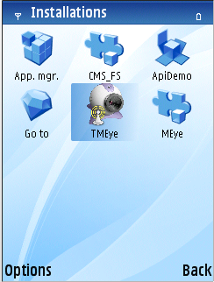
3. Click the cellular phone's supervision(TMEye), the software is running and display interface.
Lengthways and normal mode：
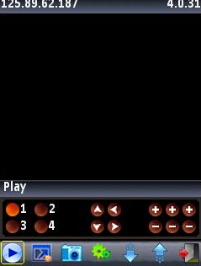

Horizontal and normal mode：
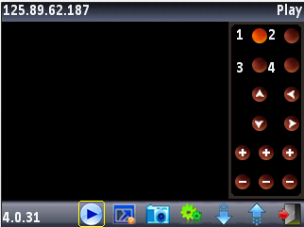
Press button versus in response to the function is as follows：
Buttons and Button's function are one-to-one;
Function key | named | Function describe
 | Play | Connected device and play video.
 | Snap | Grasp current view, and save to photos. (You can find them at the Multimedia --> Image)
 | Setting | Setting the DVR IP address or be watched of dynamic state area, port, user's name and password and alias.
 | Next Group | Can select to next group Channel
 | Exit | Program exit
 | Full Screen | Full screen display
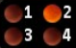 | Select Channel | Select a channel,it is will to play video of you thinks. And it and Next Group are combined.
 | PTZ Control | Carry out PTZ of up, down, left and right control
 | Zoom, Focal length, Aperture | Zoom : Adjust View  Focal length: Focal length of addition and subtraction  Aperture: Adjust the brightness

4. The first time of setup and Parameters change, you click【setup】button to enter a parameter setup interface.The following chart:
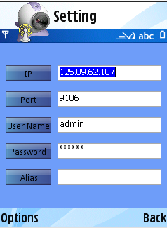

Explain:
Server address(Address):DVR male net IP address or dynamic state area.
Server port(Port):DVR's port
Equipment denomination(DeviceName):The alias of equipment is easy to classify several equipments
User's name(User ID):The user's name reconciliation that carries a setup with IE
Password(Password):The password reconciliation that carries a setup with IE
Alias(alias): Alias
Opening the menu can enter a history list. If you click menu amid of play return to playing video, and save to history list at the same time, and click right botton directly return can't save items.
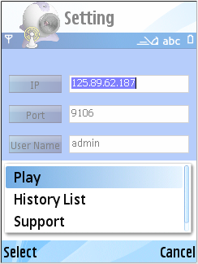
The history list's menu has OK and Delete(click the Ok after return to setting's interface, update a setup list's data at the same time, click the Delete record that you don't need:
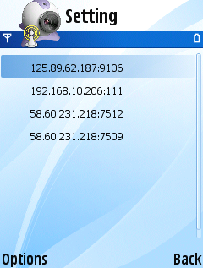
Select list's item, please click Options and click OK,you will watch your view that it needs(but must return Setting interface at frist time).

Delete a certain history list record
Pick out the record that to delete to open menu, select Delete that it can be deleted.
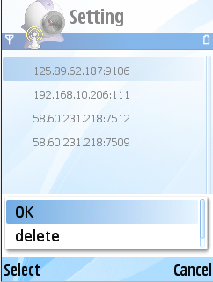
6）The video displays mode
Lengthways mode and full display
Displaying od lengthways and normal mode :
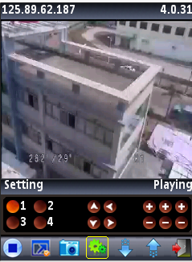
Dispaly of horizontal and normal mode：
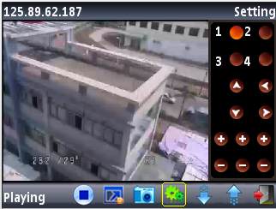

When the handle machine lays down horizontally will the automatic full dispaly.Or click
Full button.

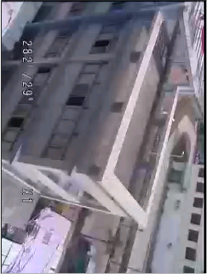
7）Change channel
Pick out homologous channel, the procedure will open homologous channel to play video.The procedure tacit approval is display 1~4 channel botton, when click Next group will cut over to 5~8, 8-12,12-16 cyclic change.

The DVR parameter that favors a cellular phone establishes's reference
Resolution:CIF or QCIF
Leads:5-10
The code flows a type:Limit
The code flows:64-256Kb/S
Note:Can accord to the cellular phone performance and the network condition.Higher cellular phone performance and network condition can display better effect.If the network condition is worse, can appropriately the step - down lead and assure fluency.

