Firefox ActiveX plugin instruction(latest version)

Because the former Firefox ActiveX plugin which is ie_tab-1.5.20090525 is not compatible with the last versions of firefox such as Firefox 3.6.12. we suggest the other plugin which is ie_tab_plus-1.95.20100930-fx+sm.xpi .
1. Open the Firefox, and drag the plugin file to the Firefox window directly ,and the Firefox will popup a dialog:
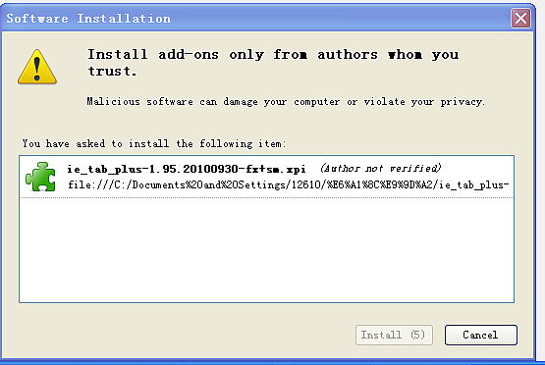
Click “Install Now ”for start install.after installation, it will ask for restart Firefox..

2. when you restart the Firefox ,you can choose Tools—Add-ons to check if you have install the plugin.
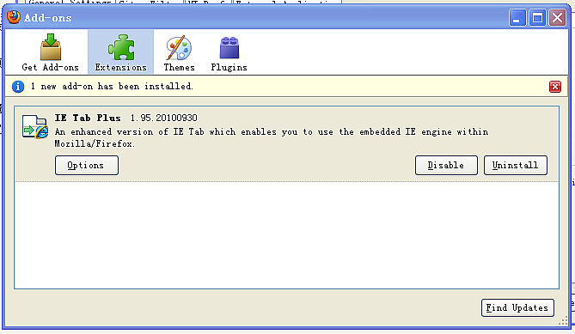
3. After installation, we need to add our target address to IE Tab before we start to access DVR web client. At the sametimes , you need to select IE Tab plus Mode.
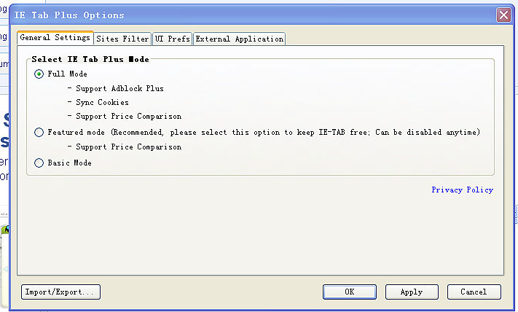
As here, my dvr address is http://10.15.5.127, so the type”http:.//10.15.5.127/* ”to the URL option.
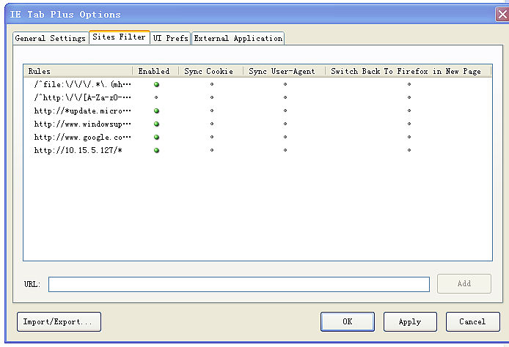
Setup completed, you can open the web of http://10.15.5.127 with the Fire fox .
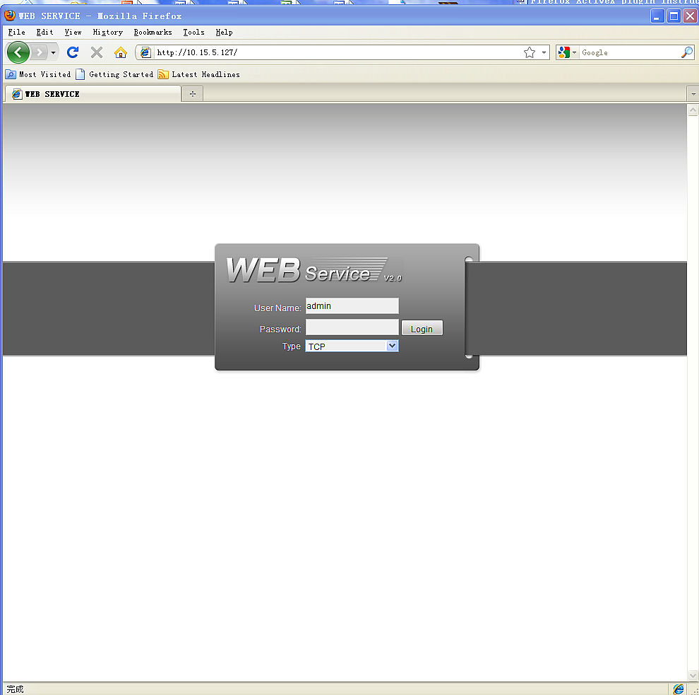
Noted :
IF you have done the follows above and you still can not open the web normally , you need to check the setting in IE to enable downloading the ActiveX..
