3G and WIFI operation manual

Now our device only support below 3G and WIFI modules:
Huawei 3G USB module
CDMA2000:EC1261/EC1262
WCDMA: E176G
TDS-CDMA：ET128
Ralink WIFI USB module RT3070

WIFI Step:
- Plug Ralink WIFI module to DVR USB port.
- Go to MainMenu->System->NetService->WIFI,click "Search",see below pic:
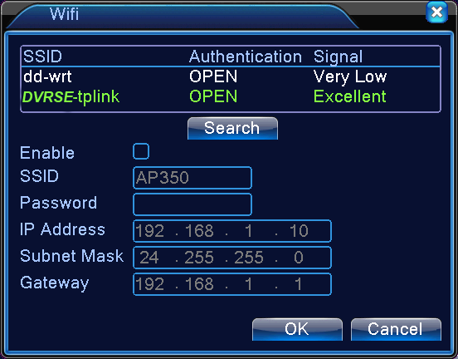

- Choose your WIFI network, for example DVRSE-tplink, then set WIFI IP address,see below pic:
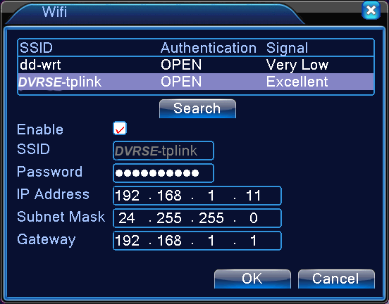
Pls note,WIFI IP address shoule be different with DVR IP address.

- Use IE or CMS to visit WIFI IP address 192.168.1.11
===================================================================

3G Step

- Plug 3G USB modem to the DVR USB port
- Go to MainMenu->System->NetService->Wireless Config,see below pic
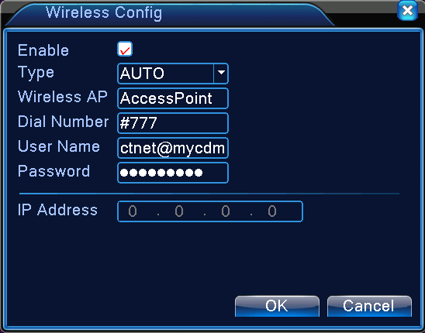
- Choose correct 3G network and fill access point,dial number,user name and password,for example Huawei E176G 3G USB modem,then click "OK",see below pic.
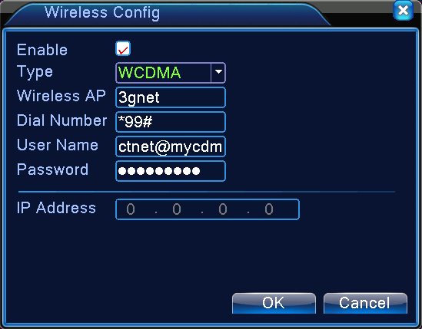
- Restart.
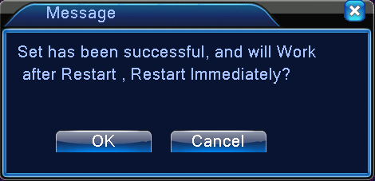

4. After restart,then go to MainMenu->System->NetService->Wireless Config,then it will appear 3G IP address(172.18.234.62),see below pic
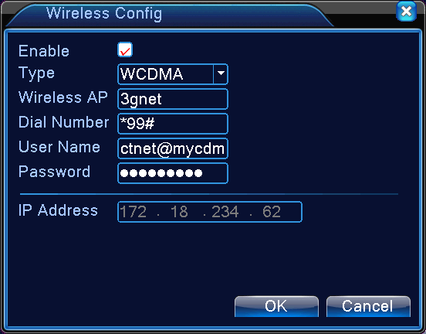

5. At last,just use IE or CMS to visit the 3G IP address,172.18.234.62

