DECODER USER MANUAL
Step 1: Rightclick to choose Netservice when preview,see below pic:

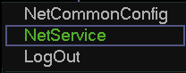
Pic 1
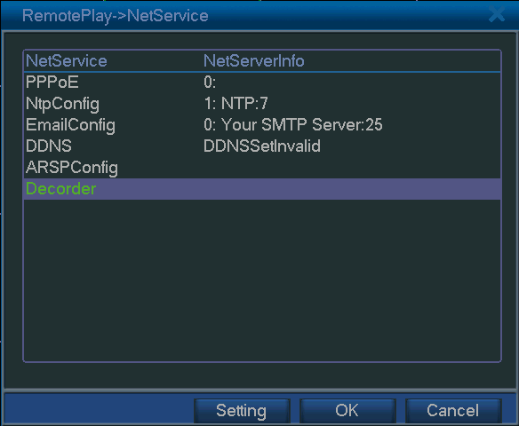
Pic 2
Step 2: Double "Decoder" to go into decoder setting,see below pic:
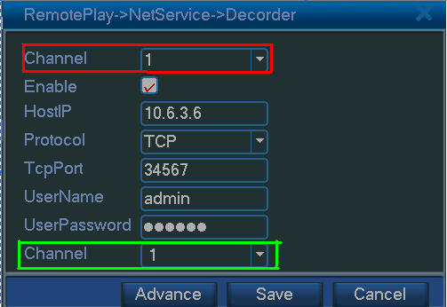
Pic 3
Channel(in red frame): channel number of decoder
Enable: enable the decoder function
HostIP: IP address of the device which you want to decode,both WAN and LAN are OK
TCP: TCP port of the device which you want to decode
User name: user name of the device which you want to decode
Password: password of the device which you want to decode
Channel: chanenl number of the device which you want to decode
After you set it,chick Save,see below Pic.
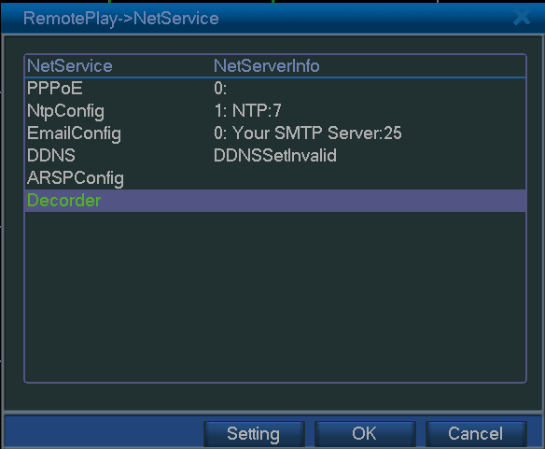
Pic 4
Step 3: In Pic 4,click OK to reboot the decoder,see below pic:
Note: Everytime you set the "decode" option, need to reboot the decoder to effect it.
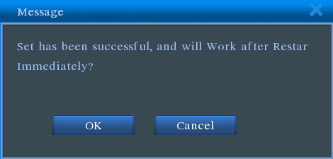
Pic 5

