UpgradeTool Operation Manual

1. To find UpgradeTool in the CD and install it,then run it,see below picture:



2.Click "IP Search",select the DVR's IP address and port,then click "Browse",see below pictures:

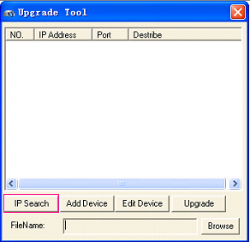

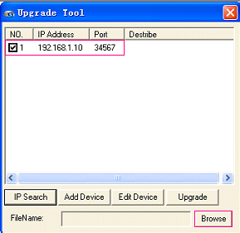

3.To Browse the Logo(bmp),see below pic:
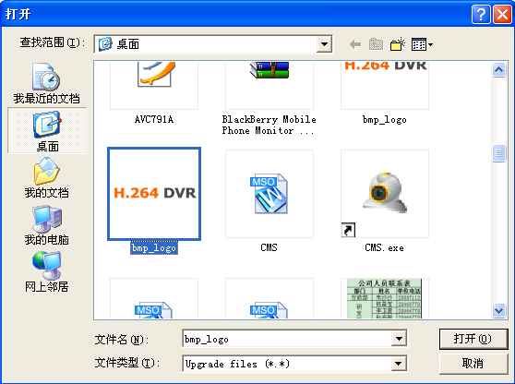

Then click "Upgrade",finally you will see Upgrade successful,at the same time the dvr is rebooting and you can see your LOGO now like below pictures:

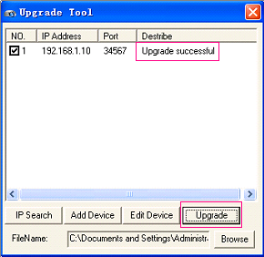

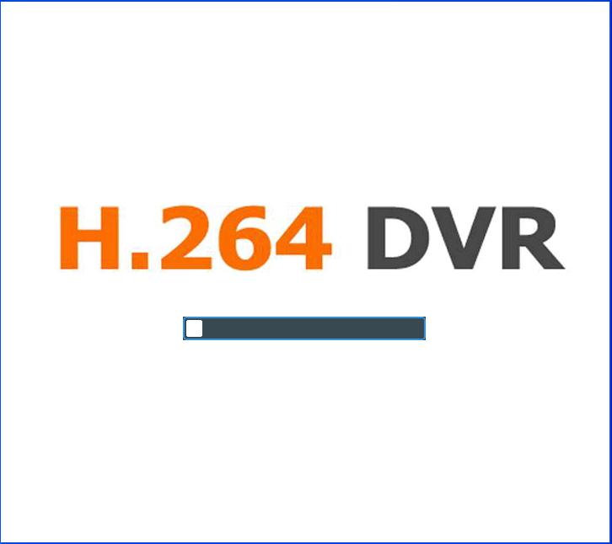

Pls Note: New version upgrade process is the same as Logo upgrade.

