AEeye User Manual
(For NVR 1.0)
- Enter NVR menu to Setting—>Network—>Management Platform—>Device ID—>Modify—>Device ID to enable it, then reboot NVR.
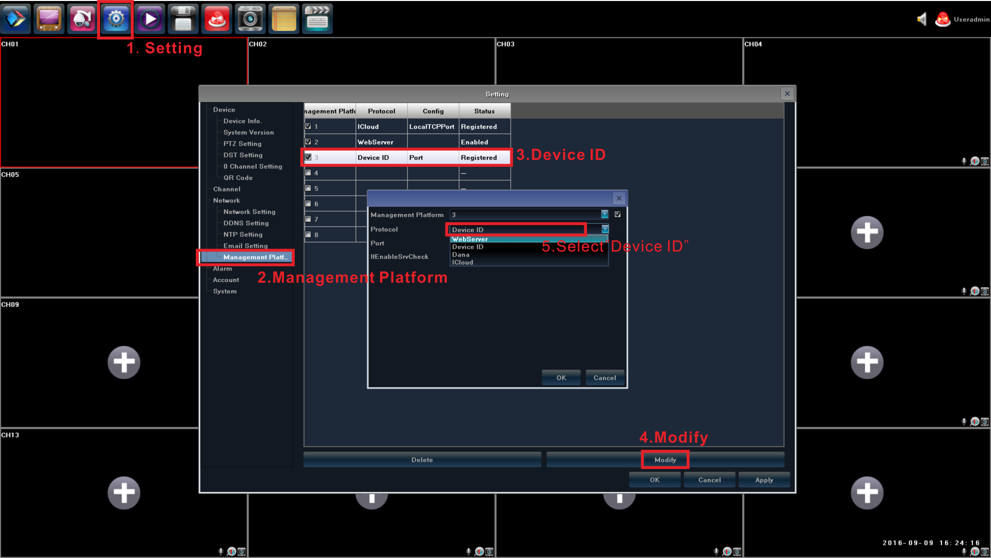
- Scan QC code to get download link for AEeye (NVR menu→Device→QR code→Device ID)
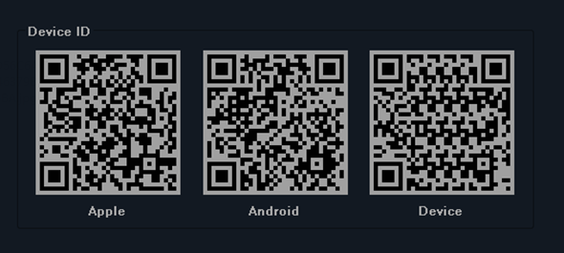
Device ID：Apple: AEeye iPhone download link
Android: AEeye Android download link
Device: After install AEeye, scan it to get NVR ID to connect

- Install AEeye successfully, open it and regist an account for login
- Login AEeye to add NVR/IPC for viewing, click menu button→Device Manager→
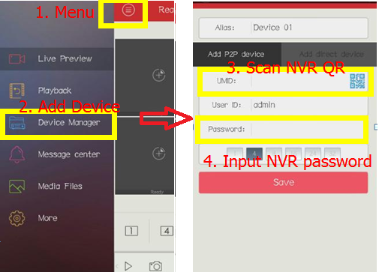
- After scan NVR QR code, it will add NVR channel automatically, then click save to finish device adding.
- Go back to Live Preview menu to watch the NVR/IPC image.
- In the bottom icons are: 1/4/9/16 are the current preview channel numbers. It below icons from left to right are Stop/Play, Capture, Recording, PTZ, HD Picture Switch, All Off/On, Microphone, Audio.

