1: about IP address basic knowledge
1.1 What is the IP address:
In the current network, the IP address is divided into public IP and private IP address. Public IP is in the Internet use IP address, and private IP address is in LAN using IP address.
1.2. What is private IP address
IP address is one kind of special, known as private IP address. Below we try to understand the private IP address.
Due to our current use of IP V4 agreement the limit, now the number of IP address is limited. So, it cannot be in each of the net for computer assigned a public IP. So, in the local area network of each computer can only use private IP address, such as our common 192.168.1. *, is private IP address.
Private IP address is a reserves the IP address. Just use in the local area network, in the Internet is not used.
1.3. Private IP address range are:
10.255.255.255 large networks 10.0.0.0-use
172.16.0.0-172.31.255.255 medium used in network
192.168.0.0-192.168.255.255 small network in use
1.4. What is the IP address segment
IP address is four section of digits, for example, have a computer IP is 192.168.2.100, so 192 is the first paragraph number, 168 is the second paragraph 2 is the third paragraph number, number, 100 is the fourth period of Numbers. We mainly is to see the third paragraph, the third paragraph number is the number two, so 192.168.2.100 is 2 segment of the network IP address;
For another example
192.168.0.101 is 0 segment of the network IP address
192.168.1.101 is one segment of the network IP address
192.168.2.101 is 2 segment of the network IP address
192.168.3.101 is 3 segment of the network IP address

2 how to check the IP address of the computer
2.1 How to check your computer IP address, we with Windows XP?
As an example to explain，In computer desktop find My Network Places icon
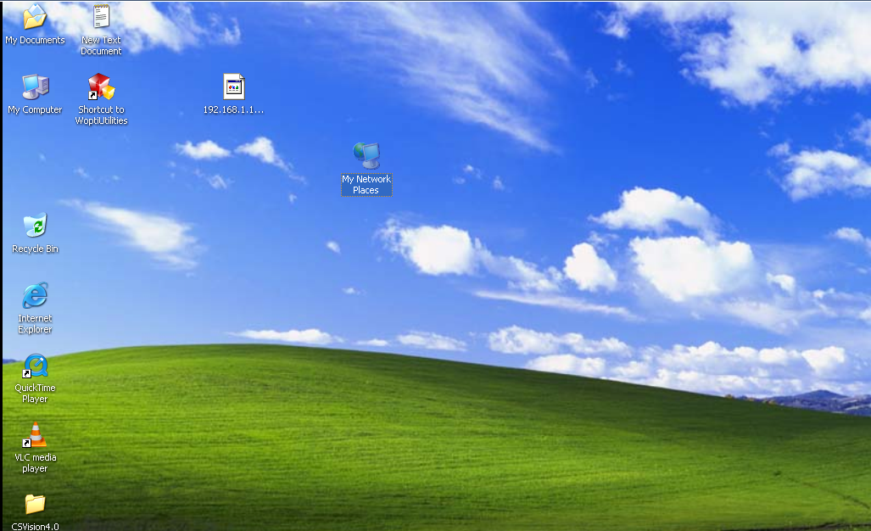

2.2 To My Network Places figure punctuation right point, as the chart Properties:
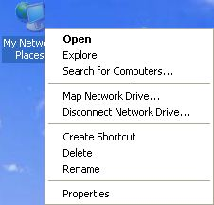

2.3 . Next to the window, to the Local Area Connection point right click on the point, as the chart: they

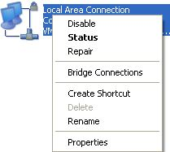
2. 4. In the following figure window, some teachers, as the chart:
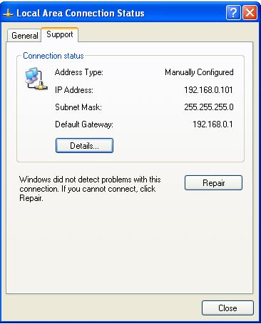

2.5. The chart the 192.168.0.101 is your computer IP
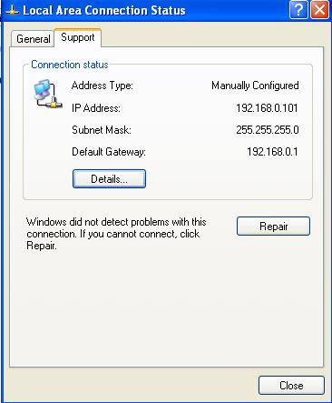

3 how computer IP address to a static IP address?
3.1Choice in this Properties
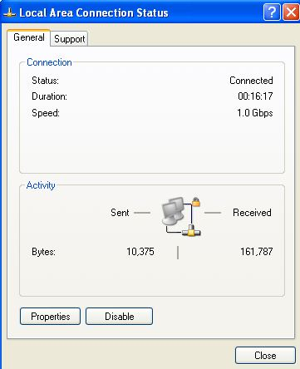
3.2 Choice in this TCP/IP Properties
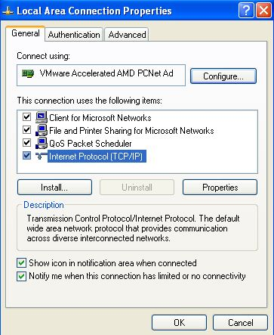
3.3 In the diagram, computer IP address can be set to a static IP address
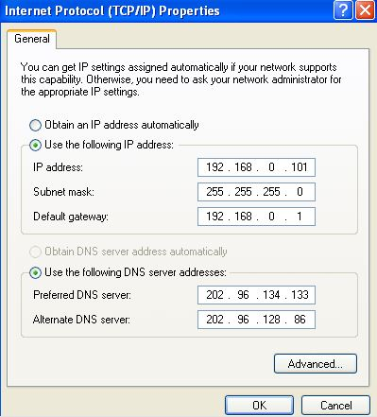
In the figure above shows that:
Computer IP address is 192.168.0.101, subnet mask (default) is the default gateway is 192.168.0.1, 255.255.255.0

4: small and medium-sized company network topology
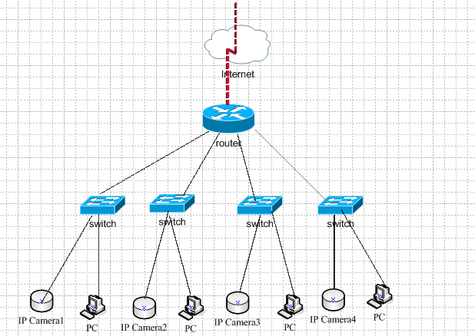

5: how to put our camera access to an existing network
5.1 first make sure we camera, and monitor the computer in the same physical network.
5.2 we each video cameras have a fixed IP address, with an interface, the router or switch up in Internet below.
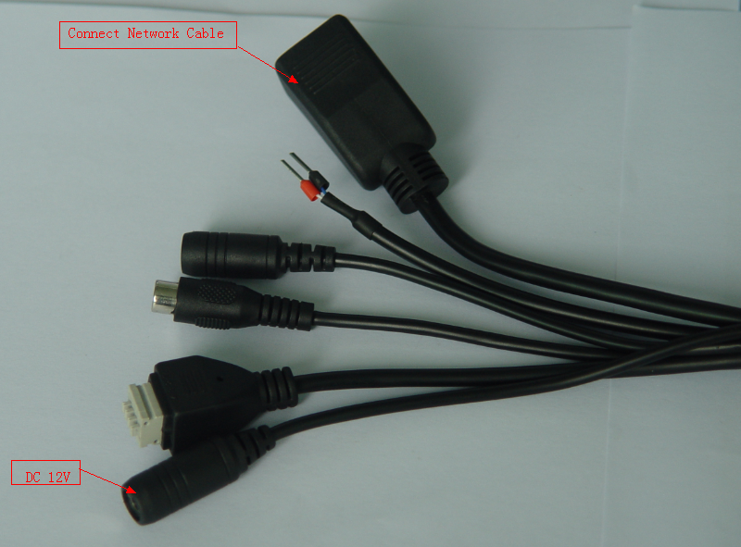
Note:
Say simply, if only to watch the connection, just need to take in the switch; they can be If need to remote watch, need to be taken up in router.

5.3. Modify the IP address of the camera, and ensure that the camera IP and monitoring in the same segment of the computer
Our every camera factory default IP address is 192.168.1.128, but its IP address can be modified. If your computer is not the monitoring and same segment, such as your network is 192.168.0. * 0 segment of the network is IP address, so need to modify our camera IP address, such as to 192.168.0.128, guarantee and monitoring in the same segment of the computer can.
Note: how to modify the camera IP address, the use of reference manual search the CD software (DeveceSearch) operation instruction handbook"

5.4. In computer Start menu in 6), input cmd
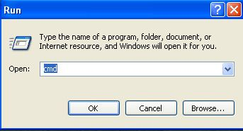

5. 5. In the picture, the ping192.168.0.128 this camera IP, if can the ping,-t is representative of has been the ping
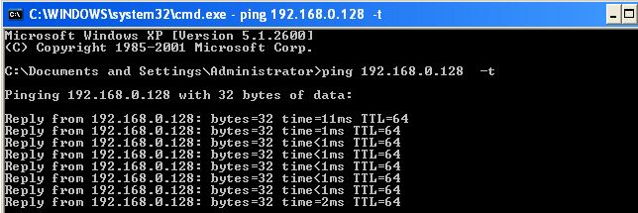

Note:
If or not, please check the ping an and crystal head has a problem, whether the proposal with new line and crystal head to test. The faster A solution is: will the computer set to static IP address, video cameras and computers even in the middle of the string, straight to use cross line, cross line is also is one end of the cable is 485 A, another head is 485 B, if not clear how do cross lines, to sell the place, an enterprise to buy A cross line.

