Camera Cotier various versions of the corresponding options

**Simple version**

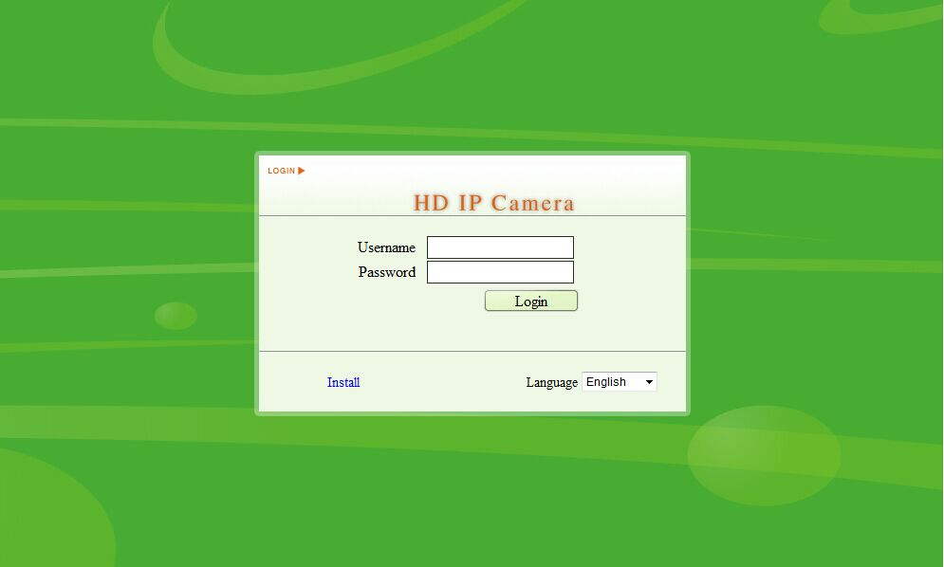IP address：192.168.0.123

username：admin

Initial password：123456

Correspond option：D/N/I 2014

**Plug and Play**

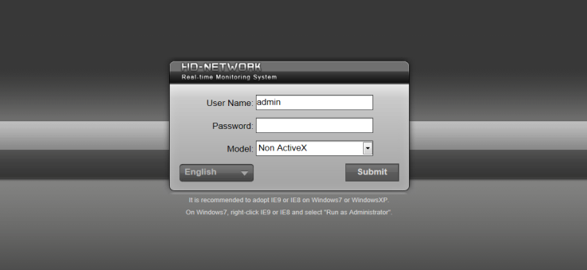IP address：192.168.1.189

username：admin

Initial password：

Correspond option：D/N/I 2014

**Full Function**

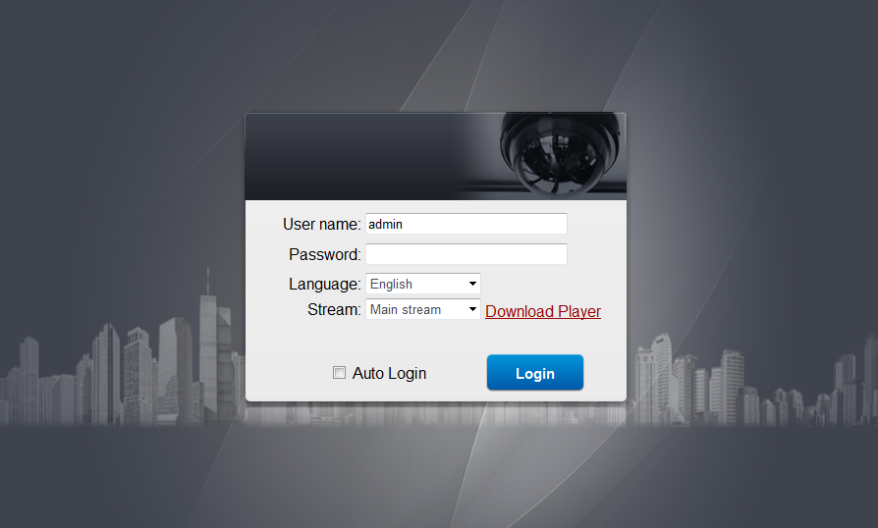

IP address：192.168.1.136

username：admin

Initial password：admin

Correspond option：IPC-III

**Autofocus**

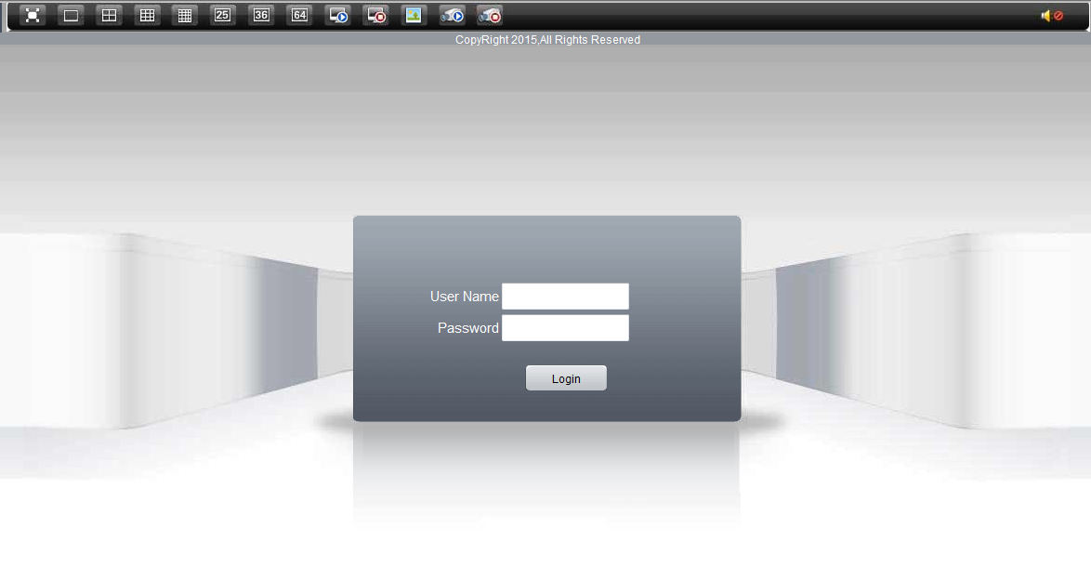IP address：192.168.1.10

username：admin

Initial password：

Correspond option：DVR-2011