Centralized Monitoring Management Platform

Manual

Contents
1. Products 5
1.1. Summary 5
1.2. Application Environment 5
1.3. Install and uninstall 6
2. Centralized Monitoring Management Platform Help 6
2.1. Software start 6
2.2. Login and Logoff System 6
2.3. Add Device 7
2.4.Main Interface Instruction 9
2.4.1.Image preview operation 11
2.4.2 Screen switch 13
2.4.3.Context menu 13
2.5. Remote operation PTZ 14
2.6. Image Management 15
2.7. System Setup 16
2.7.1 System Setup 16
2.7.2. Remote configuration 17
2.7.3. Remote Login settings 26
2.7.4. Electronic Map 27
2.7.5.Alarm relate setting 29
2.7.6. Alarm out 33
2.8. Recording Features 33
2.8.1. Open and close the video 33
2.8.2. Remote playback 35
2.8.3. Local playback 37
2.8.4. Record schedule 38
2.8.5. Set collective record 40
2.8.6. Switch video file by force 41
2.9. Advanced 43
2.9.1. Video group setup 43
2.9.2. Video group switch 44
2.9.3. Video cruise 44
2.9.4. TV Wall 44
2.9.5. Voice intercom 46
2.9.6. View log 50
2.9.7. See picture 51

1. Products

1.1. Summary
CMSVision is a large-scale network monitoring and management software, distributed network topology, and support for streaming media transmitted directly connected to the network server front-end Video Capture:
1, and highly scalable, according to customer demands to expand their control, a control point is a centralized monitoring and management platform.
2, in the user access control, streaming media transmitted adoption of a unified user access control, streaming media server user permissions check, directly connecting the server front-end video capture, video capture server-tested for competence.
3, focus on monitoring and management platform supports multi-screen images and preview images as round, as well as electronic map image preview and joint operation of the police function.
4, in the network to adopt the most advanced technology to complete port in the same network environment than the general quality of the TCP network transmission more efficient, but also support the break-even.
5, support on the market today mainstream board and the mainstream DVR-embedded DVR or DVS.
6, front-end support remote video capture server configuration, remote video capture playback front of a video file servers, remote-control video capture front-end server Haeundae or other related equipment.
7, regular support, as well as video and manual on the server front-end video capture video on mobile alarm linked in a document on video playback, the manner and time of the progress of search and playback in the process of positioning can be arbitrary time intervals operation arbitrary state support Quick Search simultaneously positioning, support cycle broadcast, video editing documents, local amplification and video files can be damaged due to brownout and automatic restoration capabilities.
8, TV wall function.
9, centralized monitoring and management platform in the front-end server records the alarm log, for real-time alarm log.
10, or between management platform to support management platform and front-end servers Video Capture speaking voice and voice broadcasting.

1.2. Application Environment
The configuration of the system requirements are as follows：
Hardware
CPU：P41.7GHz and above
Memory：256MB and above
Graphics：Geforce 4 64MB and above
Software
OS：Windows2000、Windows XP、windows2003
DX：DirectX8.1 and above
Disk Space
In order to ensure the normal operation of video, hard disk free space may not be less than 80 G.

1.3. Install and uninstall
Install and uninstall very simple installation package is a self-extracting file, double-click the mouse directly install icon will be notified by the successful installation. Uninstall program in the Start menu, the selection "Program" -> "Centralized Monitoring Management Platform" -> "Uninstall", will be able to swap unloading procedures.

2. Centralized Monitoring Management Platform Help

2.1. Software start
Direct operations in the installation directory under "CMS.exe" document will be launched on monitoring and management platform, or double-clicked desktop shortcut "CMS".

2.2. Login and Logoff System
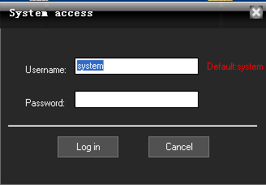
In the login dialog box, enter the administrator user name (the default is: system) and password, click on the OK button to start the system.
Click the button "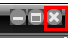" in the upper right corner of the main interface,Can pop-up confirmation
to exit the dialog box, click "Login" to exit.

。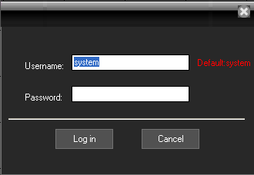
Click the button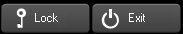"Exit" in the lower right corner, the pop-up "Exit System" dialog box, then click "Yes" button to exit.

2.3. Add Device
Device type: D/N/I 2013,DVR 2012,DVR 2011,DVR 2010 etc. D/N/I 2013(D means DVR, N means NVR, I means IPC) can automatically be searched and added.：
Enter the main interface, click on the device list area; or go to menu->System Setup->Device Management, then click 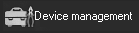, then you will see the pop-up Device Management dialog box, then click in the pop-up box to add device. Please check the following picture:
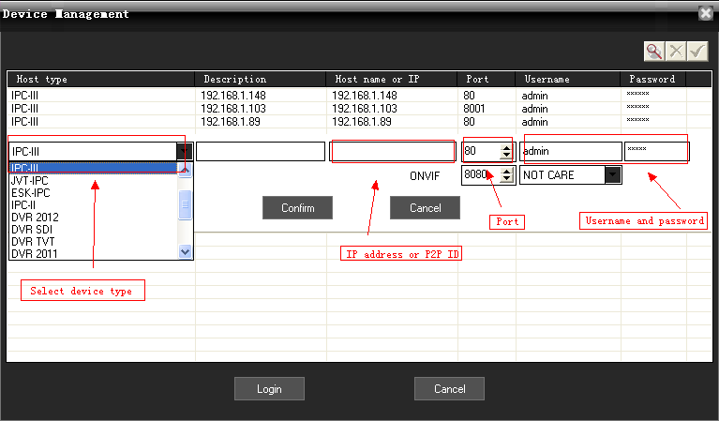

Or you can add the device by clicking . Type P2P ID in the host name, and 0 in the port, then it can connect by P2P. Please check the below picture:

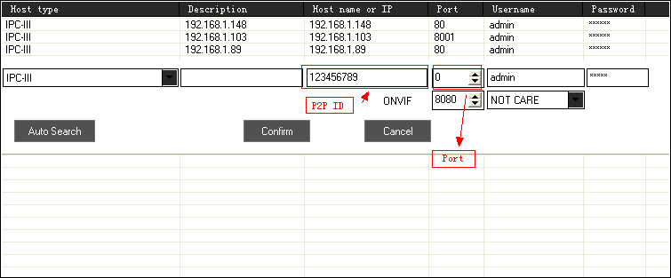
Please note:you must choose the corresponding type in host type, self-define the description, type the IP address, domain or P2P ID in host name or IP, and write CMD port of device or 0 if by P2P. The user name and the password are the same as that of the device.

2.4.Main Interface Instruction
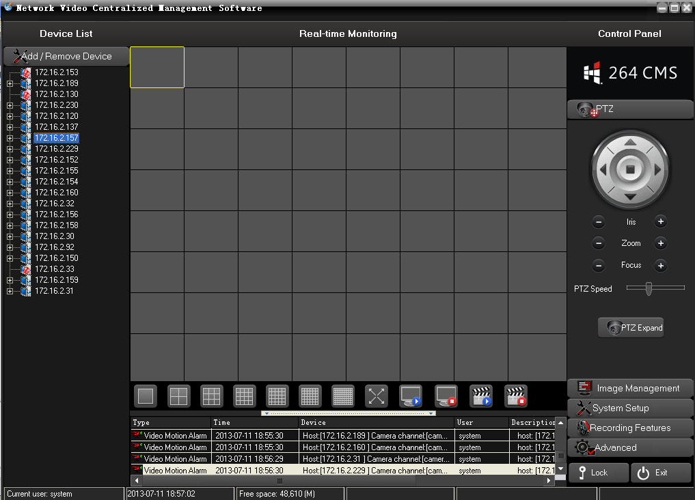

At the right of the main interface is the main menu area (ie. Control Panel area).
At the center of the main interface is the Real-time monitoring area.
At the left of the main interface is Device List area.
At the lower part is real-time alarm information display area.
Between the Real-time monitoring area and the real-time alarm information display area is the Split-screen display area.

Menu Structure
No. | First-level menu | Second-level menu | Third-level menu | Function introduction
1 | preview |  |  | Click the corresponding button to select preview mode. Tour the preview channels, switch among channels or snapshot live picture.Close / open live preview.
2 | PTZ |  |  | Move the PTZ toward up, down, right, left by the control panel; adjust the step,zoom,focus,iris of PTZ; set the preset and cruise path; when turn on the cruise function, the PTZ will move according the preset cruise path.
3 | Image management |  |  | Set brightness, contrast, saturation, hue
4 | System setup | Local setup | System setup | Select video storage, video streams; setup start-up OS and pack record.
4 | System setup | Local setup | User management | Add, delete, and manage the users; setup user name, password and authority
4 | System setup | Remote config | Device config | Setup the device configuration in remote, and keep the setup in local DVR.
4 | System setup | Device management | Add device  Revise device  Delete device | Add device; revise the host name, host IP, the user name and password; and delete device
4 | System setup | E-map | Pop-up E-map | Users can add or delete cameras in the simulate map and setup E-map alarm.
4 | System setup | E-map | Alarm relate E-map | If an alarm event occurs, and the alarm points have been added to the E-map, the map will pop up and flash the corresponding alarm device icon, double-click the icon to open the corresponding video.
4 | System setup | Alarm relate setup | Task | Alarm relate enlarge the window and start recording
4 | System setup | Alarm relate setup | schedule | The schedule setup of the alarm relate
4 | System setup | Alarm output device | Short message | Need buy the message module device to send message while alarm
4 | System setup | Close alarm sound |  | Turn on/off the alarm sound
5 | Recording features | Start record |  | Select the corresponding channels or devices to start recording
5 | Recording features | Stop record |  | Select the corresponding channels or devices to stop recording
5 | Recording features | Remote playback |  | Search the recording files from the remote device
5 | Recording features | Local playback |  | Search the recording files saved in the computer
5 | Recording features | Recording schedule |  | Set the recording time in the CMS
5 | Recording features | Set collective record |  | Set different DVR to record collectively
5 | Recording features | Switch video file |  | If the pack record time is 1 hour, and you need backup or check the recording files that is unpacked, then you can switch video files.
6 | advanced | Group setup |  | Combine or group any channels for cruise or group switch
6 | advanced | Switch group |  | switch the self-defined video group
6 | advanced | Video cruise |  | Set in group setup and automatically switch among the selected groups
6 | advanced | TV wall |  | Additional option,under development
6 | advanced | Voice intercom |  | The voice intercom among CMS
6 | advanced | View log |  | Search alarm,login, system operation, network log information
6 | advanced | See picture |  | Check the snapshot picture
6 | advanced | help |  | Users’ manual

2.4.1.Image preview operation
Right-Click on the device or any camera of the device in the Device List area, then select "Open Sub-stream" or "Open Main stream" menu, can realize the image preview function.

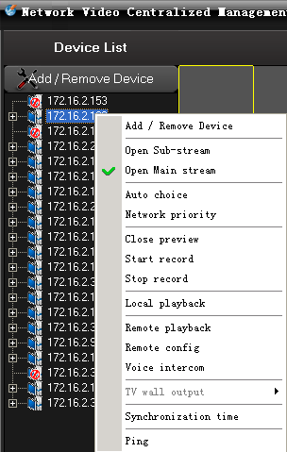
There are three ways to open Preview:
- Right-click menu "Open Preview."
- Rejection node to drag the video window on the left.
- Access nodes in the double-click.
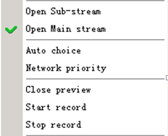
More than four menu items are selected based on the current node for the operation of the image, if selected node is the host, is that the main frame operating below all channels, if the selected channel is only the current channel operation If selected is the streaming media server, it is not gray with the state.

2.4.2 Screen switch
The area between video display area and alarm information display area is the screen switch area.
Click the left mouse button on the icon, can switch more split screen number.
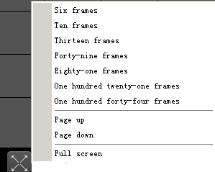
Choose a different split screen button can be switched screen number. "Page up" and "Page down" page and "Full screen"-provided function. (Hint: PageUp and PageDown can turn the pages)
Click the button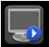can start all preview.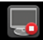stop all preview.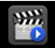start all record.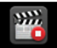stop all record.

2.4.3.Context menu

In the video display area, you can do the following operations by right-click the mouse:
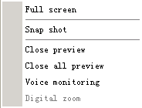
Close preview: close the video of the current channel
Close all preview: close the video of all the channels
Voice monitoring: to hear the voice from the live preview
Snapshot: snapshot the picture, and save in the computer. If the pictures are saved in the default folder, then you can check the pictures by going to menu->advanced->see picture
Full screen: full screen
Digital zoom: to zoom any area of video

2.5. Remote operation PTZ
Image window is selected as the current window, if the current window configurations are PTZ, the button was available state:
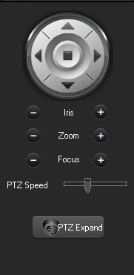
Click the completion of the operation of the same action. Then click of a button the pop-up dialog box, calling the corresponding preset points.
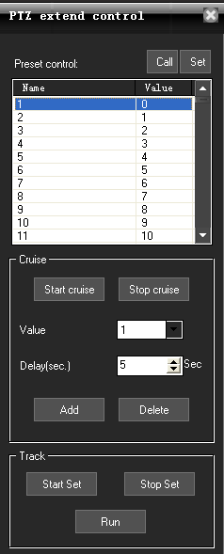

2.6. Image Management
Image window is selected as the current window, point operation "Image Management" button 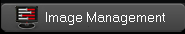or scroll bar can adjust image brightness and color, image and voice volume can be adjusted.

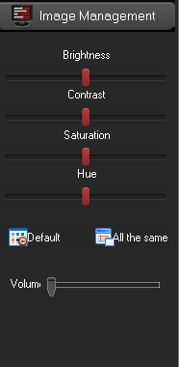

Note:
Click the "Default" button, all the configuration about image management will restore the default.
Click the "All same" button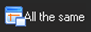, all of the other channels will be set to the same image display status as the current selected channel.

2.7. System Setup

2.7.1 System Setup
Go to menu->system setup->local setup, and pop-up the below window:
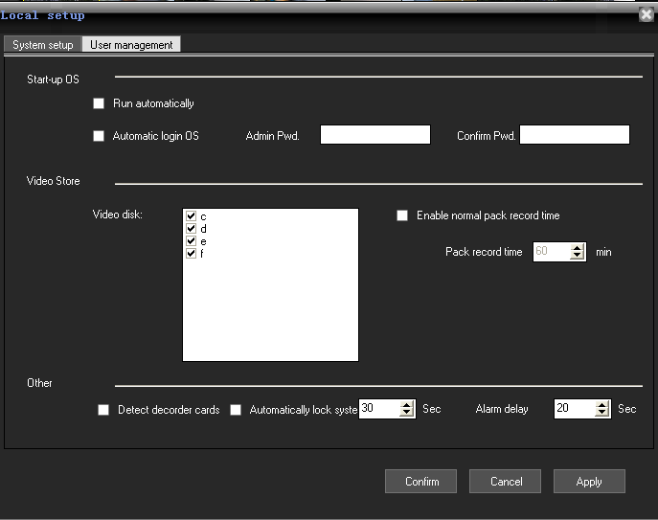

System setup: setup the system according to your habits or requirements
Please note: the system select main stream by default. If you select sub-stream, please restart the software.
User management:
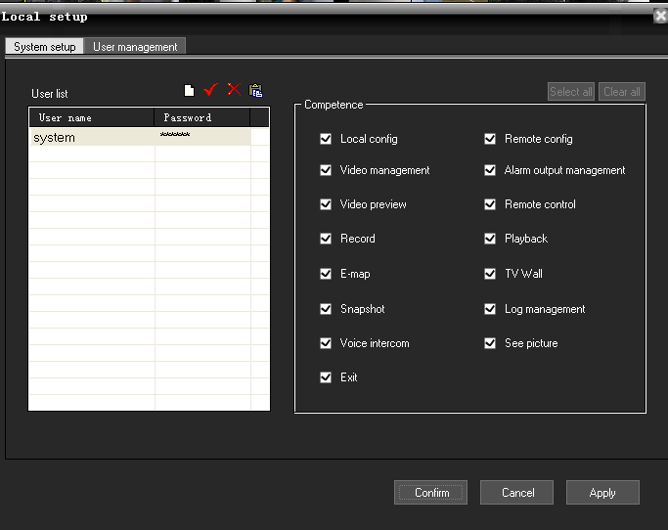

In the users management window, please click to add user, to revise the password, to delete users. The right is the authority that user could have. Only the advanced admin can assign the authority to the new users.

2.7.2. Remote configuration
In the "Device List" area to select a DVR, right-click, pop-up menu, select "Remote Config" menu
Or in the "Device List" area to select a DVR, then in the main menu, select the "System Setup"->"Remote config", click of a button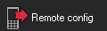, if it is embedded DVR or pop-up on the corresponding DVS brand Embedded Remote Configuration dialog.
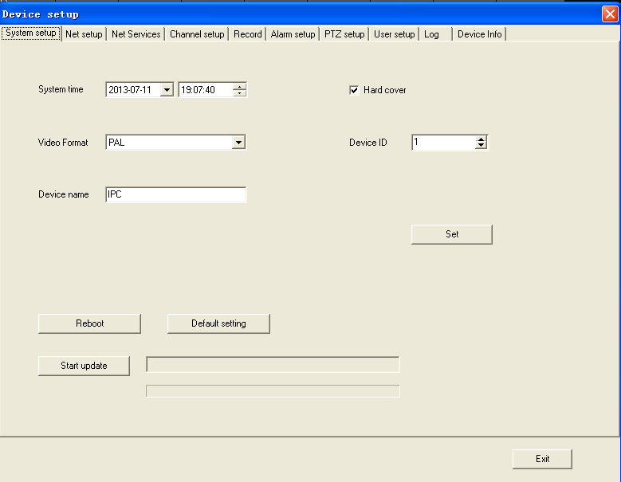
To configure and control the device by client software, select remote config and the device from the devices list.
A, system configuration. Set the basic information of device and update the device in remote. Please check the below picture:
B, network setup. Set IP, DNS and so on. Please check the detailed as below picture: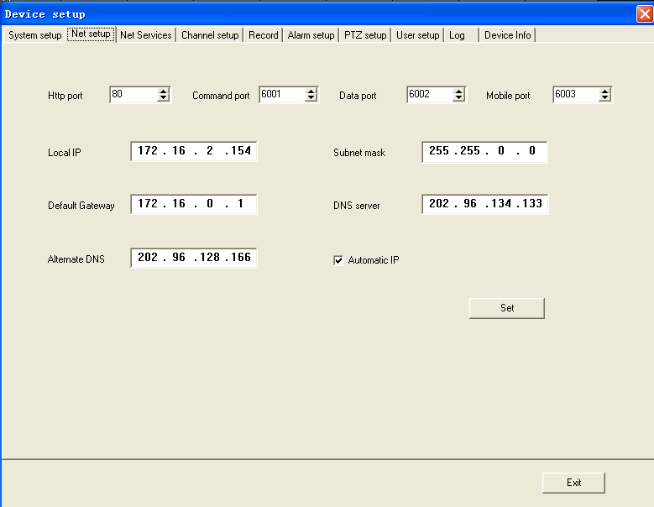
C, network service.set device to visit it by WAN and to send email.Please check the below picture:
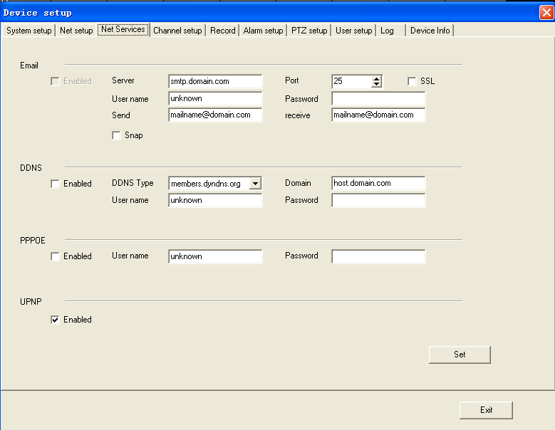
D, channel setup. Set the resolution, frame rate, bit rate and change the channel name.please check the details as the below picture:
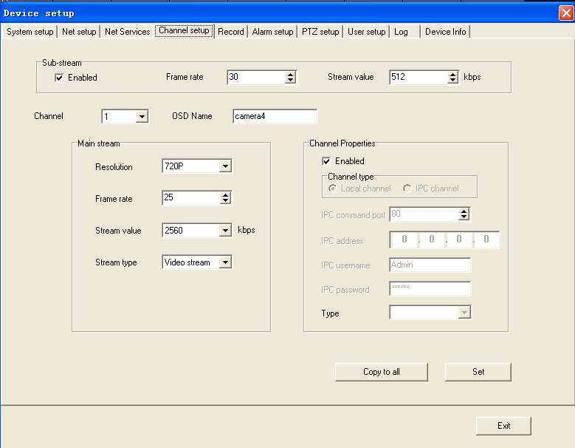
E, record setup. Set the record time, record type. Please check the below picture:
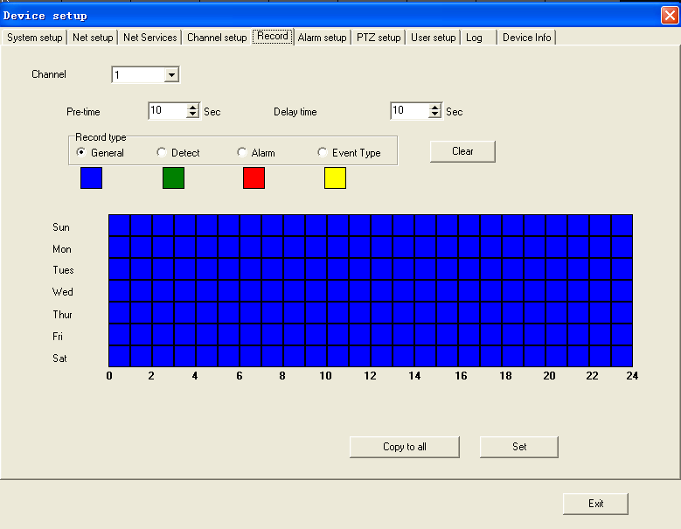
F, alarm setup. Set alarm relate when the corresponding alarm( motion detection, video lost, alarm input) is triggered. Please check the below picture:
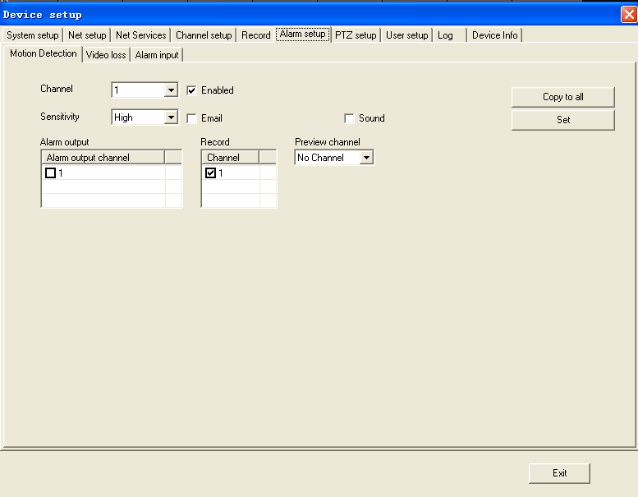
G, PTZ setup. Set the PTZ configuration to control PTZ. Please check the below picture:
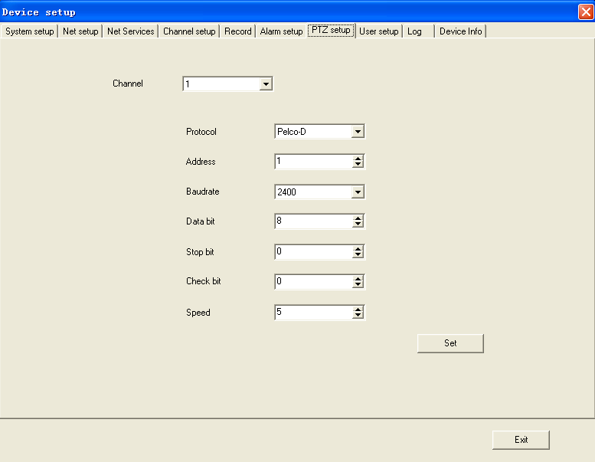
H, user setup. Add, delete, revise users and set the authority of the users. Please check the below picture:
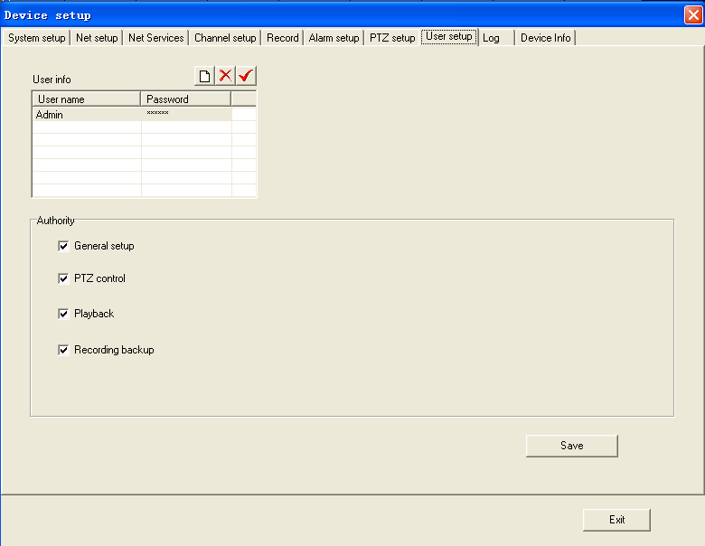
I, log. Search system log and alarm log. Set the date and click search, then you will see the below picture: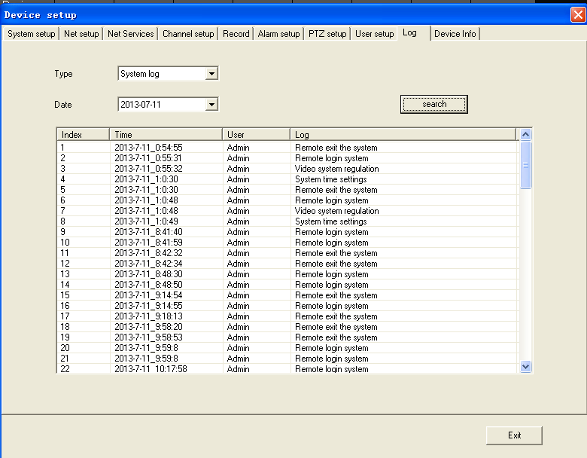
J, device info. Check the record channels, system version and other information. Please check the below picture.
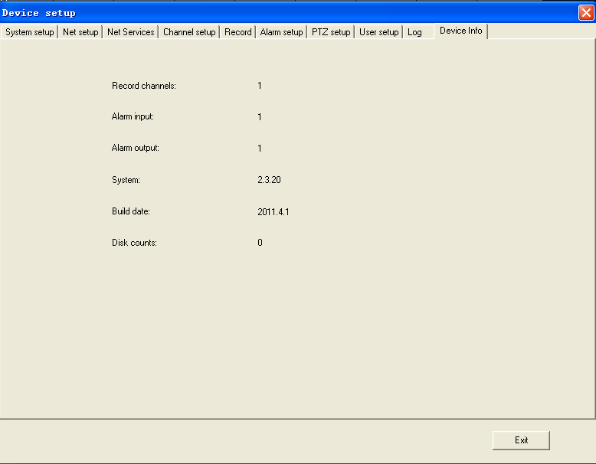

2.7.3. Remote Login settings

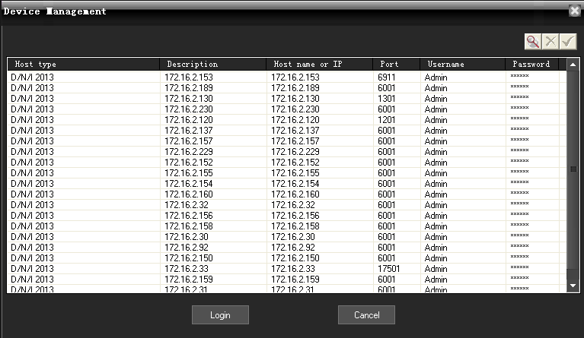

Click on the main menu "System Setup" menu,select "Device Management" menu, or right-clicked in the Device List area, select "Add / Remove Device", the pop-up Device Management dialog box.
1. Add device information: click of a buttonadd remote device information.
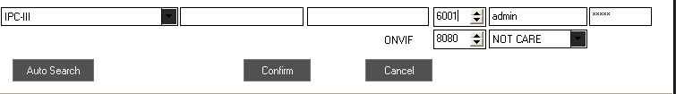

2. Delete device information: click of a button to delete the selected remote device information.
3. Modify device information: click of a button remote device information revision.

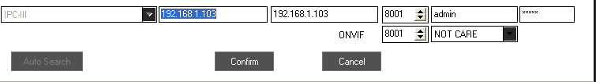

2.7.4. Electronic Map
Electronic map is a plan view of simulated field screen. In the electronic map, the user can add or delete the camera and set the E-map alarm in the corresponding position in the E-map. The electronic map intuitively show the location of each camera, and you can find the current monitoring page directly through the map .
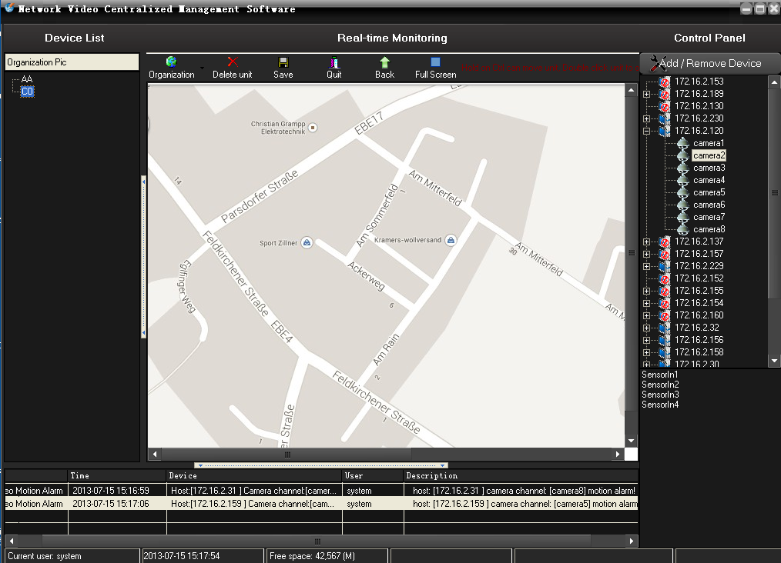
Click on the main menu to the "System Setup", then to the "E-map" menu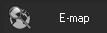, choose "pop-up electronic map" menu , can be hidden or pop-up electronic map.
- Installation of electronic map: click of a button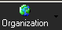, the pop-up menu configuration organizations can add, modify, delete organizational layers.
- Delete electronic equipment map: click of a button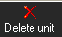 to delete the selected map icon equipment.
- The preservation of electronic map: click of a button 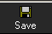preserve electronic maps installed.
- Withdraw from the electronic map: click of a button 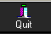hidden electronic map.

- Add electronic map equipment: Conventional operating area of the left side of the camera icon dragged on the map, the camera can be added to the map.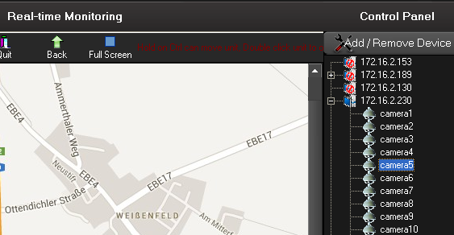

- Electronic maps equipment operators: Double-click electronic camera icon on the map, to open the camera image.
7、Electronic alarm linkage map: in the electronic map of the election or switching to an electronic map shows that, if the server front-end video acquisition occurred alarm, and the police point has been added to the electronic map, the map will pop up and flashing icon corresponding alarm equipment , double-click the icon to open the corresponding video.

2.7.5.Alarm relate setting
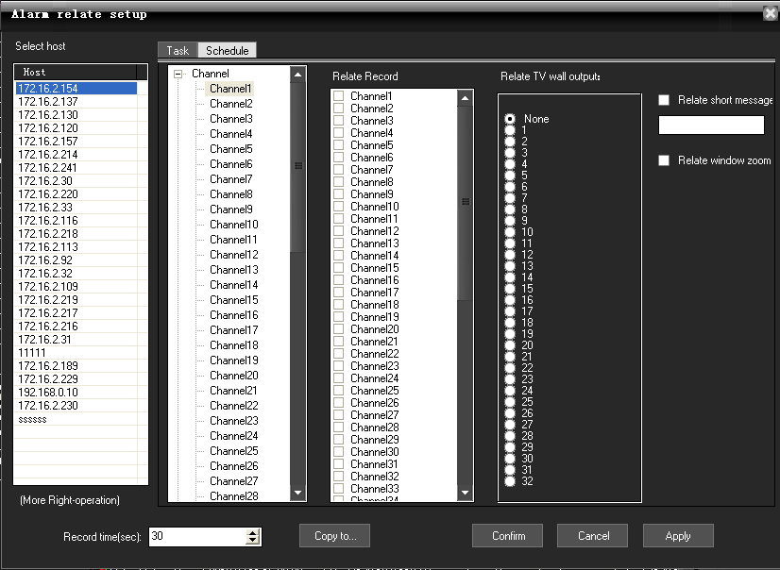
Click on the main menu "System Setup", select "Alarm relate setup" menu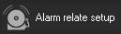, the pop-up "Alarm relate setup" dialog.
。
- cameras channel alarm linkage: Video Capture selected a server, right click, pop-up menu, choose "channel relate," the camera can be given for each video channel automatic alarm correlation can also manually set up video linkage, as long as check linkage channel video camera on the trip.
- Set up joint police sensor: a video capture selected server, right click, pop-up menu, select "sensor related", each probe can be automatically linked to the police video (such as: "sensor 1" connection "Camera 1" video), can also be manually set up joint video, as long as the check linkage channel video camera on the trip.
- Linkage video settings: Laws can be numerical.
- Copied to the other server: click of a button, the pop-up "copy to…" dialog box, check the server, click can be identified will be set up replication to other servers.
- Save Settings: Setting up good, click can be identified.

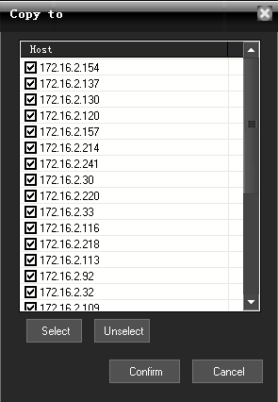

6, Click the above “schedule”, then you can make alarm relate recording schedule according to your time.
The buttoncan make the current day’s setting copy to all the other days of a week.
The buttoncan delete the current selected time section.
The buttoncan delete the current selected day’s time section.
The button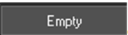can empty all the sections of a week
The buttoncan accurately set the time to seconds.
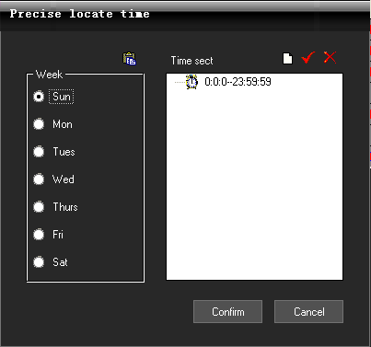
Click the button: Add Time section, enter into the precise position time interface as follows.
The button: Update Time section.
The button: Delete Time section.

2.7.6. Alarm out
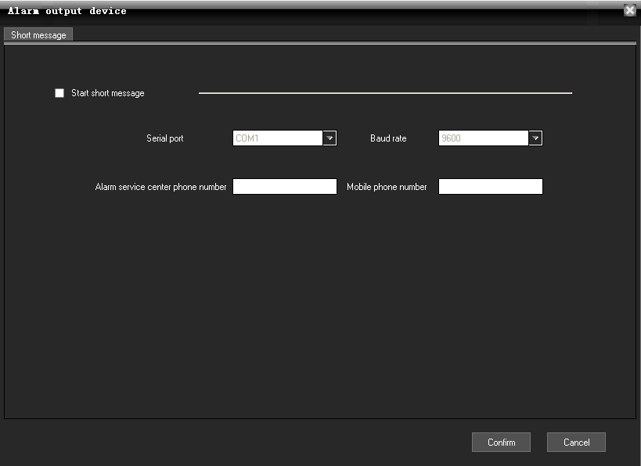
Go to main menu->system setup->alarm output device, or click 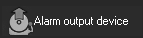, then it pop-up the window.
This is not enable by default. You can enable 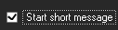 and write the serial port, bit rate, alarm service center phone number, mobile phone number. After setup, just click “confirm”

2.8. Recording Features

2.8.1. Open and close the video

In the "Device List" area, click the right mouse button, the pop-up menu, select "Start record" menu 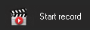launched on recording video, select "Stop record" menu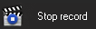 stop recording. If you choose the server, the server started all channel record, if you select the camera access, video channel started.
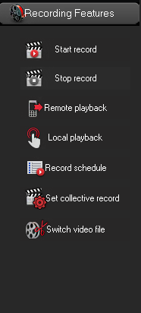

2.In the equipment list, equipment or channel nodes, right-click menu, choose "start video", can also open the local video.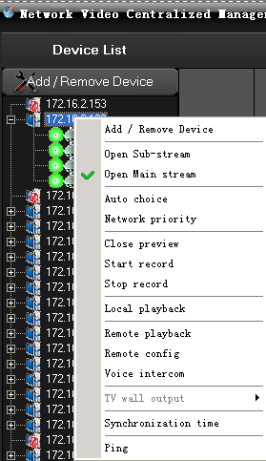
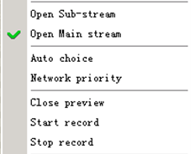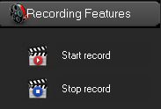
All the menu items above are based on the currently selected node for the operation of, if the selected node is host, all is operating under the corresponding host channel, if the selected channel is the only current channel operation, if the selected is streaming media server, is a state of gray is
not available。

2.8.2. Remote playback
In the "Device List" area, select a DVR, right-click, pop-up menu, select "Remote playback" menu or click of a button , if it is embedded DVR or DVS Embedded Remote playback on the pop-up interface, Embedded Remote playback supporting up to one screen , four screen ,nine screen ,sixteen screen playback, each frame of a camera corresponding channel.
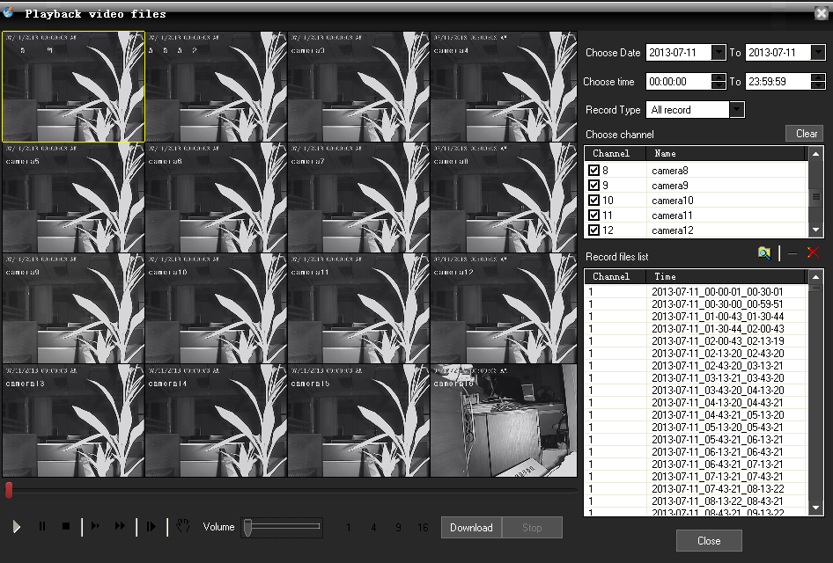

1、search records files: choose a date，select record types ，then check the cameras to channel playback
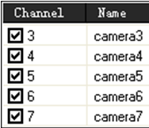，and click the buttonsearch video files, video documents show that in the list
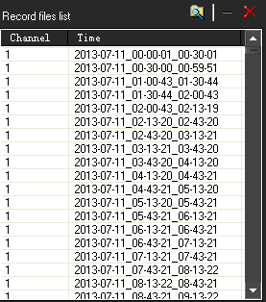，click of a button to delete the selected video files, and click clear video file list.
2. Playback video files: Double click in the list of documents or click of a button the records of players selected documents in the playback process click of a button, can be pause, stop, slow, fast forward, frame, capture picture , and other functions, drag image volume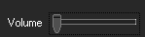 can be adjusted. ，when playing back, switch split screen number. Click, can download remote DVR record.

2.8.3. Local playback
In the "Device List" area, click the right mouse button, the pop-up menu, choose "Local playback" menus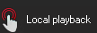, pop-up local playback interface.
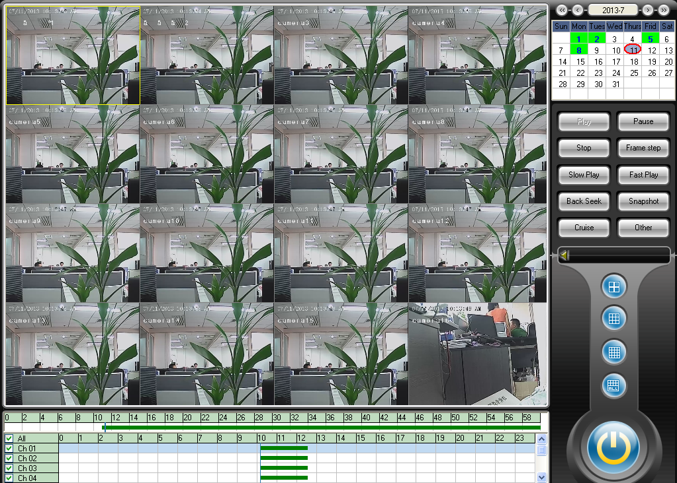

2.8.4. Record schedule
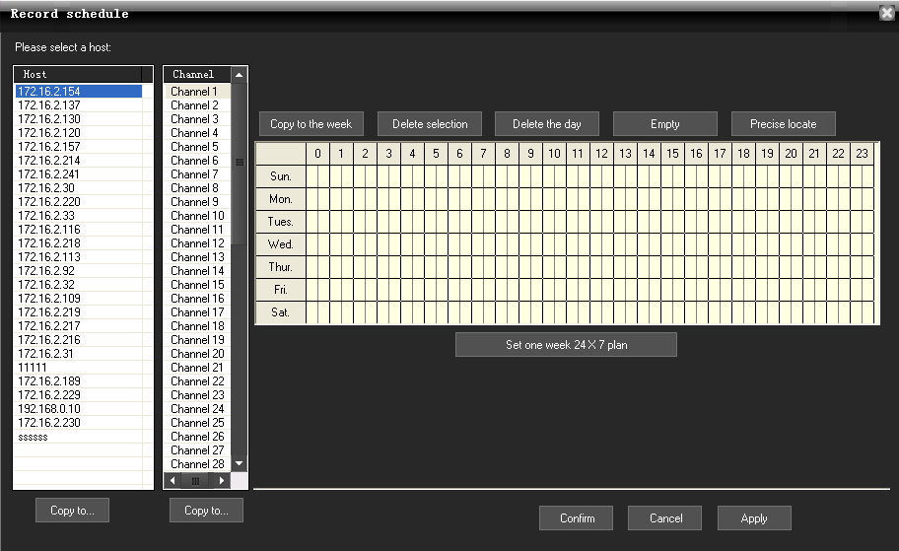

The buttoncan set continuous recording all the week.
The buttoncan make the current day’s setting copy to all the other days of a week.
The buttoncan delete the current selected time section.
The buttoncan delete the current selected day’s time section.
The buttoncan empty all the sections of a week
The buttoncan accurately set the time to seconds.

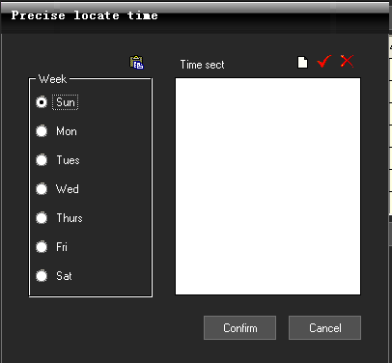

Click the button: Add Time section, enter into the precise position time interface as follows.
The button: Update Time section.
The button: Delete Time section.
If any other channels are the same recording time setting as the current channel, just need to click the button "Copy to…" 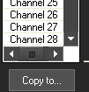 below the channel list, the pop-up dialog box.

button "Copy to…" 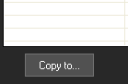 below the host list, the pop-up dialog box.

2.8.5. Set collective record
Set collective record
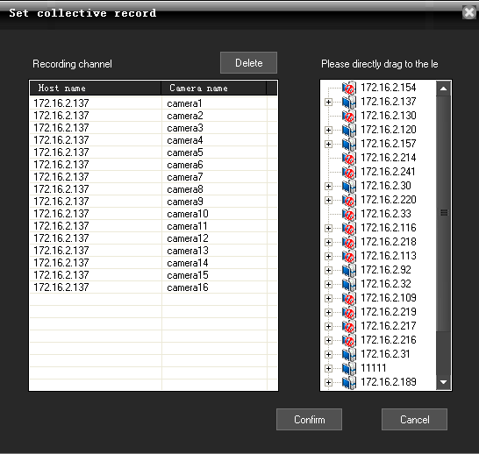

Click the Main menu ->"Recording Features" ->"Set collective record"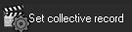, the pop-up "Set collective record" dialog box.

Select the host or some camera under host list, then directly drag to the left Camera list area. Click Confirm button. It needs to manually restart the software, the setting take effect.
Setting collect record function is used among the different channels of the multiple DVR to collect record and replay.
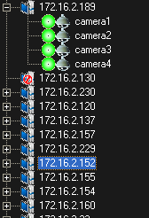

2.8.6. Switch video file by force
Click on the main menu "Recording Features", select "Forced to switch video file" menu
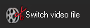, the pop-up following confirm dialog box.
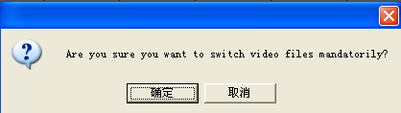
Click confirm button, all the recording video files will be packaged and then can be immediately replayed, although in the Local setup->System Setup, the Record time is 60 min. that is to say every 60 minutes, there will be one package in the Video Store area of the PC.
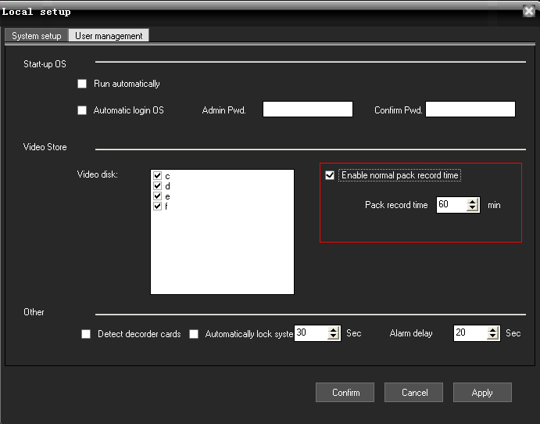

2.9. Advanced

2.9.1. Video group setup
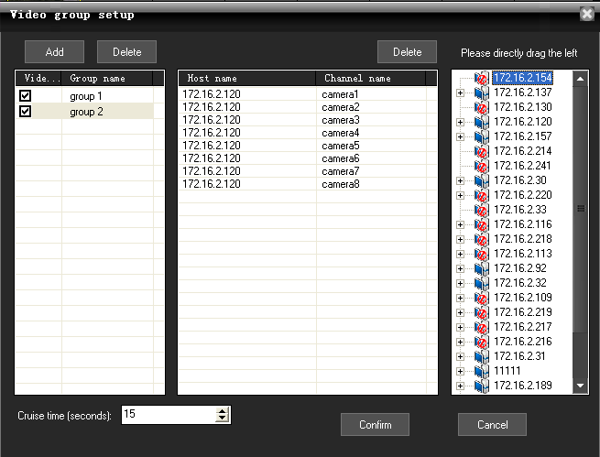
Click on the main menu "Advanced" menu, choose "Group setup" menu, the pop-up "Video Group Setup" dialog.
- Add video subgroups: adding video division click of a button.
- Delete video subgroups: click of a button to delete video division.
add video display images groups: the right camera icon will be dragged directly access the list can be added the camera channel.
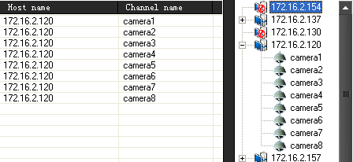
- Video settings as packet round: Amending the lower part of the value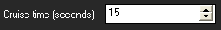, depending on time round can be set up, check the video to determine which groups will enter the round as group.
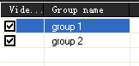

2.9.2. Video group switch
After setting multiple groups, multiple groups can be manually switched as follows:
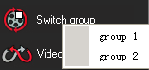
Select one group, then all the channels of the group will open preview in the Real-time monitoring area.

2.9.3. Video cruise
Click "Video cruise" button in the main menu "Advanced", then all the groups will poll and switch according to the cruise time. Every 15 seconds, the group will be switched to display, if set as follows.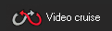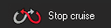

2.9.4. TV Wall
Click on Main Menu "Advanced" ->"TV wall", select "TV wall setup" menu, the pop-up "TV wall Output Settings" dialog.
Note: Decoder card must be installed or TV wall setup is disabled.
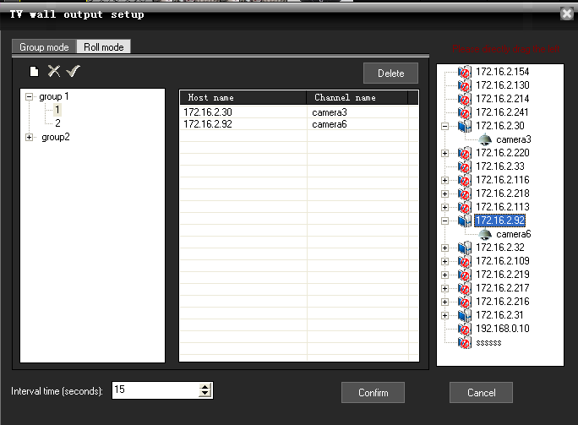
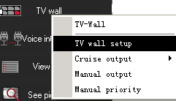
- TV wall set up sub-groups: the click of a button, add TV output wall grouped under the group name below actual output channel matrix card number automatically generated output channel list, the click of a button to delete the selected output sub-click of a button Laws selected output division title. Below is the output of each division wall TV output channel, a corresponding output channel.
- Television set output wall display images: the left side of the camera will be dragged directly on the camera can be selected for the television display output channel added output images. According to the output of each channel of the camera, and automatic segmentation images. The following chart output channel 1 added four camera images, when output to a television, the whole TV screen will be automatically divided into four images, showed that four camera images.
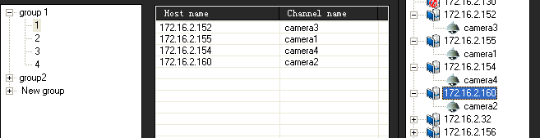

- Polling wall television set output: the lower part of the revised value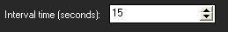 can be set by polling group output to the TV wall interval.
- TV wall output operation: the main menu click on the "TV wall", select "Round robin output" or "Manual output" menu, can be achieved by grouping polling output to a TV wall or manually select group output to a TV wall.
- If you do not want to continue to export images to TV wall at the main menu can "TV walls", select "Close output."

2.9.5. Voice intercom

2.9.5.1 Voice intercom (between CMS and DVR)
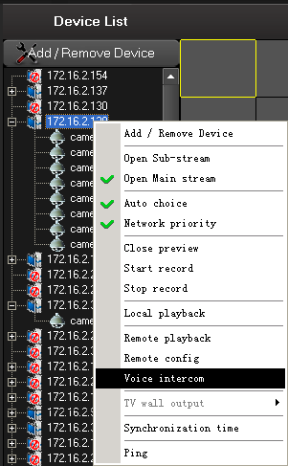

In the Device List area, right-clicked one device，select “Voice intercom”, the pop-up Network intercom dialog box as follows. 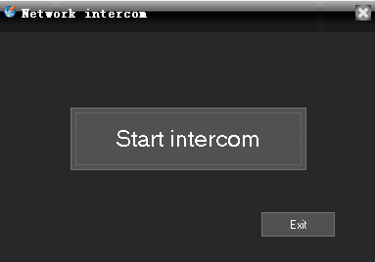
Click the “Start intercom” button to start chat.
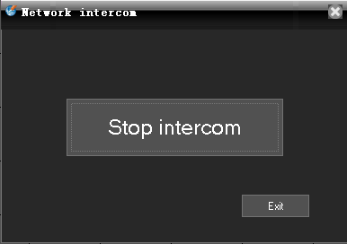

Click the “Stop intercom” button to stop chat.

2.9.5.2 Voice intercom (between CMS and CMS)
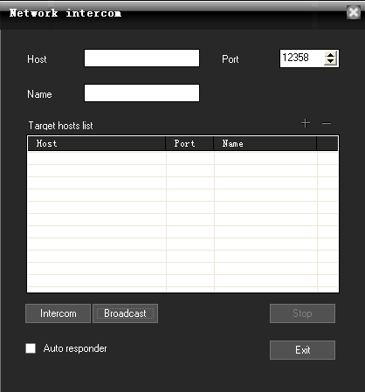
Go to main menu->advanced->voice intercom, then it pop-up the window.
1, set the host:
A, add the host:
First input the IP or domain of the host, then click, then the host is added

B, delete host:
Select a host, then click .
C, after enable , CMS directly start voice intercom without the pop-up request.
2, control voice intercom:
Select a host, then click to start voice intercom.
Click to stop voice intercom.

2.9.5.3 voice broadcast (between CMS and CMS)
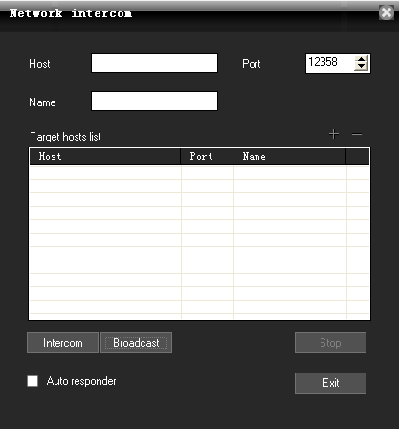
Go to main menu-> advanced-> voice intercom, then click in the pop-up window.

1, set broadcast target host. The same way as the voice intercom, and you can not set target host while broadcasting.
2, control broadcast:
Select a target host, then click to start broadcast.
Click to stop broadcast.

2.9.6. View log
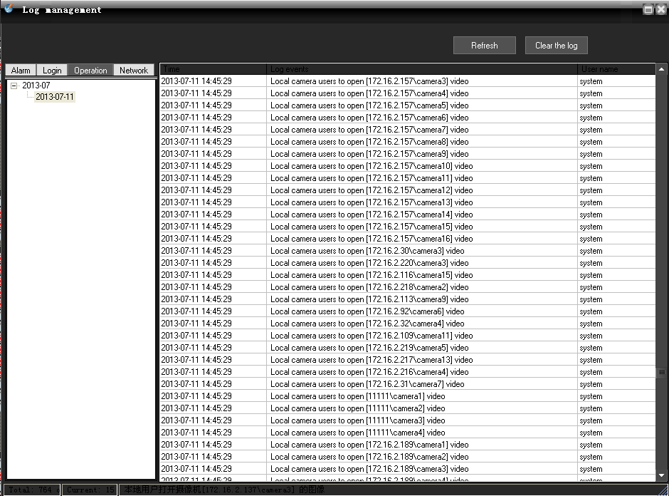
Click on the main menu "Advanced", select "View log" menu, the pop-up "Log management" dialog box.

2.9.7. See picture
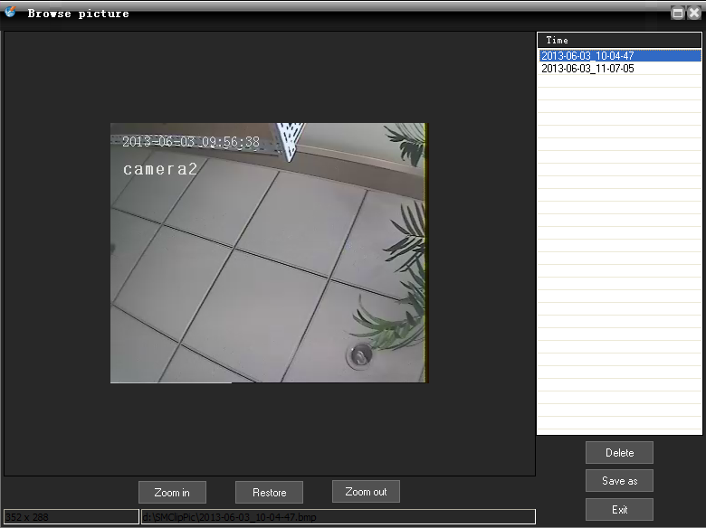
Click on the main menu "Advanced", select "See picture" menu , the pop-up plug dialog box.
Note: only can see the picture in the default snapshot path.

