Client software user manual
1．the introduction
1.1 the introduction
1.2 system requirements
Operating system：over window 2000
CPU：Inter Pentium 4 2.4G or higher
Memory：512M or more
Monitor : support 1024*768 and the higher resolution
Card : support directdraw to accelerate and opening.

1.3 convention
In order to the simplify describe in this manual ,will describe as following .
client software called software
DVR DVS called equipment
"Click" means to click the left mouse button
"double click"means to double click the left mouse button
"Right click" means to click the right mouse button

- software running
2.1 Running and login
2.11 Double-click The shortcut 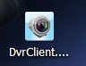 to run the software。
2.12 Login
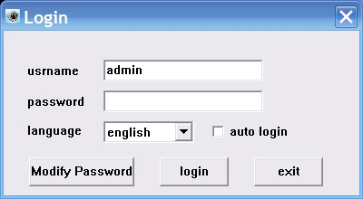

Choose the user name ,enter the password clink to enter the program. you can choose “automatically login,” so it will not appear on the window next time.
2.2 introduction of the Software interface
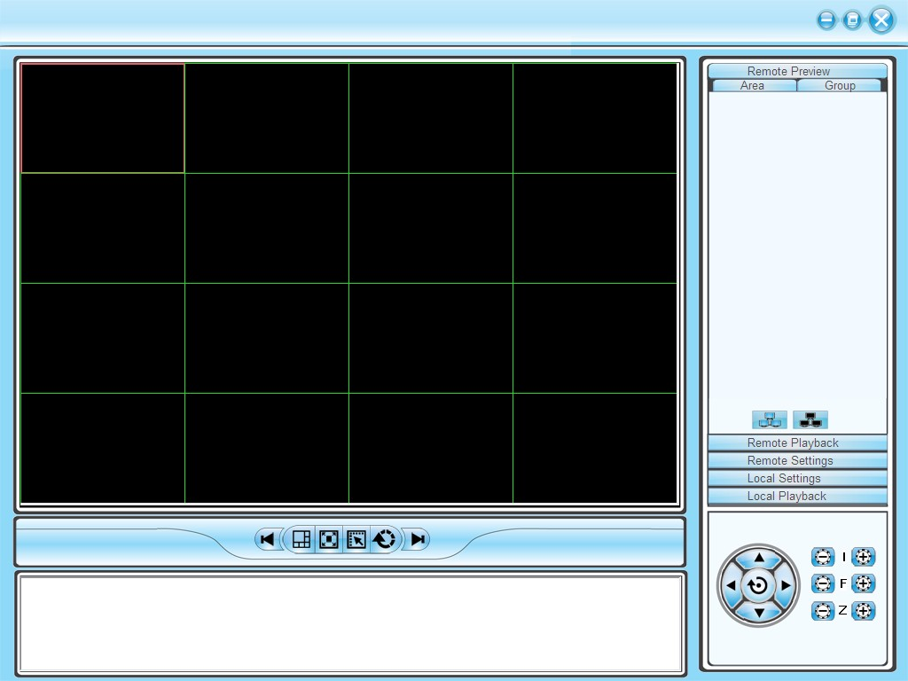
1
2
3
6
4
5

introduction of the Software interface
1) system and the button bar
Interface can be locked, minimize the window to the taskbar, close program operation。
2 )Tab bar
Contain the function of the different software models
Remote preview ：Real-time preview on the device
Remote playback :Local video playback and remote playback
Remote settings: Configuration setup
Local settings: user management,device management,system setup

3) device tree
Show each equipment and to add management group
4 )Preview Display Window
Real-time preview of the device channel
5 )PTZ control window
For PTZ control, adjust the picture
6 )Preview Control Bar
Preview control to stop, drawings, switching screen modes, full screen, rotation, etc.
3.Equipment Management
Before using the software to operate, need to add and configure the device operation. Click the tab bar "Configure" tab to enter configuration mode
Click on the left navigation bar set- "Device Manager" item to enter the device management interface.
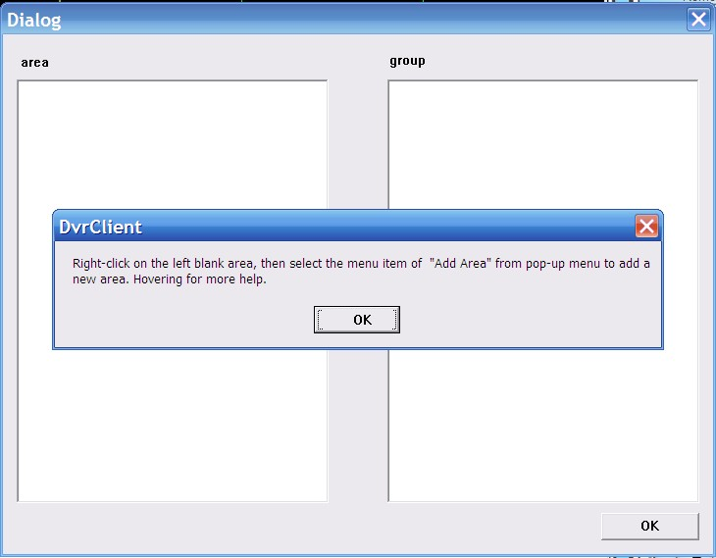
4.1 device tree configuration
When the initial run the software, the list defaults to an empty tree, right-click any blank space can be a list of trees to add area.

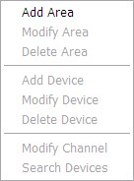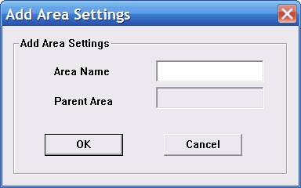

Fill in the name of the regional title bar and click OK you can add a tree to the list area, and because of this added area as the first area, there is no higher in the region area, the higher the regional name column blank.

Regional add is complete, right-click the regional nodes may choose to sub-region, add the operation of equipment

Right-click the Add area, pop-up a regional management menu.
Select "Add a sub-regional" sub-regions can be added.
Select "Delete area" will be removed in a selected state area.

Note: If you remove the region which contains other regions under, equipment or channels, then delete operation will not only delete the selected area, but will remove all of the regions under this region, equipment or channels; if the region is under the preview channel or Video will be given a warning.

3.1.1 Manually add the device
Right-click the Add area, pop-up regional management menu, select "Add Device."
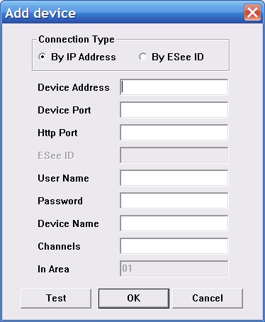
Options | Explain
device address | Device IP address or domain name
device port | device port number
http port | http port number
User name | Device’ Registered User name
User password | Device’ Registered User password
Device name | Add the device name it can be customized
channel | Device’ Channel number, please fill in the actual situation
In area | the name of the host region

click“test connection”to check if it could connect to the device
3.1.2 Search the LAN-line equipment
Right click In any regional / sub-regional, click the menu item in the search Device, search the same LAN-line equipment
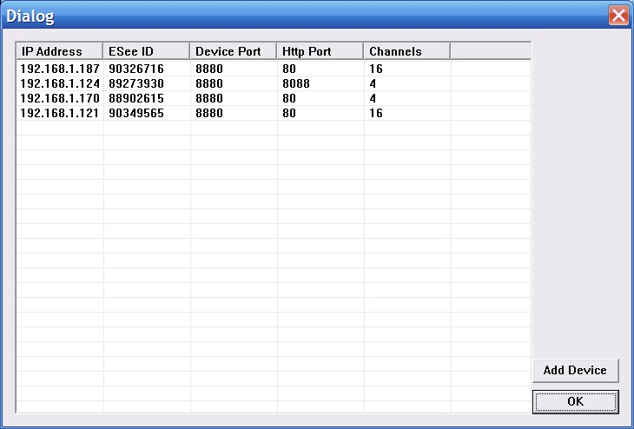

Choose one of them，click“add device”
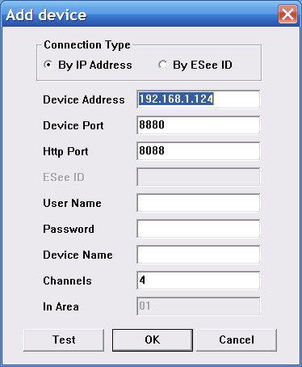

modify the device name in the device information menu so that the device name will be not same.
To fill the user name and password , click the test connection, after connect successful, choose "OK" to setup
Then continue to add other devices.

3.2 modify the device name
If the group did not contain any node in the tree, then to be add the node first
Right at the grouping column shows the space group management menu, click on "Add Group" item
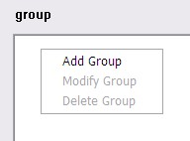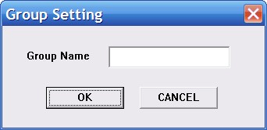
Enter a group name, click OK to add group.
Group added successfully, you can access the list in the tree node to the next selected group
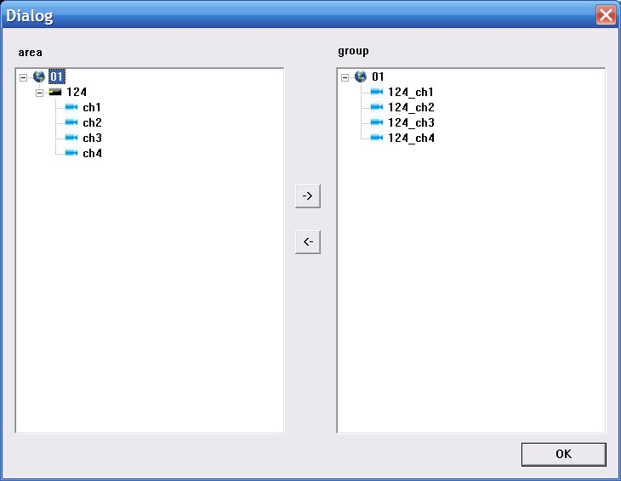

Select the channel list tree node, click "add" in the Device Configuration window to add the selected channel into the group tree
Group, the channel name will show in the form of "device name _ channel name" , after adding a channel successfully , list tree select the next channel of the device node automatically .
Select the device in list tree, click "add" in the Device Configuration window could add the all selected channel into the selected group. After a device successfully added all the channels, then select the next window select list of a device tree node.

Using the device configuration window button bar "Move" and "Down" buttons can be adjust the order of nodes under channel grouping.

Pitch up the Channels node in the grouping tree, click "delete" button in Device Configuration window to remove select the channel from the group. After removing the channel, the group tree will automatically select the next channel in the grouping.
Select the group node of group tree, click "delete" button in Device Configuration window will display the warning message dialog window. Click "OK" to delete all the channels node under the selected group.
Note: same channel couldn't be added in one group. But one channel can be added into different group

4.live video
4.1 general live mode
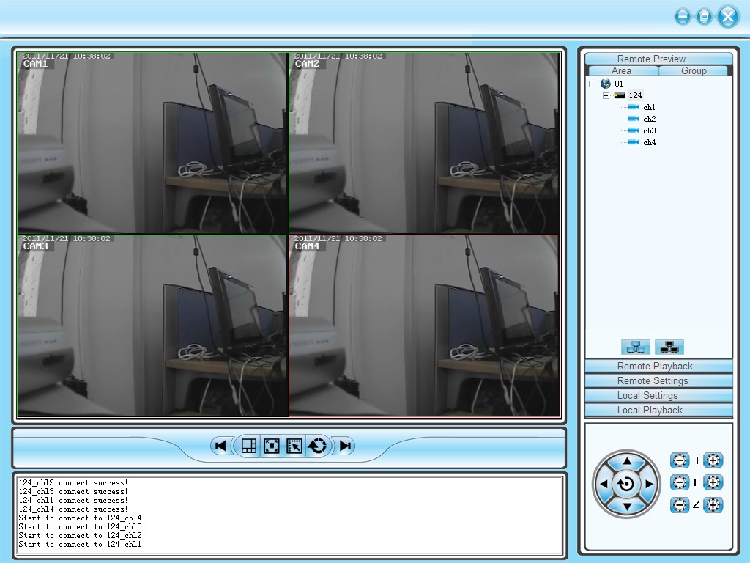
4.1.1 double click to start preview
Click a player window, the selected window frame will turn into light blue.
Double-click the device list or a grouped channel, the channel will be play in this window.

4.1.2 start /close all preview
Choose device and click right mouse to choose"open all device channel" for all open, and choose "close all device channel" for all close.

4.2 live sequence dwell
Click the switch for live sequence dwell, then begin to play.
Time can be set in the client local setting-system setting.
4.3 Other function
Double click to magnify: in the mode of multi image,double click playing window can magnify it and return after double click again
Picture mode:can be switch in multi picture.
Full screen: hide some part of item and set the play windowmaximize.
Last page,next page: show all remain window at present state. Total in 64 preview window, each time will show 1 page. Window quantity will according to the picture mode.
5.PTZ control
5.1 PTZ control:
Control the direction of rotation, speed, Iris, focus and zoom.ect miscellaneous function.

6. Record and playback
6.1 client local record
Client record:manual client record
In the preview window,click right mouse button to choose" start save video"and begin record.
Video save route can be modify in local setting-system setting
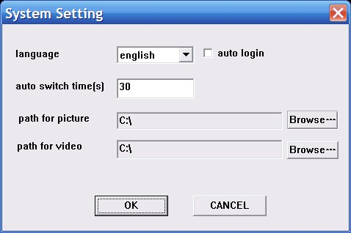
6.2 Remote playback
Click "remote playback" button can turn into remote playback interface.
6.2.1 remote video document search
To choose the needed search device in right equipment tree, and choose channel,record mode and starting time. click "search", the document will be there.
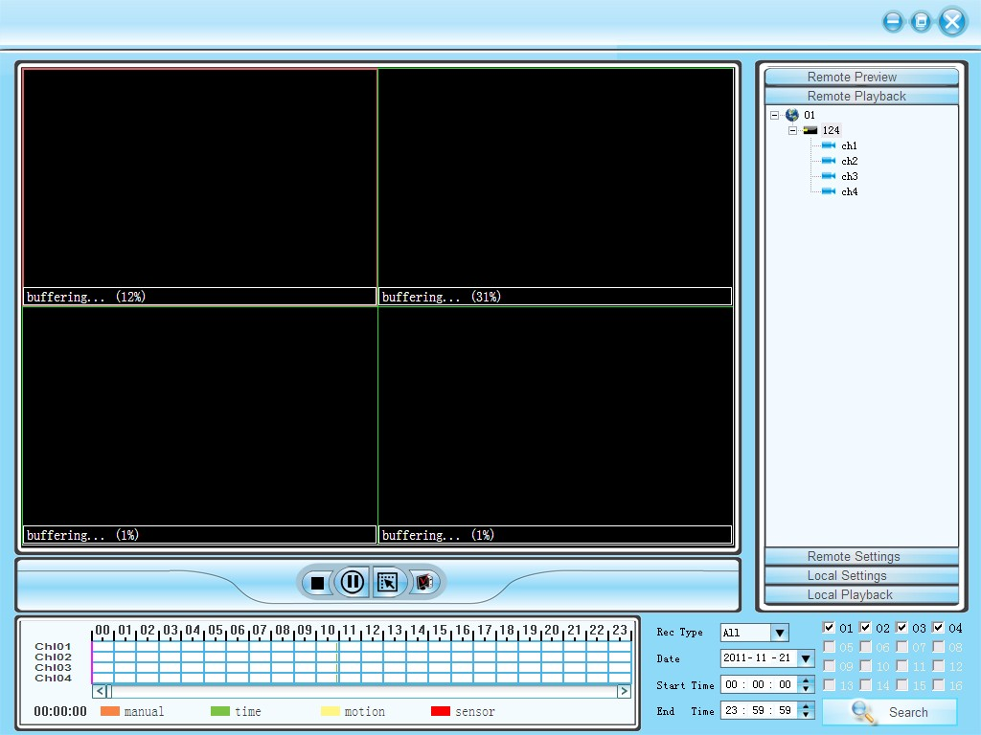
6.2.2 remote file playback
Video will be play automatically.,also ,it can be play in anytime point by dragging progress bar
Support 4channel playback in the same time.
6.2.3 screenshot
During playback, screenshot can be done to any window.click"screenshot" button.
Screenshot save route can be set in local setting-system setting.
6.2.4 Backup
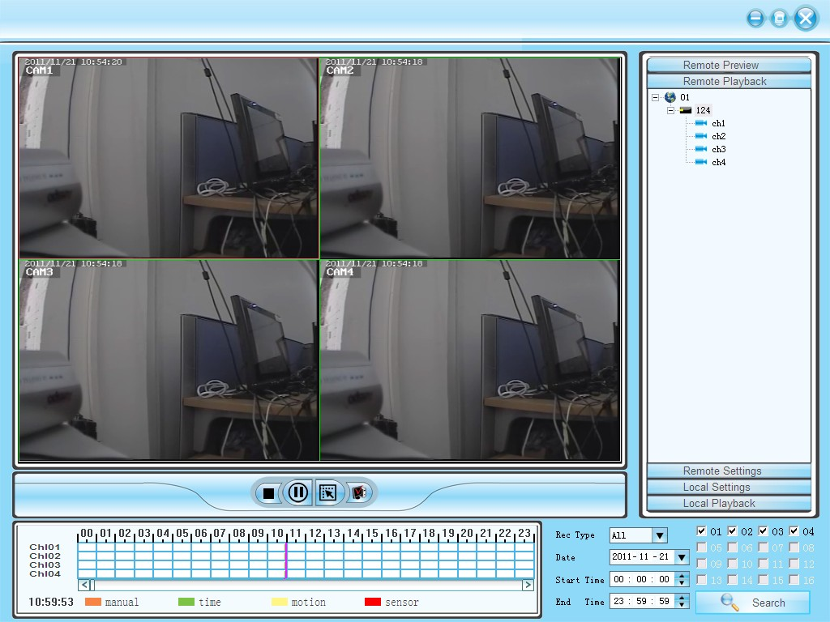
6.2.5 playback control
can drag,suspend and double click to magnify the picture for present playback.
7. remote setting
Click"remote setting" go into remote setting menu
Choose the device in the right side device tree, double click the device to go into setting interface.
7.1 system information setting
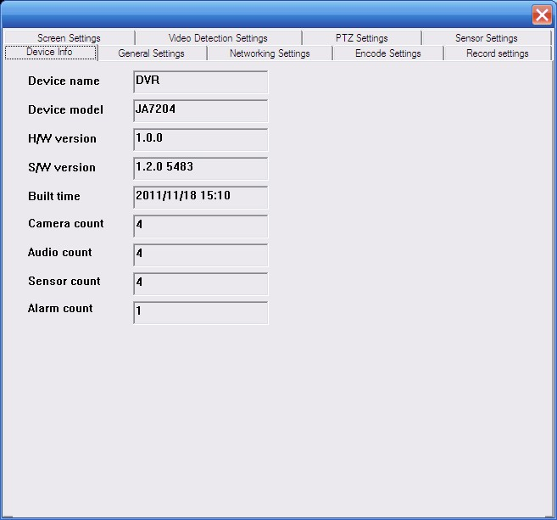
7.2 General setting
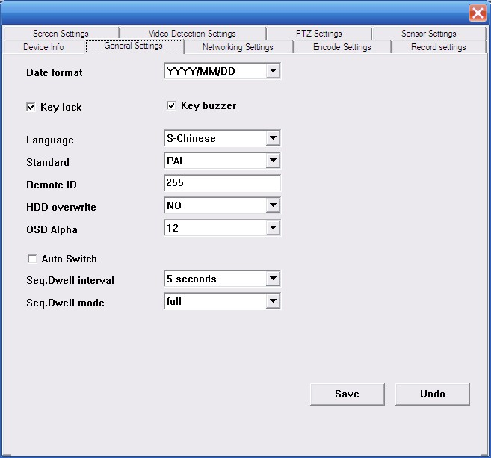
7.3 network setting
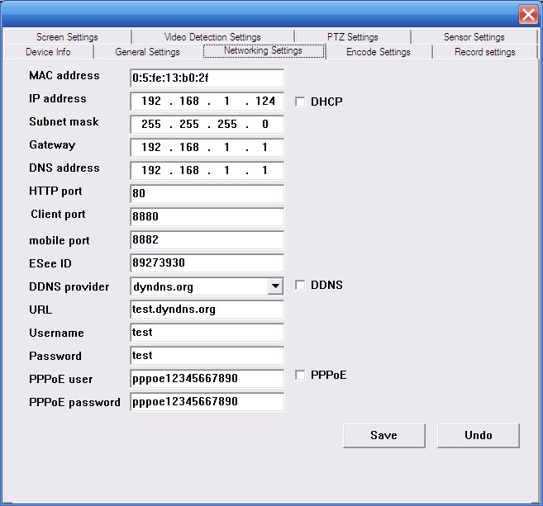
7.4 coding setting
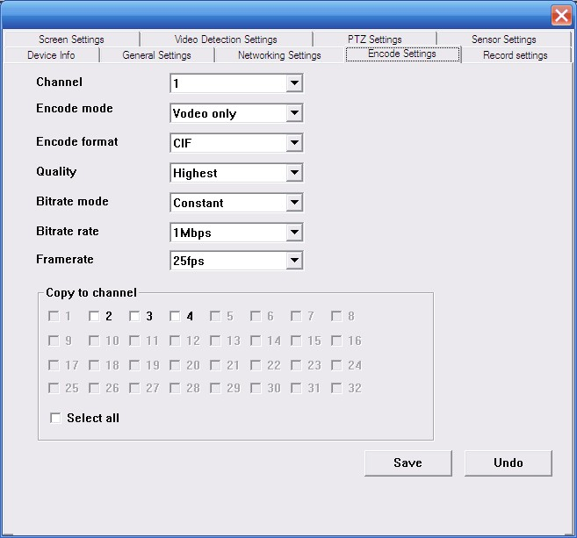
7.5 record setting
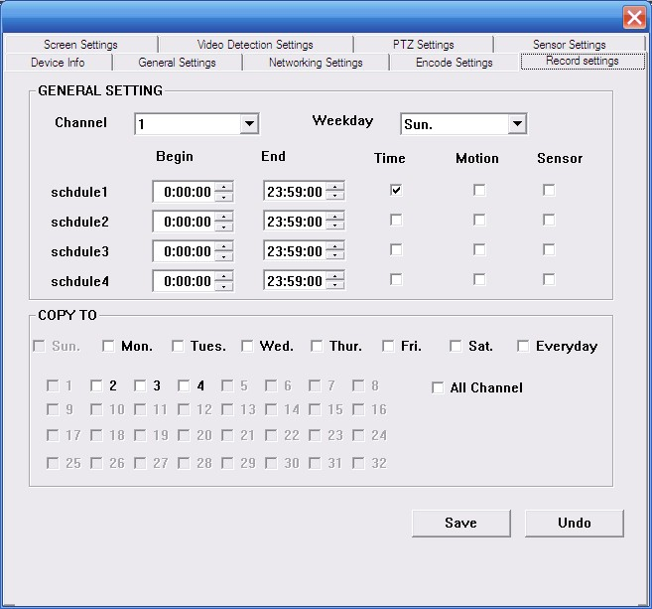
7.6 screen setting
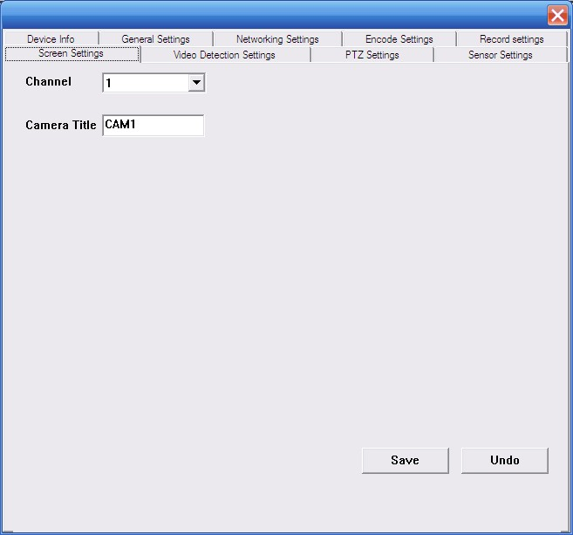
7.7 video sense setting
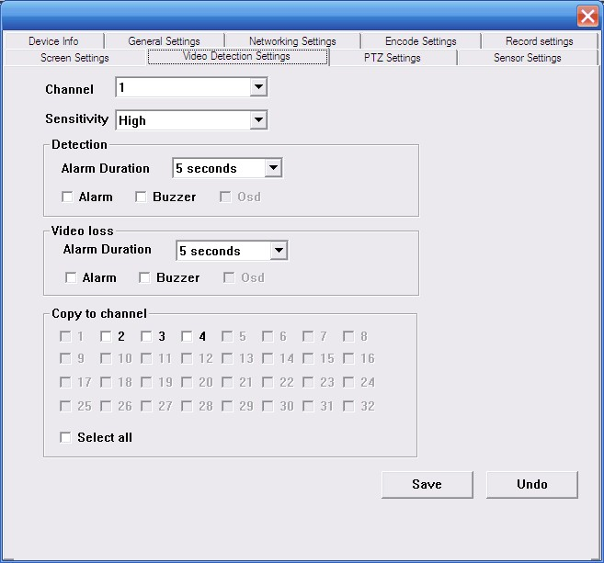
7.8 PTZ setting
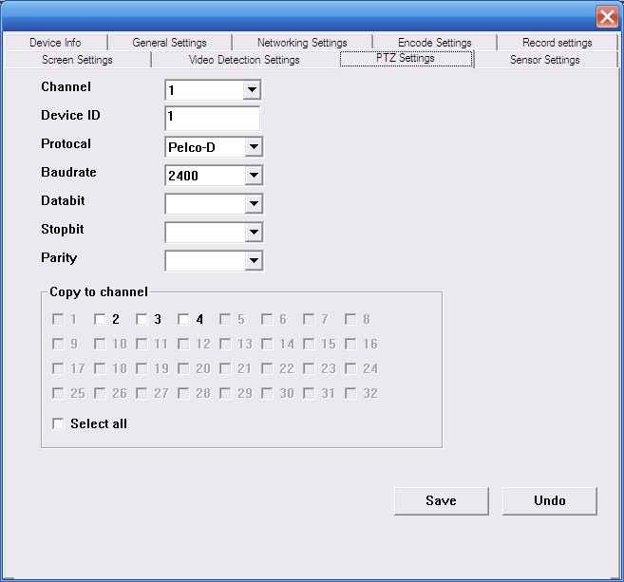
7.9 sensor setting
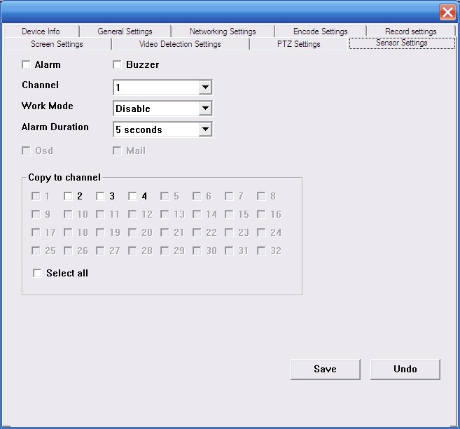
8. local setting
8.1 local setting
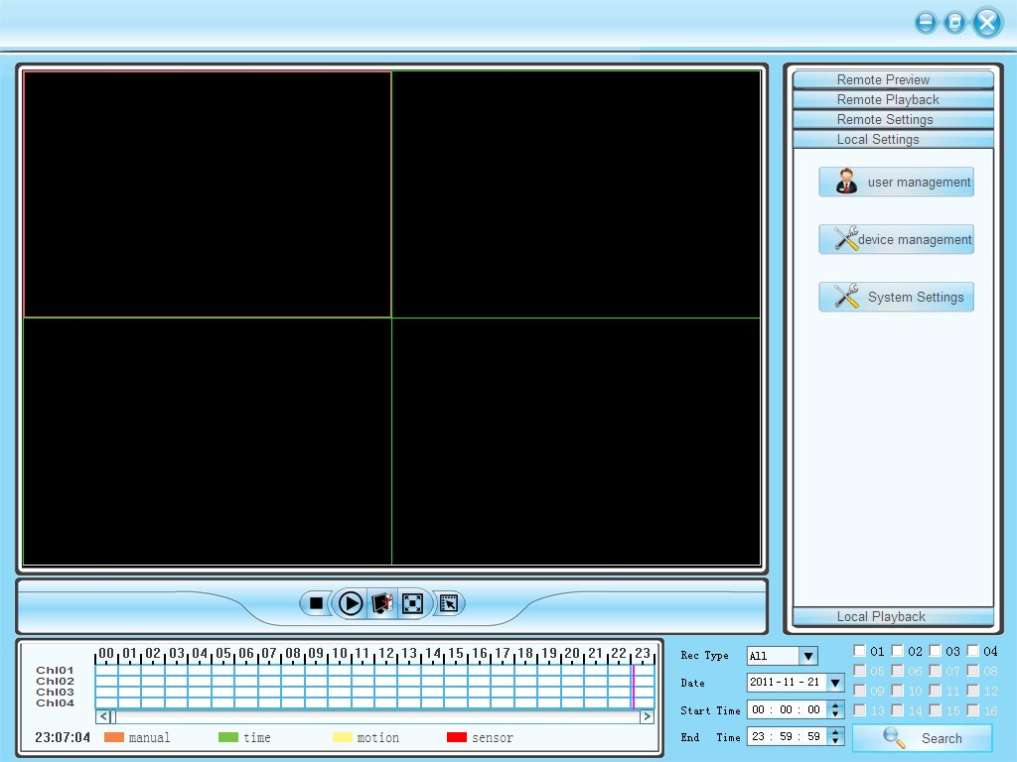
Local setting can user management, setting management, system setting
8.2 user management
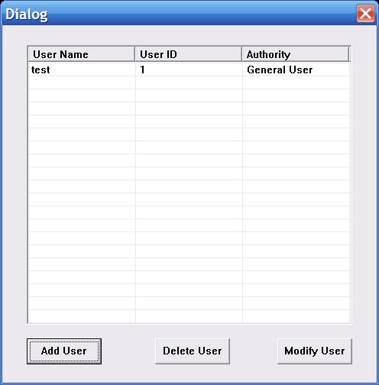
Can add user,delete user and modify user
8.2. 1 device management
Add device
8.2.2 system setting
