Dyndns Setup
1.Applying for dyndns domain name
DynDNS web：http://www.dynDNS.com/
Open the web as the below pic
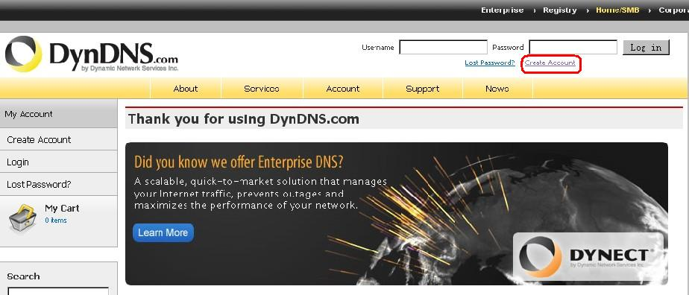
If you have registered,input name and password,click Log in
If you didn’t register before, click “Create Account” to register interface as below:
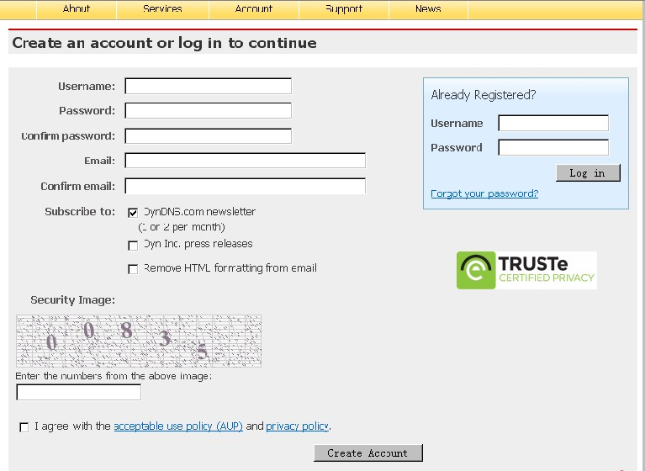
If you have finished all the above blanks,click “Create Account” button at the bottom,then go to next step.
3. Log on your email box to make an activation as below pic.
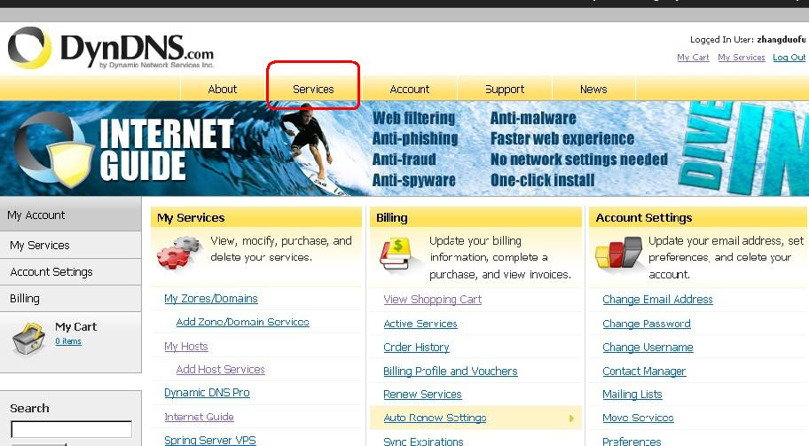
After going into your dyndns web,go to apply for free domain name,click “service” in the red frame above.

4. Choose DNS type,select “Dynamic DNS” in the below red frame.
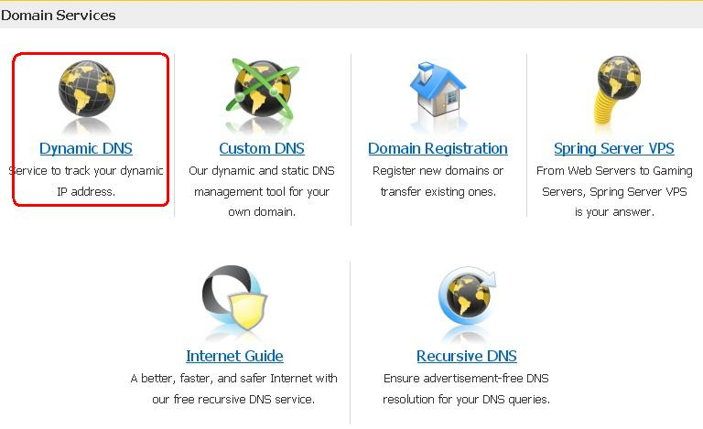

5. Choose “Dynamic DNS Free” in the below red frame.
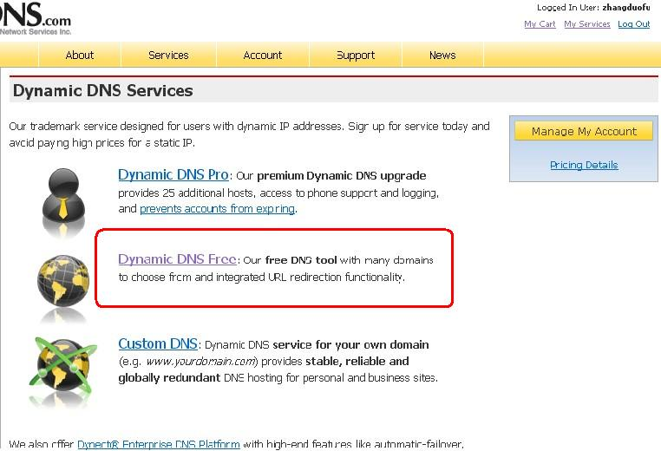
6.Choose “Get Started” in the below red frame.
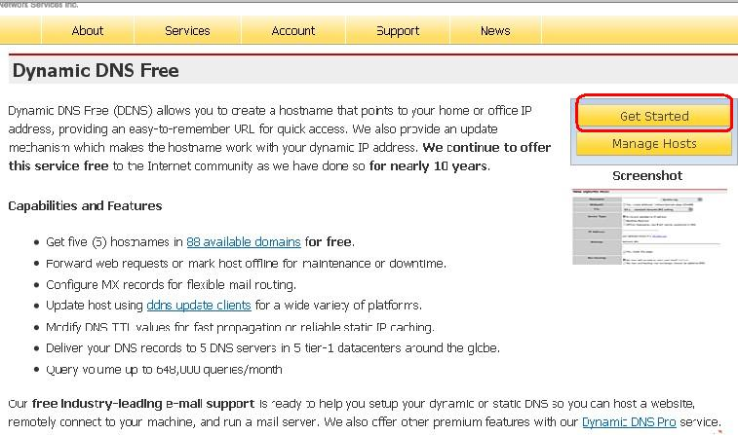
7. Applying for mainframe domain name,see below pic:
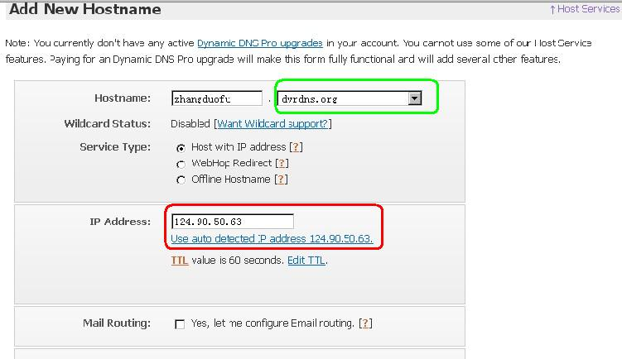
Hostname： input your domain name in the first frame, select “dvrdns.org” in the green frame.
Service Status：choose “Host with IP address”
IP Address：Directly click “Use auto detected IP address 124.90.50.63.” to get mainframe IP in the red frame above.
Set default for other option,then click “Add To Cart” at the right corner.
8.Pay, because it’s free domain name,so not need to fill the green frame,directly click “next” as below Pic.
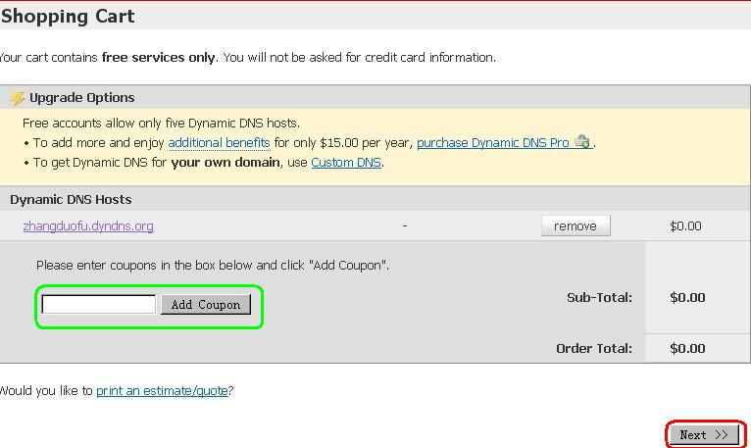
9. Startup serve,directly click “Activate Services” in the below red frame.
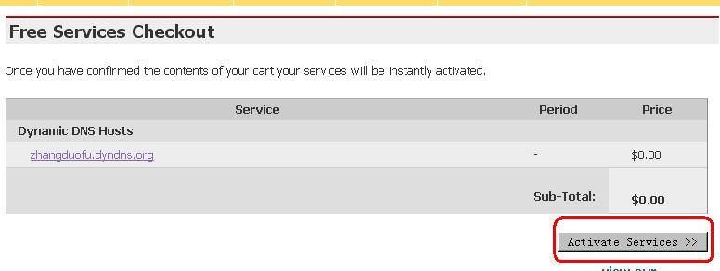

10. Compelete application. If it come up the below interface,means you have registered successfully. It will show the domain name you applied,like the red frame,it’s a domain name I applied: jufeng.dyndns.org
