Fast installation manual

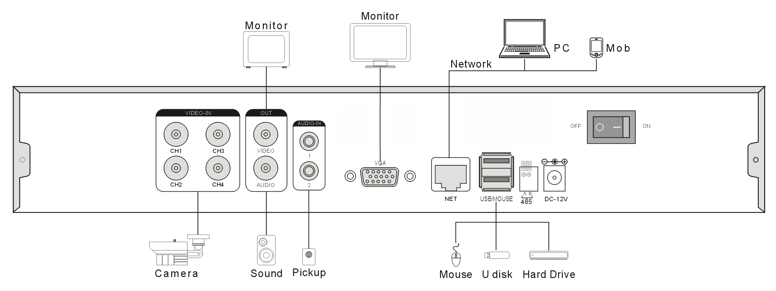

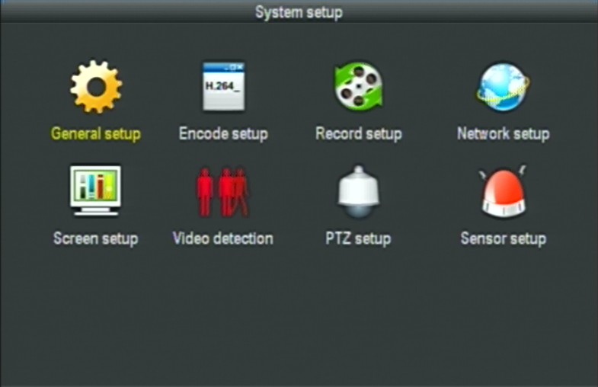
1:Users log on
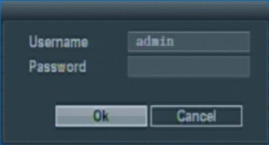
Click the right mouse button and choose "the main menu", enter the equipment the main menu interface.
The system default user "admin", the default password is empty, click ok button to enter the menu.
2:Recode setup
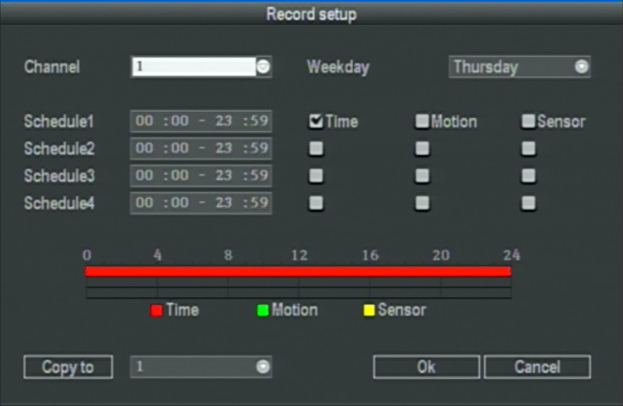
In the "system setup" menu, click "Record Setup "
Channel ：chose the right CH as needed by clicking the inverted triangle
Weekday : chose the right day as user's need, "ALL" means all days in a week.
Image mode and time ： every time slot can set different recoding mode in all 4 time slot. "Time " recording with red color , "Motion" recording with green color , "Sensor"recording with yellow color ; “☑" means working , “□” means invalid. The bottom parts has times status display, whole schedule from time 0~24 hours
Copy to ： select the target channel on the right of "copy to "button ,click "copy to" & ''ok " then system will set the current channel setup informations to other target video channel. Click button "cancel", the setup informations is non-saved but to exit.

3： Motion recording setup
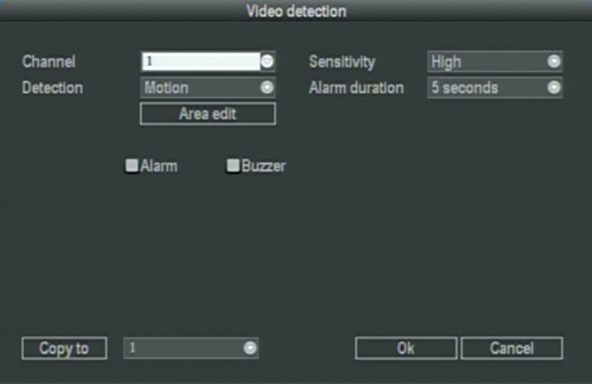
In system set interface, the choice of "motion detecting" into its set interface.
Channel: choose need to set up the channel, click options box choice.
Sensitivity: choose trigger mobile detection sensitivity. "No detection" is set in the page of the parameters of the invalid. Testing types: set alarm type, have "movement" detection alarm, "video lost" alarm, "cover up" alarm
Alarm last: set alarm triggered, the alarm extended time
Regional editor: set motion detecting area. Enter the page, press the mouse left key drag can.
record channels: the trigger mobile video channels after detection, the system has the default.
Alarm: "☑" prove open alarm, "□" prove not open alarm. To detect moving when alarm sound.
buzzer："☑" says open a buzzer, "□" said don't open a buzzer, to detect moving when sound.
Copy to ： select the target channel on the right of "copy to "button ,click "copy to" & ''ok " then system will set the current channel setup informations to other target video channel. Click button "cancel", the setup informations is non-saved but to exit.

4 ：Video Playback
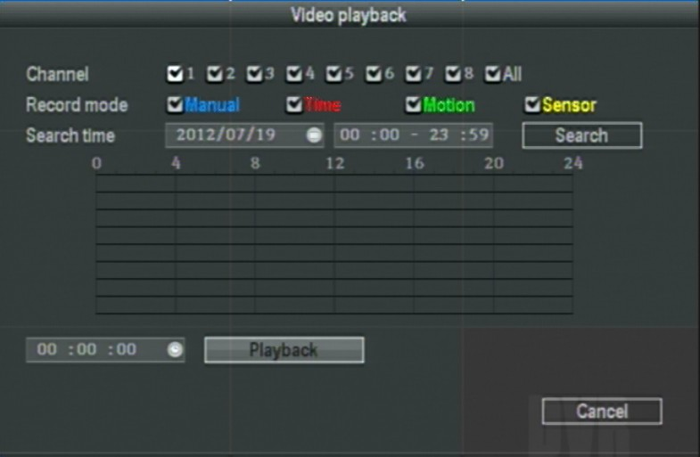
Click main menu column "video playback" into file search interface.

Video Search
Channel selection: select the target channel, click check box to choose. "√" is checked; "□" not selected.
Record mode: select the record mode of searching, click check box to choose. "√" is checked; "□" not selected. DATE Time setting: enter the beginning and end time in the edit box to search the video.
Search : after searching criteria set, click the button, the system will begin to search the corresponding video information, and list the search results. “RED”-regular time recording,” GREEN”- Motion Detection recording, ”YELLOW”-alarm recording.
Playback: Go into video playback interface, use up-down-left-right button or mouse to set the time period, click【】or left of mouse go into playback interface.
Cancel : back to previous menu

5:Video backup

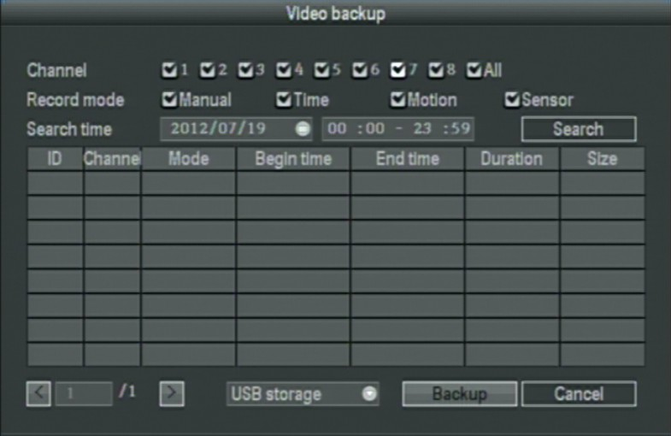
Main menu→“Video backup”。
Channel selection: select the target channel, click check box to choose. "√" is checked; "□" not selected.
Record mode: select the record mode of searching, click check box to choose. "√" is checked; "□" not selected. DATE Time setting: enter the beginning and end time in the edit box to search the video.
Search : after searching criteria set, click the button, the system will begin to search the corresponding video information, and list the search results. “RED”-regular time recording,” GREEN”- Motion Detection recording, ”YELLOW”-alarm recording.
Choose"channel"and "record mode", set the range of date and time，click "search".
After choosing a file from the column--"enter". It will be backup success when it show 100%.
Remark: Backup USB device must be fat32 form.

6:Network setup
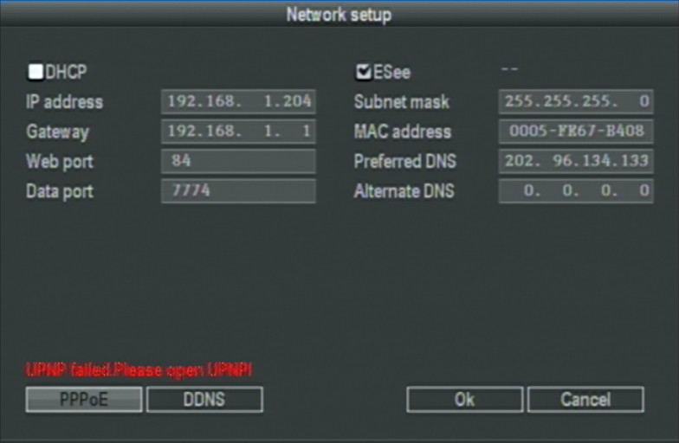
5、1：In the "system setup" menu, click " Network Setup "
MAC address：showing the device's MAC address
DHCP：select whether to start up DHCP to automatically obtain IP 。“☑”means works ；“□” means non-work
IP address ：the IP address must be unique and can not be in conflict with the host or workstation on the same network segment
Subnet Mask ：subnet for the network segment。
Gateway：need to set the gateway address to achieve communication between the different network segments.
DNS address ：devices used PPPOE protocol to access network to gain a dynamic IP address
WEB port ：port number IE browser visit , default port is "80"
DATA port ；port number device and mobile visit , default port is "8888"
ESeenet ID： after connecting internet , click“☑ Eseenet” to gain a Eseenet ID , which can be used in IP remote monitoring in ESeenet network server
PPPOE configuration :
Start using ：“☑ PPPOE”means to start up PPPOE dial-up. “□” means not to start up
PPPOE user： input the user name of ISP into edit box
PPPOE password ：input the password of ISP into edit box
After the page setup is completed, click '"OK " to save the changes ; click "cancel " , non-save but exit.
DDNS setting: automatic analytical function of dynamic domain name, supported 3322 and DYNDNS
In the "network setup" menu, click " DDNS "
Start using ：“☑”means DDNS dynamic domain services start using ;“□”means not to start up。
Select the right network server and input user name, password and domain name ，
In the "system setup" menu, click " Network Setup "

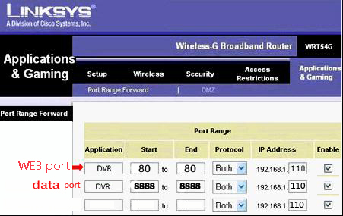
6、2：Port Forwarding Port Forwarding for Port 80 (If your ISP blocks this port, make sure to change it to 8080 or something else, on the DVR and the Router).
These DVR Models also need port 8888 open for the video stream.
These DVR Models also need port 8888 open for theMobile phone access

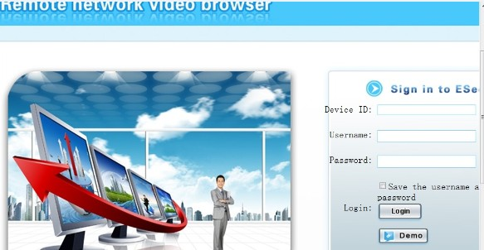
6、3：network log on

6．3.1：PC log on：Open the IE and the location bar input (www.IPC163.COM), into the landing pages, as the chart, an input device ID
（ESeenet ID），User name and password, you this user name and password and host of consistent, input the correct user information, the landing successful.

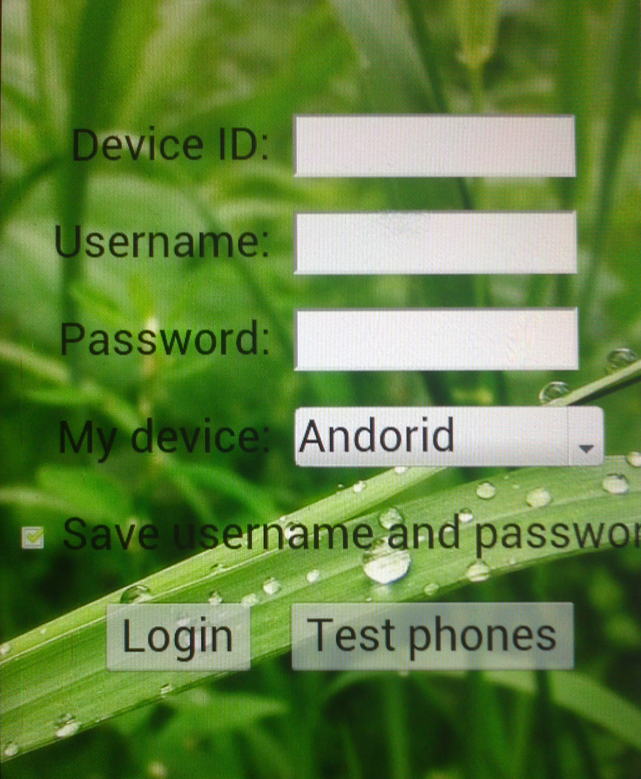
6.3.2：Mobile IE login：Open the phone system comes with IE and in the address bar of input (www.IPC163.COM), into the landing pages, as the chart, an input device ID
（ESeenet ID），User name and password, you this user name and password and host of consistent, input the correct user information, the landing successful. Choose device (now only support：Andorid、Iphone、IPAD）
Other mobile phone please install the phone system monitoring software (for details please refer to CD mobile phones monitoring manual)

