User Manual
Table of Contents
- Function introduction
- Getting Start
- Add/Edit/Delete device
- Live View
- Snapshot and Record
- Local Setting
7. Contact us.

1. Function introduction
This app allows iPhone and iPad user to view and control live video streams from IP Cameras
and DVRs.
- Stream Videos over WIFI or 3G
- View up to 4 live video streams
- Device management.
- Snapshot and browse picture
- Record and playback video
- PTZ control
- Landscape and Portrait orientation support
- Two-way pronunciation

2. Getting Start
Connect your iOS device to the target using 3G or WIFI, Open this app you will be brought to main interface.
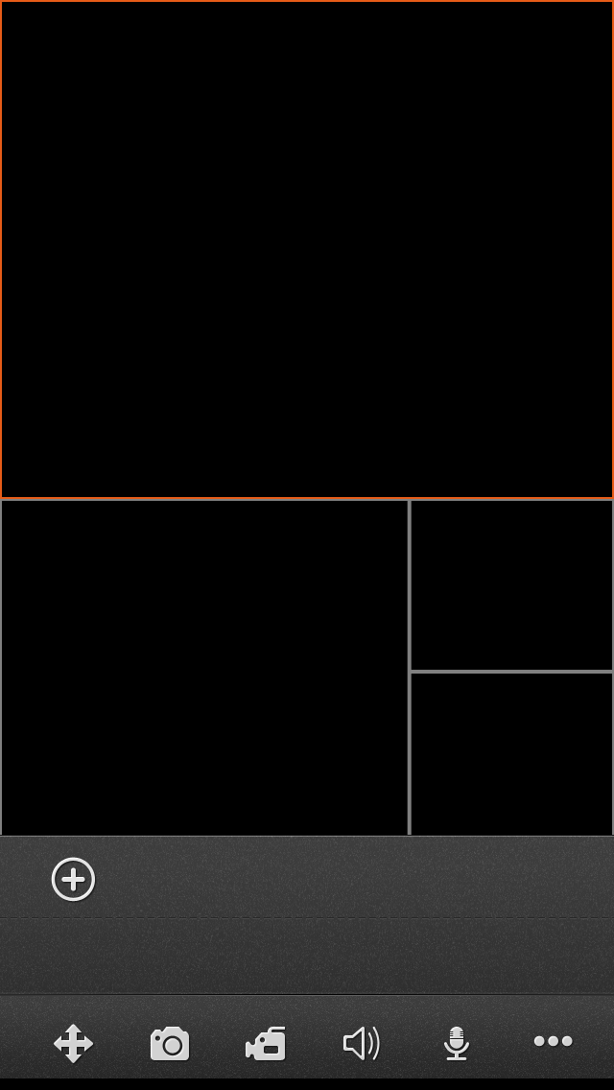

3. Add/Edit/Delete device
•Add Device
Tapto open the Add Device view,
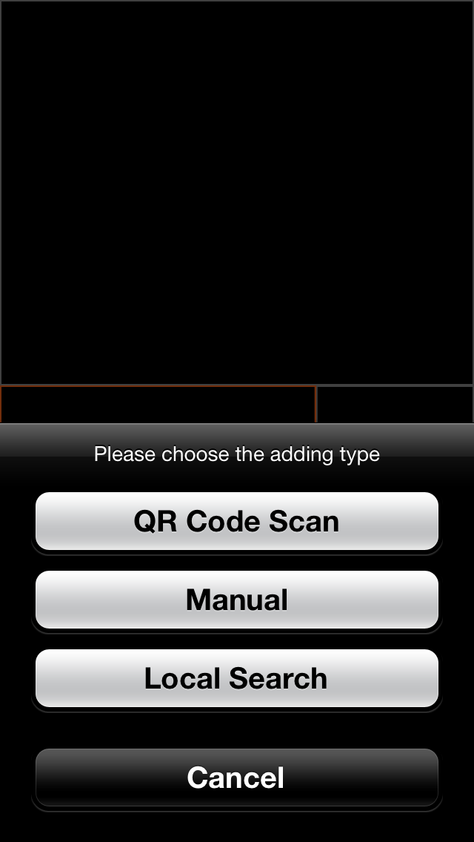

Button | Descriptions
QR Code Scan | Scan the OR code on your device to fill in the UID string,
Manual | Fill in the login info manually,
Local Search | If your DVRs are on the same local network with your phone, Goolink would find them and let you add those devices easily
All of the 3 adding methods above will lead you into the Device edit panel:
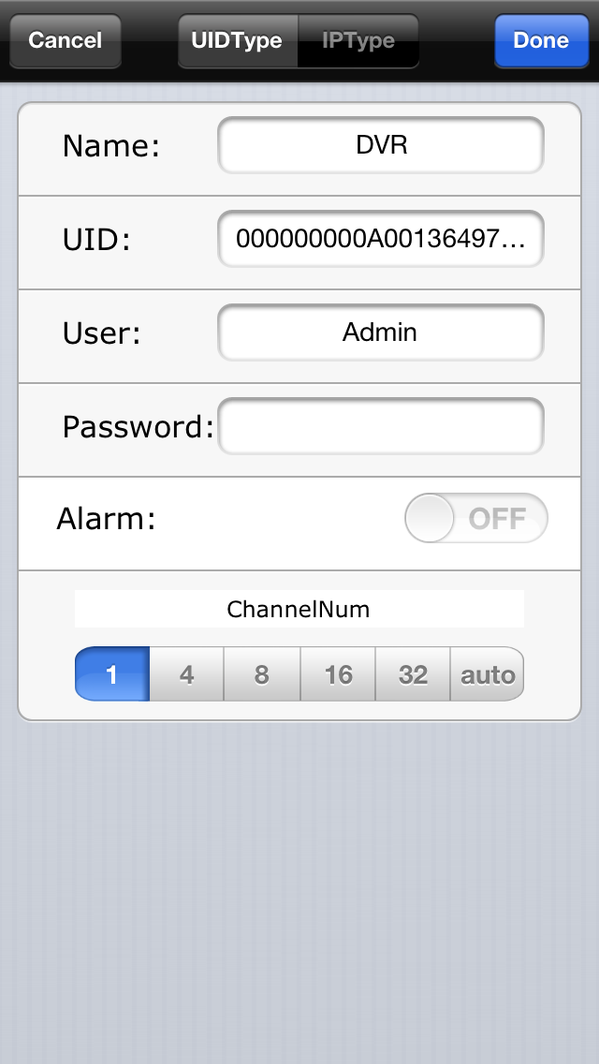
UIDType: the default type of adding device, using the device UID to get the connecting info from the GooLink server, with this type, you can free yourselves from the boring job of setting port forwarding and the IP address.

IPType: in case your device do not has the UID or fail to use the UID to connect, you could Choose the  type to add device, then tap the 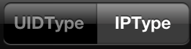 to assign the IP and port /user name …to the app, just ignore the Entry of the UIDType .

UIDType | Entry | Descriptions
UIDType | Name | Any characters that you like to identify this device. Please be noted  that the name should not duplicate with existing device’s name.
UIDType | UID | The device UID,(if you are using the QR Code Scan/ Local Search method to add device, this item will be fill automatically)
UIDType | User | DVR’s user name
UIDType | Password | DVR’s password
UIDType | Alarm | Enable the Alarm Push function(it could work if your DVR support the Alarm Push function)
UIDType | Channel Number | Select the channel number, when assign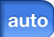, the app will set the number automatically.
IPType | Name | Any characters that you like to identify this device. Please be noted  that the name should not duplicate with existing device’s name.
IPType | Address | Target’s IP address or URL, please be noted that if URL is used,  the “http://”prefix should not be included.
IPType | Port | DVR’s cellPhone port(or call mobile Port)
IPType | User | DVR’s user name
IPType | Password | DVR’s password
IPType | Alarm | Enable the Alarm Push function(it could work if your DVR support the Alarm Push function)
IPType | Channel Number | Select the channel number, when assign, the app will set the number automatically.

•Edit/Delete Device
To Edit/Delete a device, tap  to spread out the buttons. Then tap 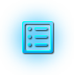 to open the Device list, you can enter into editing mode by tapping of a certain row and click 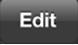 button in the upper-right corner. You can modify device login information in this view. And at the bottom of this view, you can delete the device by click the red button
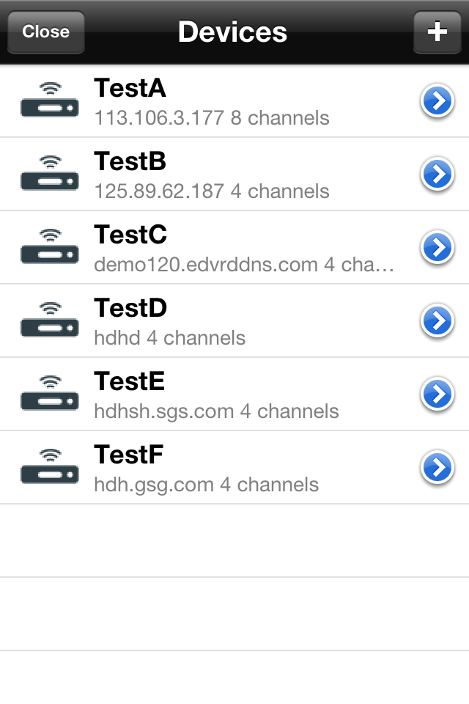
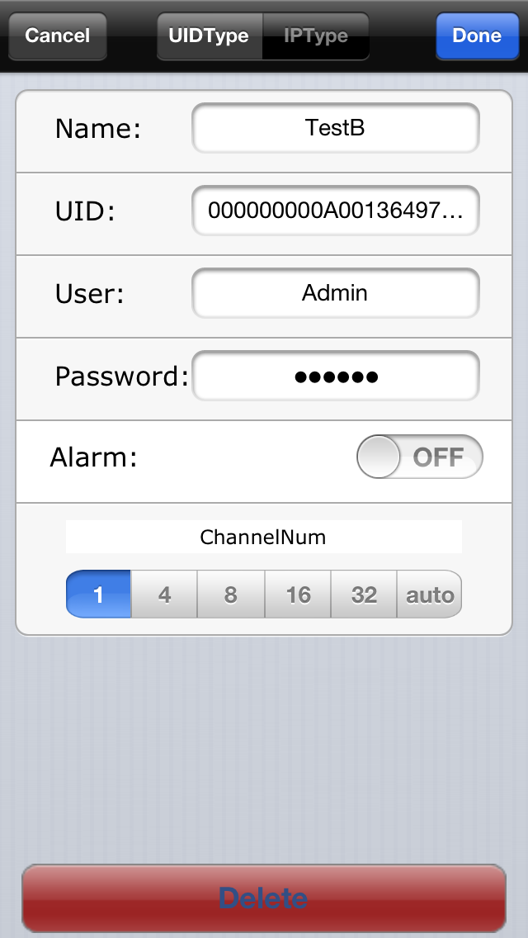

4. Live View
When finish adding device, it will show under the playing windows
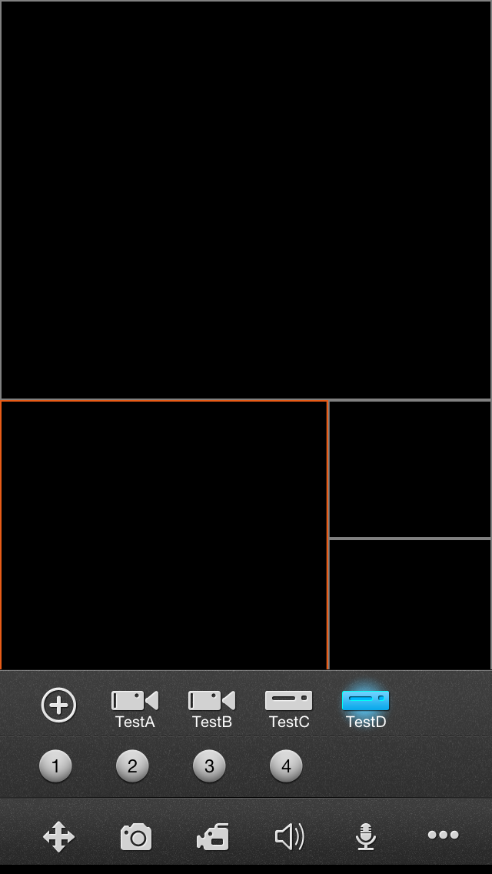
To start a live video, tap the Device icon to check out the channels, then tap the channel you want. Repeat above steps to connect to other channels of the device or another device.
When some one channel selected, the channel circle icon’s color will turn into bright-Blue. Tap the bright-Blue icon, the channel video will stop and the channel circle icon color becomes grey.
Tip: You can tap and drag the window around to swap any two of them except that dragging the
large window makes no swapping.

•Panel button description
Button Icon |  |  | Button Function
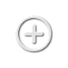 |  |  | Add a new device
 | 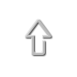 |  | PTZ:UP
 | 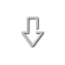 |  | PTZ:Down
 |  |  | PTZ:Right
 |  |  | PTZ:Left
 | 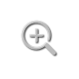 |  | Zoom In
 | 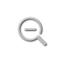 |  | Zoom Out
 | 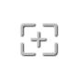 |  | Focus Add
 | 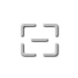 |  | Focus Minus
 |  |  | Iris Add
 |  |  | Iris Minus
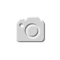 |  |  | Snapshot
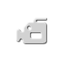 |  |  | Start/Stop Record
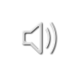 |  |  | Audio
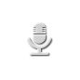 |  |  | Talkback
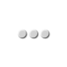 |  | 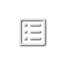 | Device List
 |  | 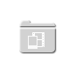 | Snapshot and Record files
 |  |  | Remote Record file Search and playback
 |  |  | Local Settings
 |  |  | User guide

•PTZ Control
Tap to open the PTZ Control panel. Slide to show more PTZ control button; to hide the panel, you can either tap the button again or tap any video window.
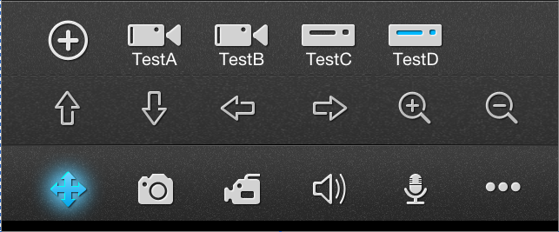

5•Snapshot and Record files
•Snapshot and Record Playback
Tap to visit the Snapshots & Records view, you can playback or delete the files from this view.
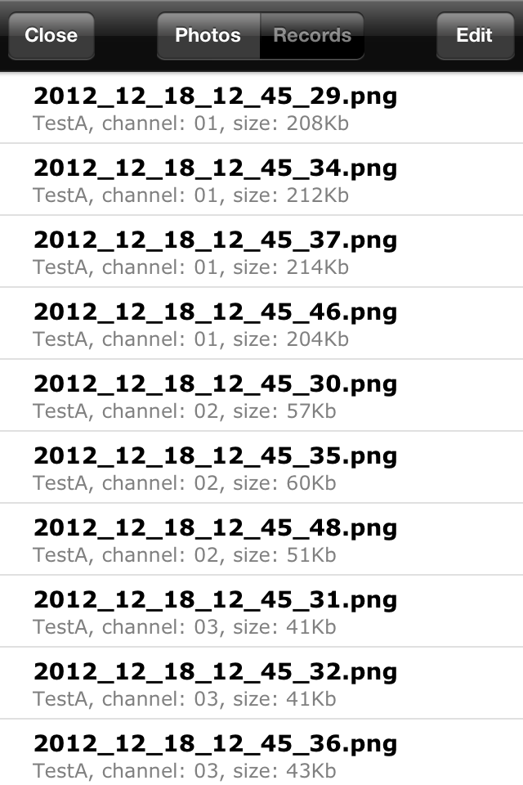

•Snapshot and Record File Export
In the photo display view or record replay view, tap 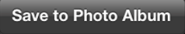 to copy your files to the System Camera Roll, so that you can Email/Assign or export the file to your PC.

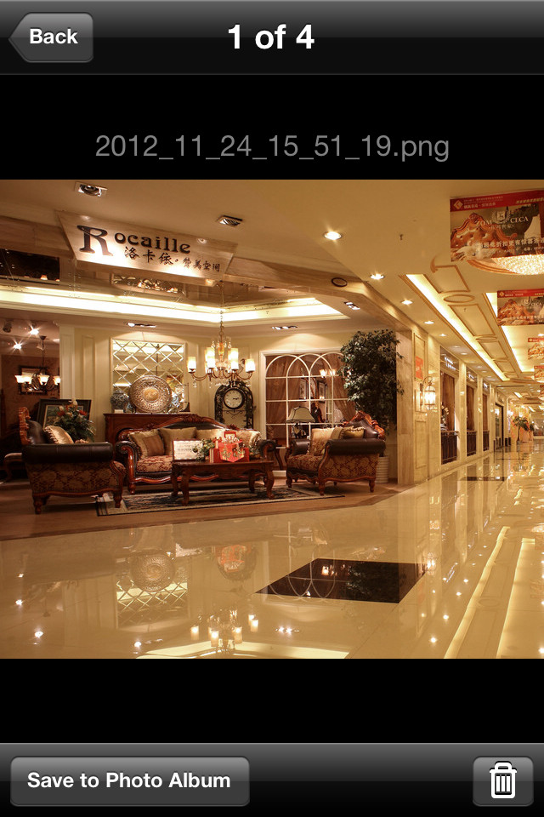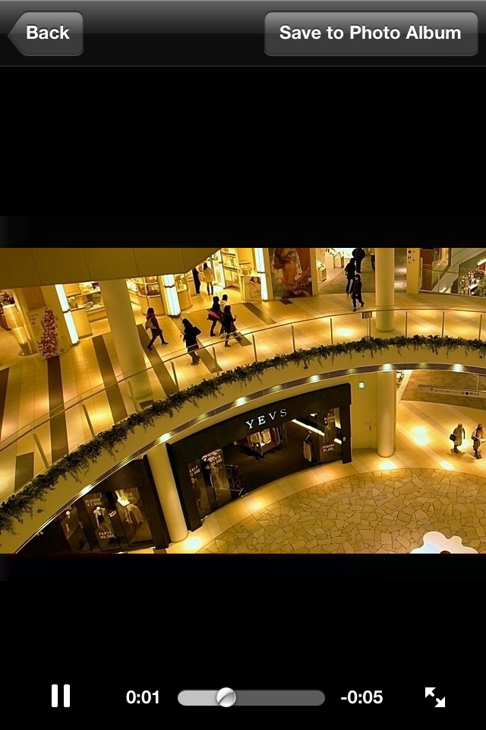

6•Local Settings
Tap to open the Settings view:
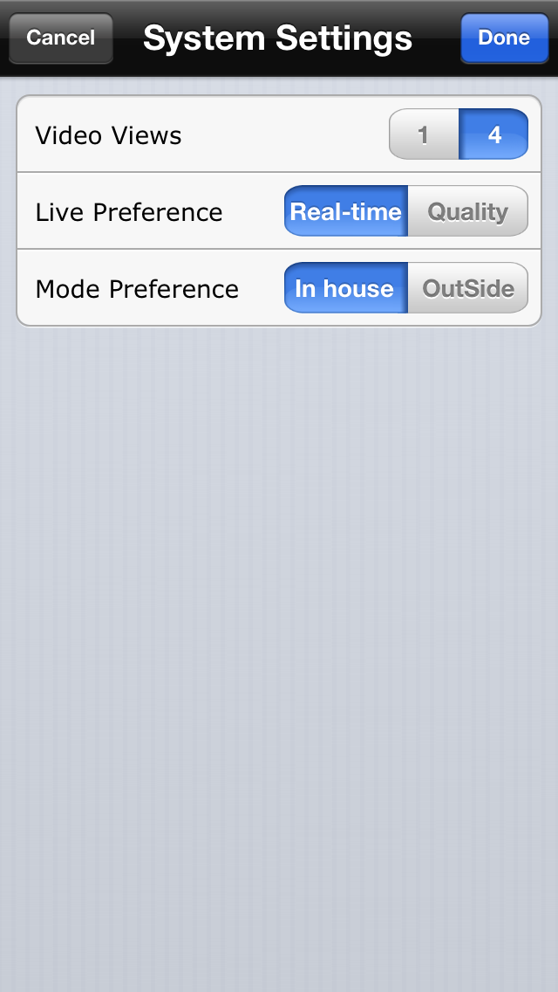

Video Views | 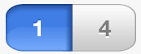 | One window display on the Live view
Video Views | 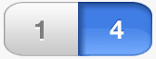 | Four windows display on the Live view
Live Preference | 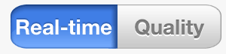 | Real-time mode: no buffering, which means there is minimum  delay of the video display and video fluency may be suffered;
Live Preference | 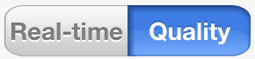 | Quality mode: buffering enabled, the video will be more fluent in  this mode;
Mode Preference | 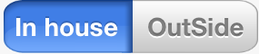 | If your device is on the same local network with your iPhone, strongly recommend using the “In house” Type; GooLink will priorities connect the DVR using the LAN network to get more fluent video and save your Network Traffic. If fail to connect with LAN network, Goolink will automatic turn to WAN conneced
Mode Preference |  | Choosing this type,Goolink won’t try to connect with LAN but immediately connect with WAN. choose this type to save the connecting time if you need to outside in majority of the time

7•Contact us
If you have any feedbacks or encounter any problems, please feel free to contact us.
Technical support: ezeyehelp@gmail.com.

This app is one product of EZeye Technologies. http://www.myEZeye.com

