The Blackberry

- Essential Contition
Support the phone with V4.6 upward Blackberry system , 480*360 and 480*320 screen resolution. includes:8900、9000、9700 and 9630, etc.The watching effection will be better if the Blackberry is the special version.
The detail is:
8900/9000 is V5.0.0.90
9700 is V5.0.0.714 or V5.0.0.344
- Install and the opration
  - Load the TMEye.cod and TMEye.alx Install packages into the Blackberry via the desktop manager
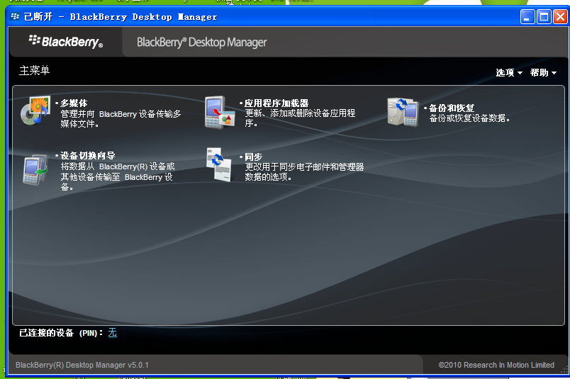
Click the applicated program loader,starting
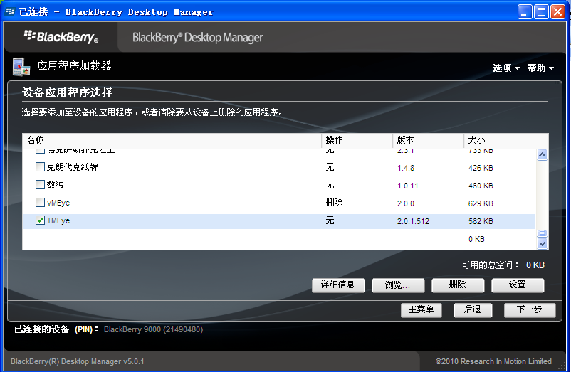
Go into the program install interface, click”browse”and choose the install package of Blackberry monitor software ,complete the loading and click next, then finish.
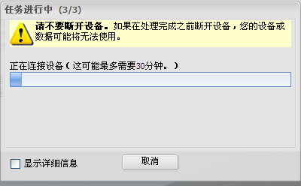
The program will load into the Blackberry automatically, and it shows instantly that the loading operation has been successful after finished.
  - Click “options”on phone desktop, show as the following illustration.
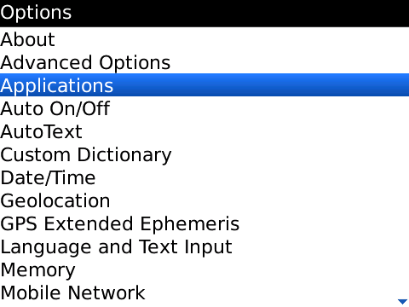
  - Click “application” to find the TMEye，enter it and click”Edit Acess”, set up all acess with “allow”, if some can’t be set up with “allow”(the option is grey and can’t be changed), ignore it and click “save”directly.
  - Click TMEye program icon, run the program and get into the initial interface by a Initialized Splash screen .
Note:
Name：the alias is easy to distinguish more device.
Address：The IP VPN address or dynamic DNS.
Port：The server port set on DVR
User ID: coincident with the ID set on DVR
Password: coincident with the password set on the DVR
Network Type: choose the network type you want
  - Click “load”, play the main interface:
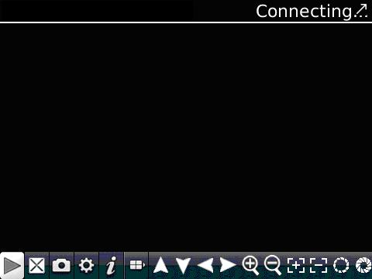
The relative function of the buttons as below：
Function Key | Name | The Description of Function
 | Play | Connect the device and start to play the vedio
 | Full Screen | Play with full screen
 | Capture | Capture the current image（save the capture image to the defult photo content of the defult phone ）
 | Setup | Set the DVR’s IP address or dynamic DNS、port、user name、password and device alias
 | Next | Enable to choose the next channel
 | About | About the information
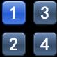 | Choose the channel | Select to play the video from one channel
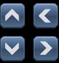 | PTZ control | Control the PTZ up、down、left or right
 | Zoom | Get far or close
 | Focal length | Addition and subtraction to achieve Focal length
 | Aperture | Addition and subtraction to achieve aperture
6）The mode of video display
Switch between normal mode and full screen mode .
normal mode
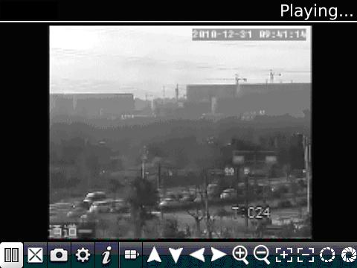
full screen mode

